# [***80 FR 48964***](https://advance.lexis.com/api/document?collection=administrative-codes&id=urn:contentItem:5GNW-R3B0-006W-83HS-00000-00&context=)

Vol. 80, No. 157, Part II, Friday, August 14, 2015

Rules and Regulations

**Reporter**

80 FR 48964 *

***Federal Register* > *2015* > *August* > *Friday, August 14, 2015* > *Rules and Regulations* > *SECURITIES AND EXCHANGE COMMISSION (SEC)***

**Title:** **Registration Process for Security-Based Swap Dealers and Major Security-Based Swap Participants**

**Action:**  Final rule.

**Agency**

SECURITIES AND EXCHANGE COMMISSION (SEC)

**Identifier:** **[Release No. 34-75611; File No. S7-40-11]** > **RIN 3235-AL05**

**Administrative Code Citation**

**17 CFR Parts 240 and 249**

**Synopsis**

**SUMMARY:** The Securities and Exchange Commission (the "Commission") is adopting new Rules 15Fb1-1 through 15Fb6-2 and Forms SBSE, SBSE-A, SBSE-BD, SBSE-C and SBSE-W in accordance with Section 15F of the Securities Exchange Act of 1934 (the "Exchange Act"). Section 15F, which was added to the Exchange Act by Section 764(a) of Title VII of the Dodd-Frank Wall Street Reform and Consumer Protection Act ("Dodd-Frank Act"), requires the Commission to issue rules to provide for the registration of security-based swap dealers ("SBS Dealers") and major security-based swap participants ("Major SBS Participants") (collectively, "SBS Entities"). These new rules and forms establish a process by which SBS Entities can register (and withdraw from registration) with the Commission.

**Text**

**SUPPLEMENTARY INFORMATION:**

**Table of Contents**

I. Background

A. Dodd-Frank Act

B. Proposed Rules

C. Comments Received

D. Summary of Final Rules

II. Final Exchange Act Rules and Forms

A. Registration Application and Amendment

1. Rule 15Fb2-1

i. Form of Application

ii. Senior Officer Certification

iii. Conditional Registration

iv. Electronic Filing and Completeness of the Application

v. Standards for Granting or Initiating Proceedings to Determine Whether to Deny Registration

vi. Comments on Substituted Compliance

2. Amendments to Form SBSE, Form SBSE-A, and Form SBSE-BD: Rule 15Fb2-3

B. Associated Persons

1. Associated Person Certification

i. Associated Person Entities

ii. Involved in Effecting Transactions

iii. Licensing

2. Questionnaire or Application for Employment and Background Checks

3. Final Rule for Associated Person Certification

C. Termination of Registration

1. Duration of Registration: Rule 15Fb3-1

2. Withdrawal: Rule 15Fb3-2

3. Cancellation and Revocation: Rule 15Fb3-3

D. Special Requirements for Nonresident SBS Entities

1. Definition of Nonresident SBS Entities

2. United States Agent for Service of Process

3. Access to Books and Records, and Onsite Inspections and Examinations, of Nonresident SBS Entities

E. Special Situations

1. Succession: Rule 15Fb2-5

2. Insolvency: Rule 15Fb2-6

F. Electronic Signatures

G. Forms

1. Form SBSE

2. Form SBSE-A

3. Form SBSE-BD

4. Form SBSE-C

5. Form SBSE-W

III. Explanation of Dates

A. Effective Date

B. Registration Compliance Date

C. SBS Entity Counting Date

IV. Paperwork Reduction Act

A. Summary of Collection of Information

B. Proposed Use of Information

C. Respondents

D. Total Initial and Annual Reporting and Recordkeeping Burdens

1. Burden Associated With Filing Application Forms

2. Burden Associated With Amending Application Forms

3. Burdens Relating to Associated Persons

4. Burdens on Nonresident SBS Entities

5. Burden Related to Retention of Manually Signed Signature Pages

6. Burden Associated With Filing Withdrawal Form

E. Retention Period of Recordkeeping Requirements

F. Collection of Information Is Mandatory

G. Confidentiality

V. Economic Analysis

A. Introduction and Broad Economic Considerations

B. Baseline

1. Current Security-Based Swap Market

i. Dealing Structures and Participant Domiciles

ii. Market Centers

iii. Current Estimates of Number of SBS Dealers and Major SBS Participants

2. Levels of Security-Based Swap Trading Activity

3. Cross-Market Participation

4. Statutory Disqualification

C. Benefits of Registration

1. Direct Benefits

i. Disciplinary History and Other Information

ii. Statutory Disqualification

iii. Senior Officer Certification and Nonresident Entity Certification

iv. Other Direct Benefits

2. Indirect Benefits

D. Costs of Registration

1. Direct Compliance Costs

2. Other Direct Costs

i. Costs Related to the Disciplinary History Disclosure Requirement

ii. Costs Related to Certifications

iii. Costs Related to the Associated Person Requirements

iv. Costs for Nonresident SBS Entities

2. Indirect Costs

E. Effects on Efficiency, ***Competition***, and Capital Formation

F. Registration Rule Alternatives

1. Associated Person Certification Requirement

2. Licensing, Control Affiliates and CCO Certification Regarding Associated Persons

3. Requirements on Nonresidents

4. Other Considerations

VI. Regulatory Flexibility Act Certification

VII. Statutory Basis

**I. Background**

*A. Dodd-Frank Act*

Section 764 of the Dodd-Frank Act added Section 15F to the Exchange Act to require the Commission to adopt rules to provide for registration of SBS Entities. Section 15F(a) of the Exchange Act prohibits any person from acting as a "security-based swap dealer" n1 or **[*48965]** "major security-based swap participant" n2 without being registered with the Commission. n3 Section 15F(b)(1) further states that a person "shall register as a security-based swap dealer or major security-based swap participant by filing a registration application with the Commission," and Section 15F(b)(2)(A) states that "[t]he application shall be made in such form and manner as prescribed by the Commission, and shall contain such information, as the Commission considers necessary concerning the business in which the applicant is or will be engaged." In addition, Section 15F(d)(1) of the Exchange Act directs the Commission to "adopt rules for persons that are registered as [SBS Entities] under [Section 15F]."

n1 *See* Exchange Act Section 3(a)(71)(A) [[*15 U.S.C. 78c(71)(A)*](https://advance.lexis.com/api/document?collection=statutes-legislation&id=urn:contentItem:4YF7-GHC1-NRF4-407J-00000-00&context=)] and Rule 3a71-1 [[*17 CFR 240.3a71-1*](https://advance.lexis.com/api/document?collection=administrative-codes&id=urn:contentItem:5NBM-FNY0-008G-Y18W-00000-00&context=)]. *See also, Further Definition of "Swap Dealer," "Security-Based Swap Dealer," "Major Swap Participant," "Major Security-Based Swap Participant" and "Eligible Contract Participant,"* Exchange Act Release No. 66868 (Apr. 27, 2012), [*77 FR 30596*](https://advance.lexis.com/api/document?collection=administrative-codes&id=urn:contentItem:55PP-R380-006W-8100-00000-00&context=) (May 23, 2012) ("Intermediary Definitions Adopting Release") and *Application of "Security-Based Swap Dealer" and "Major Security-Based Swap Participant" Definitions to Cross-Border Security-Based Swap Activities,* Exchange Act Release No. 72472 (Jun. 25, 2014), [*79 FR 47278*](https://advance.lexis.com/api/document?collection=administrative-codes&id=urn:contentItem:5CWM-FH00-006W-8559-00000-00&context=) (Aug. 12, 2014) ("Cross-Border Adopting Release").

n2 *See* Exchange Act Section 3(a)(67)(A) [[*15 U.S.C. 78c(67)(A)*](https://advance.lexis.com/api/document?collection=statutes-legislation&id=urn:contentItem:4YF7-GHC1-NRF4-407J-00000-00&context=)] and Rule 3a67-1 [[*17 CFR 240.3a67-1*](https://advance.lexis.com/api/document?collection=administrative-codes&id=urn:contentItem:5NBM-FNY0-008G-Y18J-00000-00&context=)]. *See also,* the Intermediary Definitions Adopting Release and Cross-Border Adopting Release.

n3 *See Temporary Exemptions and Other Temporary Relief, Together With Information on Compliance Dates for New Provisions of the Securities Exchange Act of 1934 Applicable to Security-Based Swaps,* Exchange Act Release No. 64678 (Jun. 15, 2011), [*76 FR 36287, 36299-300*](https://advance.lexis.com/api/document?collection=administrative-codes&id=urn:contentItem:5351-V100-006W-83H9-00000-00&context=) (Jun. 22, 2011) (the "Effective Date Release").

*B. Proposed Rules*

The Commission proposed new rules 15Fb1-1 through 15Fb6-1 and Forms SBSE, SBSE-A, SBSE-BD, SBSE-C, and SBSE-W to establish a process by which SBS Entities could register (and withdraw from registration) with the Commission. n4 As described in the Registration Proposing Release, this process was designed to be comprehensive, and included, among other things: (1) A requirement to amend an inaccurate application for registration; (2) procedures for succession to, or withdrawal from, registration; (3) procedures for the Commission to cancel or revoke registration; (4) a requirement for an SBS Entity to certify that none of its associated persons that effect, or are involved in effecting, security-based swaps on the SBS Entity's behalf is subject to statutory disqualification; and (5) special requirements applicable to nonresident SBS Entities relating to service of process, opinion of counsel, Commission access to documents and Commission onsite examinations.

n4 *Registration of Security-Based Swap Dealers and Major Security-Based Swap Participants,* Exchange Act Release No. 65543 (Oct. 12, 2011), [*76 FR 65784*](https://advance.lexis.com/api/document?collection=administrative-codes&id=urn:contentItem:543G-5JW0-006W-83D1-00000-00&context=) (Oct. 24, 2011) (the "Registration Proposing Release").

The Commission re-proposed Forms SBSE, SBSE-A, and SBSE-BD in May 2013. n5 Among other things, the re-proposed Forms provide registrants with a method to provide the Commission with information regarding the registrant's intent to rely on a substituted compliance determination by the Commission with respect to those requirements in Exchange Act Section 15F and the rules and ***regulations*** thereunder for which the Commission determines that substituted compliance may be available.

n5 *See Cross-Border Security-Based Swap Activities; Re-Proposal of* ***Regulation*** *SBSR and Certain Rules and Forms Relating to the Registration of Security-Based Swap Dealers and Major Security-Based Swap Participants,* Exchange Act Release No. 69490 (May 1, 2013), [*78 FR 30968*](https://advance.lexis.com/api/document?collection=administrative-codes&id=urn:contentItem:58GH-T430-006W-840H-00000-00&context=) (May 23, 2013) ("Cross-Border Proposing Release").

In general, the proposed rules would have required an SBS Entity to register with the Commission by filing either Form SBSE, Form SBSE-A, or Form SBSE-BD, as appropriate, electronically. The Commission would have then either granted conditional registration to the SBS Entity or initiated proceedings to deny registration. Once all of the substantive requirements applicable to SBS Entities were adopted by the Commission, the SBS Entity would have been required to electronically file Form SBSE-C, a certification signed by a knowledgeable senior officer stating that, to the best of that person's knowledge the SBS Entity had the operational, financial, and compliance capabilities to act as an SBS Dealer or Major SBS Participant, as appropriate. Upon receipt of that certification, the Commission would have either granted ongoing registration or instituted proceedings to deny such registration.

The Commission's proposed registration requirements for SBS Entities were largely modeled after the registration regime applicable to broker-dealers, n6 while also taking into account the Commodity Futures Trading Commission's (CFTC's) registration requirements for intermediaries. n7 This approach was designed to both ease the regulatory burden on market participants that register as both an SBS Entity and a broker-dealer by establishing a consistent and complementary registration regime, and to avoid unnecessary duplication by permitting SBS Entities that are otherwise registered or registering as intermediaries with either the Commission or the CFTC to complete simplified application forms.

n6 This includes rules promulgated under Sections 15(b) and 17(a) of the Exchange Act.

n7 [*17 CFR 3.1*](https://advance.lexis.com/api/document?collection=administrative-codes&id=urn:contentItem:5S36-B540-008G-Y2F3-00000-00&context=) *et. seq.* Futures commission merchants ("FCMs") and introducing brokers presently register with the CFTC by filing Form 7-R with the National Futures Association ("NFA"). On January 11, 2012, the CFTC issued final rules requiring swap dealers and major swap participants to become and remain members of a registered futures association (the NFA is presently the only registered futures association) and amending Rule 3.10 to include swap dealers and major swap participants to the list of entities that must register by filing Form 7-R with the NFA. *Registration of Swap Dealers and Major Swap Participants,* [*77 FR 2613*](https://advance.lexis.com/api/document?collection=administrative-codes&id=urn:contentItem:54S1-RNW0-006W-825G-00000-00&context=) (Jan. 19, 2012) (the "CFTC Final Registration Rules"). At the same time, the CFTC delegated to NFA the authority to process swap dealer and major swap participant registration applications. *See Performance of Registration Functions by National Futures Association With Respect To Swap Dealers and Major Swap Participants,* [*77 FR 2708*](https://advance.lexis.com/api/document?collection=administrative-codes&id=urn:contentItem:54S1-RNX0-006W-826S-00000-00&context=) (Jan. 19, 2012).

*C. Comments Received*

In the Registration Proposing Release, the Commission requested comment on all aspects of the proposal, including specific questions and a number of more general requests. The Commission originally received four comment letters in response to the proposed rules and forms. n8 The Commission later received 31 additional comment letters in response to the reopening of comment periods for certain proposals applicable to security-based swaps. n9 Of those comment letters, one letter (from six industry groups) requested an extension of time to provide comment, and six specifically commented on the proposed registration process and forms. n10

n8 Comments were received from Chris Barnard of Germany, dated Oct. 24, 2011 (the "2011 Barnard Letter"); the Securities Industry and Financial Markets Association, dated Dec. 16, 2011 (the "SIFMA Letter"); and Better Markets, Inc., dated Dec. 19, 2011 (the "2011 Better Markets Letter"). One other comment letter directed to the Registration Proposing Release file did not address the content of that release.

n9 *Reopening of Comment Periods for Certain Rulemaking Releases and Policy Statement Applicable to Security-Based Swaps Proposed Pursuant to the Securities Exchange Act of 1934 and the Dodd-Frank Wall Street Reform and Consumer Protection Act,* Exchange Act Release No. 69491 (May 1, 2013), [*78 FR 30800*](https://advance.lexis.com/api/document?collection=administrative-codes&id=urn:contentItem:58GH-T410-006W-83W2-00000-00&context=) (May 23, 2013) ("Release Reopening the Comment Period").

n10 *See* letters from: The Association of Financial Guaranty Insurers, dated Jul. 22, 2013 (the "AFGI Letter"); Better Markets, Inc., dated Jul. 22, 2013 (the "2013 Better Markets Letter"); the Institute of International Finance, dated Aug. 8, 2013 (the "IIF Letter"); the Institute of International Bankers, dated Aug. 21, 2013 (the "IIB Letter"); the European Commission, dated Aug. 21, 2013 (the "EC Letter"); and Nomura Global Financial Products, Inc., dated September 10, 2014 (the "Nomura Letter").

The Commission also received 38 comment letters in response to the Cross-Border Proposing Release, which re-proposed ***Regulation*** SBSR and certain rules and forms relating to the registration of SBS Entities. n11 Of those, **[*48966]** three commented on the proposed registration process and forms. n12

n11 Twenty-five persons submitted the same comment letter in response to both the Release Reopening the Comment Period and the Cross-Border Proposing Release.

n12 All of those persons submitted the same letter to both the Release Reopening the Comment Period and the Cross-Border Proposing Release. These include the IIF Letter, the IIB Letter, and the EC Letter.

While commenters generally supported the proposed rules, a few raised various concerns, including whether a senior officer certification should be required; whether the Commission should require an independent pre-registration review of applicants; whether the Commission should require that SBS Entities investigate their associated persons; and whether nonresident applicants should be required to provide an opinion of counsel as to whether they can provide records to the Commission and allow the Commission to inspect them. Many commenters, while not commenting on the registration process, generally commented that the Commission should model its rules on those adopted by the CFTC in order to reduce the impact on market participants.

*D. Summary of Final Rules*

The registration rules and Forms the Commission is adopting today largely follow those proposed, with certain modifications. n13 In particular, as explained more fully below, we are adopting the following rules: n14

n13 The Commission asked questions regarding limited registration in the Registration Proposing Release. *See* Registration Proposing Release, 76 FR at 65795, questions 62 through 66. We received one comment on this issue, which contended that "the Commission should allow for limited designation and registration, including by trading unit, type of activity and type of counterparty." *See* the SIFMA Letter, at 10-11. The Commission later adopted Rule 3a71-1(c), in the Intermediary Definitions Adopting Release, to provide that "a person that is a security-based swap dealer in general shall be deemed to be a security-based swap dealer with respect to each security-based swap it enters into, regardless of the type, class, or category of the security-based swap or the person's activities in connection with the security-based swap, unless the Commission limits the person's designation as a security-based swap dealer to specified types, classes, or categories of security-based swaps or specified activities of the person in connection with security-based swaps." In that release, the Commission and the CFTC stated that the SEC expects to address the process for submitting an application for limited designation as a security-based swap dealer, along with principles to be used by the Commission in analyzing such applications, as part of separate rulemakings. *See* Intermediary Definitions Adopting Release, footnote 573. The Commission has not yet addressed a process through which firms could submit an application for limited designation as a security-based swap dealer. In order to evaluate a process for limited registration, the Commission would need to consider how the substantive rules should be applied to entities that might be subject to limited designations. In light of the fact that the Commission has not yet adopted all rules implementing the Title VII regime that may affect how firms structure their security-based swap business and market practices more generally, the Commission is not addressing limited designation at this time.

n14 If any provision of these rules, or the application thereof to any person or circumstance, is held to be invalid, such invalidity shall not affect other provisions or application of such provisions to other persons or circumstances that can be given effect without the invalid provision or application.

* Rule 15Fb1-1 specifies the format and certain requirements for signatures to electronic submissions (including signatures within the forms and certifications required by Rules 15Fb2-1, 15Fb2-4 and 15Fb6-2, discussed below).

1. Rule 15Fb2-1 describes the process through which an SBS Entity can apply for registration with the Commission. This Rule identifies the Form of application various types of entities must use to register, how such application must be filed, and the standard the Commission will use to determine whether to grant registration. Under Rule 15Fb2-1, an application for registration of an SBS Entity must be filed on Form SBSE, Form SBSE-A or Form SBSE-BD, as appropriate. An applicant also must file Form SBSE-C as part of its application, which includes two separate certifications. One of those certifications, provided for in Rule 15Fb2-1(b), requires a senior officer of the applicant to certify that, after due inquiry, he or she has reasonably determined that the applicant has developed and implemented written policies and procedures reasonably designed to prevent violations of the federal securities laws and the rules thereunder, and that he or she has documented the process by which he or she reached such determination (the "Senior Officer Certification").
2. Rule 15Fb2-3 requires an SBS Entity to promptly file an amendment where the information contained in its Form SBSE, Form SBSE-A, or Form SBSE-BD, as applicable, or in any amendment thereto, is or has become inaccurate for any reason.
3. Rule 15Fb2-4 requires that nonresident SBS Entities obtain a U.S. agent for service of process and an opinion of counsel determining that they can, as a matter of law, provide the Commission with access to their books and records and submit to onsite examination. Rule 15Fb2-4 also requires that, as part of their applications, these entities provide the Commission with information regarding their agent for service of process and certify that they can, as a matter of law, and will provide the Commission with access to their books and records and submit to onsite examination.
4. Rule 15Fb2-5 provides a process through which an SBS Entity may succeed to the business of another SBS Entity.
5. Rule 15Fb2-6 provides a process through which an executor, administrator, guardian, conservator, assignee for the benefit of creditors, receiver, trustee in insolvency or bankruptcy or other fiduciary appointed or qualified by order, judgment or decree of a court of ***competent*** jurisdiction may continue the business of an SBS Entity.
6. Rule 15Fb3-1 concerns the duration of registration and provides that an SBS Entity will continue to be registered until the effective date of any cancellation, revocation or withdrawal of registration.
7. Rule 15Fb3-2 provides a process by which an SBS Entity may withdraw from registration with the Commission.
8. Rule 15Fb3-3 provides a process by which the Commission may cancel or revoke the registration of an SBS Entity.
9. Rule 15Fb6-1 provides that unless otherwise ordered by the Commission, when it files an application to register with the Commission as an SBS Dealer or Major SBS Participant, an SBS Entity may permit a person that is associated with it that is not a natural person and that is subject to statutory disqualification to effect or be involved in effecting security-based swaps on its behalf, provided that the statutory disqualification(s), described in Sections 3(a)(39)(A) through (F) of the Securities Exchange Act of 1934 ([*15 U.S.C. 78c(a)(39)*](https://advance.lexis.com/api/document?collection=statutes-legislation&id=urn:contentItem:4YF7-GHC1-NRF4-407J-00000-00&context=)), occurred prior to the compliance date of this rule, and provided that it identifies each such associated person on Schedule C of Form SBSE (§ 249.1600 of this chapter), Form SBSE-A (§ 249.1600a of this chapter), or Form SBSE-BD (§ 249.1600b of this chapter), as appropriate.
10. Rule 15Fb6-2 requires that the Chief Compliance Officer ("CCO") of an SBS Entity certify on Form SBSE-C that it neither knows, nor in the exercise of reasonable care should have known, that any person associated with it who effects or is involved in effecting security-based swaps on its behalf is subject to statutory disqualification, unless otherwise specifically provided by rule, ***regulation*** or order of the Commission (the "CCO Certification Regarding Associated Persons"). This rule also requires that to support the certification, the CCO, or his or her designee, review and sign the questionnaire or application for employment executed by each of the **[*48967]** SBS Entity's associated persons who are natural persons and effect or are involved in effecting security-based swaps on behalf of the SBS Entity.

In addition, the Commission is adopting the following forms:

* Form SBSE-BD, the registration form for SBS Entities registered or registering with the Commission as broker-dealers;

1. Form SBSE-A, the registration form for SBS Entities registered or registering with the CFTC as swap dealers or major swap participants (and not also registered or registering with the Commission as broker-dealers);
2. Form SBSE, the registration form for SBS Entities that do not fit either of the above categories;
3. Form SBSE-C, the certification form for SBS entity applicants containing the Senior Officer Certification required by Rule 15Fb2-1(b) and the CCO Certification Regarding Associated Persons required by Rule 15Fb6-2(a).
4. Form SBSE-W, the form that SBS Entities would file for notice of withdrawal from registration.

The Commission is not adopting proposed Rule 15Fb2-2T, which would have required SBS Entities, among other things, to file their applications in paper form, because the EDGAR system will be updated to receive these application Forms before the effective date of these rules. n15

n15 *See infra,* Section II.A.1.iv.

In developing these rules and forms, Commission staff consulted and coordinated with the CFTC and the prudential regulators. n16

n16 Section 712(a)(2) of the Dodd-Frank Act provides in part that the Commission shall "consult and coordinate to the extent possible with the Commodity Futures Trading Commission and the prudential regulators for the purpose of assuring regulatory consistency and comparability, to the extent possible."

**II. Final Exchange Act Rules and Forms**

*A. Registration Application and Amendment*

1. Rule 15Fb2-1

Rule 15Fb2-1, as adopted, describes the process through which an SBS Entity will apply for registration with the Commission. As set forth in the rule, each SBS Entity will complete and submit an application Form electronically. The Rule also requires that a senior officer of the SBS Entity must certify, on Form SBSE-C, that, after due inquiry, he or she has reasonably determined that the SBS Entity has developed and implemented written policies and procedures reasonably designed to prevent violations of the federal securities laws and the rules thereunder, and that he or she has documented the process by which he or she reached such determination. In addition, the rule prescribes the timing of such filings and the standard of review that will be applied by the Commission in determining whether to grant registration or institute proceedings to deny registration. While it may be appropriate for certain rules applicable to SBS Dealers to differ from those applicable to Major SBS Participants, the Commission believes that the registration rules and forms need not differ because the of information the Commission will need to review to determine whether to grant registration or institute proceedings to deny such registration is similar for both types of entities.

i. Form of Application

As proposed, paragraph (a) of Rule 15Fb2-1 provided that an SBS Entity could apply for registration by filing either Form SBSE, Form SBSE-A, or Form SBSE-BD. The Commission proposed three separate Forms to recognize that, if an entity is already registered with the Commission or the CFTC, the Commission can otherwise access certain information on that registrant. n17

n17 The Commission will be able to access information on registered broker-dealers through its access to the CRD system. Form SBSE-A, which would apply to entities already registered with the CFTC, requires that firms filing that form also submit a copy of the Form 7-R they file with NFA. *See* [*17 CFR 3.10(a)*](https://advance.lexis.com/api/document?collection=administrative-codes&id=urn:contentItem:5S36-B540-008G-Y2F5-00000-00&context=) (which generally requires that "application for registration as a futures commission merchant, retail foreign exchange dealer, swap dealer, major swap participant, introducing broker, commodity pool operator, commodity trading advisor, or leverage transaction merchant must be on Form 7-R, completed and filed with the NFA in accordance with the instructions thereto"). *See also supra,* footnote 7.

As proposed, an SBS Entity that has filed Form BD via FINRA's Central Registration Depository (or "CRD") system to register as a broker-dealer would be able to use Form SBSE-BD to register with the Commission as an SBS Entity. Similarly, an SBS Entity that has filed Form 7-R with the CFTC (or its designee) to register as a swap dealer or major swap participant would be able to use Form SBSE-A to register with the Commission as an SBS Entity. n18 All others would be required to use Form SBSE to register with the Commission as an SBS Entity. Form SBSE is, necessarily, a longer form because the entities using it would not have already submitted any of the requisite information the Commission can otherwise access. In the Cross-Border Proposing Release, the Commission re-proposed these registration forms to add questions relating to substituted compliance. n19

n18 According to the instructions on Form SBSE-A, the applicant would also need to attach a copy of the Form 7-R they filed with NFA to the Form SBSE-A.

n19 *See supra,* footnote 5 and accompanying text.

In general, commenters supported the application of SBS Entities via the use of these multiple Forms. n20 The Commission is adopting paragraph (a) of Rule 15Fb2-1, as proposed, with two modifications. We have added a sentence stating that applicants shall also file as part of their application the required certifications on Form SBSE-C (§ 249.1600c of this chapter). This is designed to clarify that the application for registration includes the certifications. n21 We also made a technical change to increase the precision of paragraph (a) of Rule 15Fb2-1 by replacing the phrase "in accordance with this section" with the phrase "in accordance with paragraph (c)" because paragraph (c) specifies the method by which applicants must file their application forms. n22

n20 *See* 2011 Barnard Letter, at 3 and SIFMA Letter, at 4.

n21 As discussed in more detail in Section II.A.iii. below, the requirement that an applicant file the certifications on Form SBSE-C at the same time they file an application on Form SBSE, SBSE-A, or SBSE-BD, as appropriate, facilitates conditional registration upon filing, which is designed to assure that existing entities are not required to cease operations pending the Commission's consideration of their application. We have also moved the CCO Certification Regarding Associated Persons, which had been included as Schedule G to the Forms, into Form SBSE-C. As proposed, that certification would have been required to be provided as part of Forms SBSE, SBSE-A, and SBSE-BD.

n22 *See infra,* Section II.G. for a discussion of the information required on each of the Forms.

ii. Senior Officer Certification

Proposed Rule 15Fb2-1(b)(1) and Form SBSE-C would have required that a knowledgeable senior officer of the SBS Entity certify that, after due inquiry, he or she has reasonably determined that the SBS Entity has the operational, financial, and compliance capabilities to act as an SBS Entity. In addition, the proposed Rule would have required that the senior officer certify that he or she had documented the process by which he or she reached that determination. n23

n23 As proposed, this was a one-time certification (*See* Registration Proposing Release, 76 FR at 65810), where a senior officer would be certifying as to the SBS Entity's capabilities at the time of the certification (*See* Registration Proposing Release, at 65789-91).

Two commenters took issue with the proposed Senior Officer Certification. n24 **[*48968]** One commenter indicated that it believes the Senior Officer Certification is unnecessary, overly burdensome, and unduly vague and indeterminate. n25 This commenter pointed out that the untested nature of the Dodd-Frank regulatory regime would make it difficult for any senior officer to confidently or meaningfully certify that an SBS Entity would have the necessary capabilities. n26 Both commenters contended that the Commission had not adequately defined "operational, financial, and compliance capabilities" nor what constitutes "due inquiry." n27 Further, one of the commenters suggested that, as an alternative, the Commission require a "policies and procedures"-type certification, such as that set forth in Question 21 to the Registration Proposing Release. n28

n24 *See, e.g.,* SIFMA Letter, at 5-7; 2011 and the Better Markets Letter, at 5-6.

n25 *See, e.g.,* SIFMA Letter, at 5-7.

n26 *See, e.g.,* SIFMA Letter, at 5.

n27 *See supra,* footnote 24.

n28 *See* SIFMA Letter, at 6; and Registration Proposing Release, 76 FR at 65791. In pertinent part, Question 21 asks, "Should the Senior Officer Certification instead require that a senior officer certify that to the best of his or her knowledge, after due inquiry, the security-based swap dealer or major security-based swap participant has developed and implemented written policies and procedures reasonably designed to prevent violation of federal securities laws, the rules thereunder, and applicable self-regulatory organization rules?' "

As more fully discussed below, after considering the comments, we believe that we can still achieve the objective of the Senior Officer Certification, while avoiding undue uncertainty over what the senior officer is certifying to, by adopting a certification requirement similar to the one articulated in Question 21 in the Registration Proposing Release.

Specifically, the Senior Officer Certification requirement, as adopted in Rule 15Fb2-1(b) and Form SBSE-C, requires that a senior officer n29 certify that: (1) After due inquiry, he or she has reasonably determined that the security-based swap dealer or major security-based swap participant has developed and implemented written policies and procedures reasonably designed to prevent violation of federal securities laws and the rules thereunder, and (2) he or she has documented the process by which he or she reached such determination. n30 The language of this certification is similar to the language in Question 21, and to the language that was supported by the commenter. n31 However, we retained the requirement for the senior officer to have made a reasonable determination from the proposed certification, and modified the language from what was presented in Question 21 to eliminate the reference to "applicable self-regulatory organization rules" because SBS Entities generally will not be subject to those rules. n32 In addition, we retained the proposed requirement that the senior officer certify that he or she had documented the process by which he or she reached his or her determination. We received no comment on that aspect of the certification and believe it would be helpful to the staff when performing examinations to assure compliance with the certification requirement.

n29 For purposes of this certification requirement, the term "senior officer" is intended to cover only the most senior executives in the organization, such as an applicant's chief executive officer, chief financial officer, chief legal officer, chief compliance officer, president, or other person at a similar level. Additionally, the person who signs the certification must have the legal authority to bind the applicant.

n30 *See* Form SBSE-C, Certification 1. Similar to what was proposed, this is a one-time certification, for purposes of registration, where the senior officer certifies as to his or her understanding of the SBS Entity's policies and procedures at the time the certification is signed. While this certification is only required at the time of initial registration, Exchange Act Section 15F(k)(2) establishes duties for a CCO which include, among other things, a requirement that the CCO ensure compliance with Exchange Act Section 15F and the ***regulations*** thereunder relating to security-based swaps, including each rule prescribed by the Commission under this section. In addition, the Commission has proposed rules that would require each SBS Entity to establish, maintain and enforce a system to supervise, and to supervise diligently, the business of the SBS Entity involving security-based swaps. Those proposed rules would require that this system be reasonably designed to achieve compliance with applicable federal securities laws and the rules and ***regulations*** thereunder. *See* Proposed Rule 15Fh-3(i). In addition, the proposed rules would require that an SBS Entity establish, maintain, and enforce written policies and procedures addressing the types of business in which the security-based swap dealer or major security-based swap participant is engaged that are reasonably designed to achieve compliance with applicable securities laws and the rules and ***regulations*** thereunder. *See* Proposed Rule 15Fh-3(i)(2)(iii). The proposed rules also indicate that an SBS Entity would not be deemed to have failed to diligently supervise any other person if, among other things, it has established and maintained written policies and procedures, and a documented system for applying those policies and procedures, that would reasonably be expected to prevent and detect, insofar as practicable, any violation of the federal securities laws and the rules and ***regulations*** thereunder relating to security-based swaps. *See* Proposed Rule 15Fh-3(i)(3). *See also, Business Conduct Standards for Security-Based Swap Dealers and Major Security-Based Swap Participants,* Exchange Act Release No. 64766 (Jun. 29, 2011), [*76 FR 42396*](https://advance.lexis.com/api/document?collection=administrative-codes&id=urn:contentItem:53BJ-W3G0-006W-81X5-00000-00&context=) (Jul. 18, 2011) (the "Business Conduct Standards Proposing Release"), at 42419 through 42421.

n31 *See supra,* footnote 28.

n32 SBS Entities that are also registered as broker-dealers are subject to the rules of a self-regulatory organization ("SRO") of which they are a member due to their being a registered broker-dealer.

We believe the certification standard that we are adopting in Rule 15Fb2-1(b) and Form SBSE-C is more concrete and understandable than the one that we proposed. n33 Thus, it should be easier for SBS Entities to implement. Further, we believe that the Senior Officer Certification we are adopting is reasonably designed to provide assurances that each SBS Entity has put in place a framework to enable it to operate in compliance with the applicable laws, rules and ***regulations***. The certification requirement should help to protect both investors and markets from potential problems arising from SBS Entities that may have not put in place a framework that enables them to operate their security-based swap business in compliance with their regulatory obligations. n34 Specifically, we believe that receipt of the Senior Officer Certification in Form SBSE-C, which requires that a senior officer certify that he or she has reasonably determined that the SBS Entity has developed and implemented written policies and procedures reasonably designed to prevent violation of federal securities laws and the rules thereunder, is further support that an SBS Entity has undertaken a thorough review of applicable ***regulations***, including any rules adopted by the Commission relating to minimum operational, financial, and compliance standards. n35 **[*48969]** In essence, this Senior Officer Certification is designed to help assure that each SBS Entity has thought through what it needs to do to be able to operate in compliance with those requirements applicable to a registered SBS Entity under the federal securities laws (including those related to operations, financial and compliance standards), and has developed and implemented written policies and procedures reasonably designed to prevent violation of those laws, rules, and ***regulations***. n36

n33 This standard is used in Exchange Act Section 15(b)(4)(E) and we believe industry participants are familiar with it.

n34 *See* Registration Proposing Release, at 65789 through 65790.

n35 The Commission has separately proposed rules to establish financial, operational and compliance standards for SBS Entities, with which these entities would need to comply upon registration, if the Commission were to adopt the proposed rules. In the Registration Proposing Release, the Commission provided guidance regarding the meaning of the terms operational capability (at footnote 26), financial capability (at footnote 27), and compliance capability (at footnote 28). In its guidance regarding operational capability (or standards), the Commission stated that it expected "that a key foundation for the Senior Officer Certification would be the capability of an SBS Entity to comply with the obligations that would be imposed by the Trade Acknowledgment Proposing Release [*Trade Acknowledgment and Verification of Security-Based Swap Transactions,* Exchange Act Release No. 63727 (Jan. 14, 2011) [*(76 FR 3859,*](https://advance.lexis.com/api/document?collection=administrative-codes&id=urn:contentItem:520M-8380-006W-80TC-00000-00&context=) Jan. 21, 2011) (the "Trade Acknowledgment Proposing Release")], if adopted, other legal obligations applicable to the operations of an SBS Entity, and the capability of the SBS Entity to conduct its business as represented in the SBS Entity's application for ongoing registration. This would include rules proposed in *Recordkeeping and Reporting Requirements for Security-Based Swap Dealers, Major Security-Based Swap Participants, and Broker-Dealers; Capital Rule for Certain Security- Based Swap Dealers,* Exchange Act Release No. 71958, (Apr. 17, 2014) [*(79 FR 25194,*](https://advance.lexis.com/api/document?collection=administrative-codes&id=urn:contentItem:5C3W-TWG0-006W-84H4-00000-00&context=) May 2, 2014) (the "Books and Records Proposing Release"). In its guidance regarding financial capability, the Commission indicated that it would separately propose capital rules for SBS Entities (*See e.g., Capital, Margin, and Segregation Requirements for Security-Based Swap Dealers and Major Security-Based Swap Participants and Capital Requirements for Broker-Dealers,* Exchange Act Release No. 68071 (Oct. 18, 2012), [*77 FR 70214*](https://advance.lexis.com/api/document?collection=administrative-codes&id=urn:contentItem:573X-KRF0-006W-801M-00000-00&context=) (Nov. 23, 2012) (the "Capital and Margin Proposing Release"). In its guidance regarding compliance capability, the Commission referenced the Business Conduct Standards Proposing Release.

n36 In the Business Conduct Standards Proposing Release the Commission proposed rules to prescribe business conduct standards for SBS Entities, as authorized under Exchange Act Section 15F(h) and 15F(k), including rules that relate to diligent supervision of the business of the registered SBS Entity (provided for in Exchange Act Section 15F(h)(1)(B)) and rules establishing the duties of the SBS Entity's CCO (provided for in Exchange Act Section 15F(k)). The Commission intends to clarify the obligations underlying these rules when it adopts rules under Exchange Act Sections 15F(h) and 15F(k).

Another commenter, however, contended that, while the proposed process to require an application and certification would establish a registration process that is simple and efficient, the approach taken would be ineffective and would rely too much on the industry and on each entity seeking registration. n37 This commenter suggested that the Commission independently review SBS Entities prior to granting registration. n38 This commenter argued that requiring SEC pre-registration investigations would harmonize the registration process for SBS Entities with others (including SRO review of broker-dealers and NFA review of swap entities), reduce regulatory arbitrage, and protect investors. This commenter also suggested, in the alternative, that we should require each SBS Entity to have an independent auditor conduct a pre-registration review. n39

n37 *See* 2011 Better Markets Letter, at 2.

n38 *Id.,* at 3-4.

n39 *Id.,* at 5. The commenter did not specify what a pre-registration review by an independent auditor should entail.

The Commission is not, at this time, adopting the commenter's suggestion that the Commission conduct a pre-registration examination of each applicant, or that we require an applicant to obtain a pre-registration review from an independent auditor. n40 The Commission does not presently conduct pre-registration reviews for other types of market intermediary applicants, such as investment advisers, municipal advisors and transfer agents, or require that they obtain a pre-registration examination from an independent auditor. We recognize that SROs perform pre-registration reviews for broker-dealers, however, the Exchange Act does not create an SRO structure for SBS Entities. n41 The Commission believes that the Senior Officer Certification that applicants must submit should help ensure that each applicant itself has thoroughly reviewed what it must do to comply with applicable federal securities laws and the rules thereunder. In addition, the CCO Certification Regarding Associated Persons is designed to provide the Commission with representations that each applicant has determined that none of its associated persons who effect or are involved in effecting security-based swaps on its behalf is subject to a statutory disqualification, unless otherwise specifically provided by Commission rule, ***regulation*** or order. n42 Additionally, the Commission will review all of the documents and other information provided by the applicants on the required Form. The Commission also may, based on an initial assessment of an application, request follow-up information from the applicant. n43 The Commission believes that its review of the information provided in the application, coupled with the Senior Officer Certification as discussed above, is a reasonable approach to registration.

n40 As with any new class of registrants, Commission staff will incorporate oversight of those registrants into its examination program to review for compliance with the federal securities laws, rules and ***regulations***.

n41 *See infra,* footnote 46 and accompanying text.

n42 *See infra,* Section II.B.3.

n43 In the case of an entity registered with the CFTC through NFA, the staff may contact the CFTC or NFA to discuss the application.

As noted above, commenters asked that we clarify what we mean by "due inquiry" in the certification requirement. n44 Essentially, the senior officer should perform diligence regarding the content of what he or she is required to certify. We believe, however, that SBS Entities should have flexibility to determine the steps that the senior officer who must sign the certification will take to be comfortable that he or she has made appropriate inquiries regarding the SBS Entity's written policies and procedures in order to make the certification. For instance, a senior officer might review the SBS Entity's written policies and procedures and/or speak with the SBS Entity's legal and compliance personnel regarding the SBS Entity's written policies and procedures, how they were developed, and how they have been implemented by the SBS Entity. Alternatively, there may be one or more senior officers that are already familiar with the SBS Entity's written policies and procedures and how they have been developed and implemented. It would not be appropriate for a senior officer with little or no knowledge of the firm's written policies and procedures, or its processes to comply with applicable ***regulations***, to sign this certification without taking any steps to learn more information. In light of this, we also have eliminated the requirement that the senior officer signing the form be "knowledgeable" because inclusion of the requirement that the senior officer be "knowledgeable" in addition to requiring that the senior office make "due inquiry" would be unnecessary.

n44 *See* SIFMA Letter at 6.

One commenter also contended that this requirement differed from the CFTC's registration requirements for swap entities, and that the lack of a similar certification requirement in the CFTC's proposed registration rule "provides further evidence that such a requirement is not needed to promote financial stability or investor protection." n45 While this certification requirement differs from rules adopted by the CFTC to register swap dealers and major swap participants, the Commodity Exchange Act ("CEA") and the Exchange Act differ in some respects. While the provisions in the CEA directly relating to swap dealers and major swap participants are similar to those in the Exchange Act relating to SBS Entities, other CEA provisions provide the CFTC with the ability to require swap dealers and major swap participants to become members of NFA, and thus leverage the existing registration process and forms (including a pre-registration review by NFA) used by other CFTC registrants. n46 However, Exchange Act Sections 15A(a) and 3(a)(3)(B) limit the membership of national securities associations to brokers and dealers. In light of the fact that SBS Entities are not subject to SRO oversight, and thus are not subject to the registration review process of an SRO, the adopted Senior Officer Certification is designed to cause SBS Entities to consider whether they have taken steps **[*48970]** to thoroughly review the federal securities laws and the rules thereunder that are applicable to SBS Entities and develop and implement written policies and procedures that are reasonably designed to prevent violation of the those laws, rules and ***regulations***.

n45 *See id.*

n46 CEA Section 17(b)(2) permits any CFTC registrant to become a member of a registered futures association (*i.e.,* NFA) and CEA Section 8a(5) gives the CFTC rulemaking authority "to effectuate any of the provisions or to accomplish any of the purposes of this Act." In addition, CEA Section 4s(b)(4) gives the CFTC general authority to prescribe rules applicable to swap dealers and major swap participants.

iii. Conditional Registration

The Commission proposed in Rule 15Fb2-1 a conditional registration requirement that would have required an SBS Entity to apply for conditional registration by submitting a complete Form SBSE, Form SBSE-A, or Form SBSE-BD to the Commission, then file a Senior Officer Certification (on Form SBSE-C) n47 before the Last Compliance Date n48 to facilitate the Commission's review of each firm's application for ongoing, permanent registration. The Commission proposed conditional registration as a way to register SBS Entities within the Dodd-Frank Act deadline, while allowing SBS Entities to come into compliance with new rules on each respective compliance date and then providing the certification after the last compliance date. n49

n47 Form SBSE-C was designed to provide a standard format by which SBS Entities could file their Senior Officer Certifications (discussed in Section II.1.ii., *supra*).

n48 The term "Last Compliance Date" was defined, in paragraph (e) to proposed Rule 15Fb2-1, to mean the latest date, designated by the Commission, by which SBS Entities must comply with any of the initial, substantive rules promulgated under Section 15F.

n49 *See also infra* Sections II.A.1.v., which discusses the proposed standard for granting conditional registration in proposed Rule 15Fb2-1(e)(1), and II.C.1., which discusses the proposed timing of conditional registration in proposed Rule 15Fb3-1.

The Commission is adopting a conditional registration process, but with changes to take into account the adopted definitions of SBS Dealer and Major SBS Participant, the timing of the compliance date for registration (*See* Section III below), and the modification to the certification.

Pursuant to Rules 3a71-2 and 3a67-8, upon filing of a complete application, a person is deemed to be an SBS Dealer or a Major SBS Participant, respectively. n50 However, Exchange Act Section 15F(a) makes it unlawful for a person to act as an SBS Entity unless the person is registered as such with the Commission. Consequently, we believe it is necessary and appropriate to provide conditional registration for SBS Entities upon the filing of a complete application on Form SBSE, SBSE-A, or SBSE-BD, as applicable, and Form SBSE-C so that existing entities are not required to cease operations during the Commission's consideration of their application. Thus, we are adopting a conditional registration process to permit applicants to continue engaging in security-based swap activities after they file an application to register as an SBS Entity but before the Commission acts on their application for ongoing registration.

n50 Pursuant to Exchange Act Rule 3a71-2(b), a person will be deemed not to be a security-based swap dealer until the earlier of the date on which it submits a complete application for registration or two months after the end of the month in which that person becomes no longer able to take advantage of the *de minimis* exception. Rule 3a71-2(b). Similarly, a person that meets the criteria in Rule 3a67-1(a) to be a major security-based swap participant will be deemed not to be a major security-based swap participant until the earlier of the date on which it submits a complete application for registration or two months after the quarter in which it met those criteria. *See* Rule 3a67-8. *See also,* Intermediary Definitions Adopting Release which, among other things, further defines the terms "security-based swap dealer" and "major security-based swap participant." In that release, adopted jointly with the CFTC, the Commission adopted Rule 3a71-2, which provides a *de minimis* exemption from the definition of "security-based swap dealer," and provided timeframes within which an entity must register with the Commission after it exceeds the *de minimis* threshold [at [*77 FR 30643, 30754 and 30756].*](https://advance.lexis.com/api/document?collection=administrative-codes&id=urn:contentItem:55PP-R380-006W-8100-00000-00&context=) The Commission also adopted Rule 3a67-8, which establishes the timing requirements within which a person must register with the Commission if it meets the criteria in Rule 3a67-1 to be a major security-based swap participant.

Under the rule as adopted, an applicant must submit the Senior Officer Certification on Form SBSE-C at the same time it submits its Form SBSE, SBSE-A or SBSE-BD, as applicable. Given that the compliance date for the SBS Entity registration rules is not immediate and we have amended Form SBSE-C to include a modified Senior Officer Certification along with the CCO Certification Regarding Associated Persons, the certifications will be a necessary part of the Commission's determination of whether to grant, or institute proceedings to deny, ongoing registration. Consequently, applicants must file the certifications on Form SBSE-C as part of their applications at the same time they file Form SBSE, SBSE-A, or SBSE-BD, as applicable. Thus, paragraph (d) of new Rule 15Fb2-1 states that a person that has filed a complete Form SBSE-C and Form SBSE, SBSE-A, or SBSE-BD, as applicable, with the Commission in accordance with paragraph (c) within the time periods set forth in Exchange Act rules 3a67-8 and 3a71-2, as applicable, and has not withdrawn from registration, n51 will be conditionally registered. n52

n51 A conditionally registered SBS Entity would withdraw from registration by filing Form SBSE-W as described in more detail below in Section II.C.2.

n52 Once an SBS Entity is conditionally registered, all of the Commission's rules applicable to registered SBS Entities will apply to the entity and it must comply with them. For instance, a conditionally registered SBS Entity will be required to comply with any recordkeeping rules applicable to SBS Entities. In addition, the staff may choose to conduct an examination of a conditionally registered firm.

An applicant will be considered to be conditionally registered upon filing a complete application, but will not have ongoing registration until the Commission takes action to grant such registration. In that regard, final Rule 15Fb3-1(b), discussed more fully below, provides that a person conditionally registered as an SBS Entity will continue to be so registered until the date the registrant withdraws from registration or the Commission grants or denies the person's ongoing registration in accordance with Rule 15Fb2-1(e).

iv. Electronic Filing and Completeness of the Application

Paragraph (c)(1) of proposed Rule 15Fb2-1 would have established that the application, certification, and any additional registration documents would need to be filed electronically with the Commission or its designee. In addition, paragraph (c)(2) of proposed Rule 15Fb2-1 would have provided that an SBS Entity's application submitted pursuant to paragraph (c)(1) will be considered filed only when a complete Form SBSE, Form SBSE-A, or Form SBSE-BD, as appropriate, and all required additional documents are filed with the Commission or its designee. In addition, the Commission proposed temporary Rule 15Fb2-2T to require SBS Entities to, among other things, file their applications on Form SBSE, Form SBSE-A, or Form SBSE-BD, as applicable, and all additional documents in paper form by sending them in hard-copy to the Commission, notwithstanding paragraph (c)(1) of Rule 15Fb2-1, if the development of an electronic system to receive those Forms was not yet functional by the time final rules were adopted.

The Commission stated in the Registration Proposing Release that it "[anticipated] that the EDGAR system will be expanded to facilitate registration of SBS Entities because it likely would provide the most cost-effective solution." n53 In addition, the instructions to proposed Forms SBSE, SBSE-A, and SBSE-BD all indicated that "[t]he applicant must file [the Form] through the EDGAR system, and must utilize the EDGAR Filer Manual (as defined in 17 CFR 232. 11) to file and amend [the Form] electronically to **[*48971]** assure the timely acceptance and processing of those filings."

n53 *See* the Registration Proposing Release, at 65793.

One commenter stated that its members believe that the use of the EDGAR system to facilitate registration may raise technological issues for entities whose computer systems cannot access the EDGAR system because of incompatible security protocols or technology. n54 This commenter suggested that the Commission should provide at least six months between the adoption of final rules and the effective date of the registration requirement to allow for resolution of these types of issues.

n54 *See* SIFMA Letter, at 3.

The Commission is adopting proposed paragraph (c)(1) regarding the electronic filing requirement substantially as proposed. Thus, paragraph (c)(1) of Rule 15Fb2-1 will require applications and any additional documents to be filed electronically with the Commission through the Commission's EDGAR system. n55 Given the timing of the compliance date for these rules (see Section III below), we believe firms will have sufficient time to work out any technological issues associated with filing registration forms through the Commission's EDGAR system. The Commission is not adopting Rule 15Fb2-2T because the EDGAR system will be updated to receive these application Forms before the compliance date of these rules.

n55 As discussed in the Registration Proposing Release, because the registration forms will be required to be submitted through EDGAR, the electronic filing requirements of ***Regulation*** S-T will apply. *See* 17 CFR 232 (governing the electronic submission of documents filed with the Commission). General information about EDGAR is available at [*http://www.sec.gov/info/edgar.shtml*](http://www.sec.gov/info/edgar.shtml), where the EDGAR Filer Manual can also be accessed. The EDGAR Filer Manual contains all the technical specifications for filers to submit filings using the EDGAR system. The Commission recommends that applicants read this filer manual before they begin using the system. Generally, entities filing documents in electronic format through the EDGAR system must comply with the applicable provisions of the EDGAR Filer Manual in order to assure the timely acceptance and processing of those filings.

In the Registration Proposing Release, the Commission also discussed the possibility of requiring firms to "tag" data submitted using a computer markup language that can be processed by software programs for analysis (such as eXtensible Markup Language (XML) and eXtensible Business Reporting Language (XBRL)). n56 At that time we indicated that collecting the information in a standardized format would allow us to make the information available to the public in a format that makes it easier to review and manipulate. n57 We received no comments on the possible use of XML or XBRL.

n56 *See* Registration Proposing Release, 76 FR at 65806.

n57 *Id.*

The process we will use to collect the Forms, and the data contained thereon, is consistent with what was proposed. The Forms are being developed with a graphical user interface that will allow users to complete a fillable Form on the EDGAR Web site. n58 As the data will be collected in a structured format, we believe it is not necessary to require that SBS Entities submit the information in a "tagged" format. Collecting the data in a structured format will allow us to make the data public in a manner that will enable users of that data to retrieve, search, and analyze the data through automated means.

n58 To access the Forms, applicants will need to complete the Form ID process and obtain a CIK number and passcode from the Commission.

We are also planning to allow a batch filing process utilizing the XML tagged data format that firms could use to upload application information to the EDGAR system. Applicants and SBS Entities will not be required to utilize this process, but may choose to do so. We believe that some applicants and/or SBS entities may prefer to register or amend their Forms using the batch XML format because it would allow them to automate aspects of the registration process, which may minimize burdens and generate efficiencies. This may be especially true for firms that are already using Edgar's Filer Constructed Submissions capabilities to submit other forms. In connection with the batch filing process, we anticipate publishing a taxonomy of XML data tags in advance of the compliance date for SBS Entity registration for use by filers taking advantage of the optional batch submission process. n59

n59 Use of such an XML taxonomy will allow the Commission to normalize the data received using the batch filing process with the data collected through the use of the structured Forms and thereby make the data available to the public in a seamless way.

The Commission received no comments on paragraph (c)(2) of proposed Rule 15Fb2-1, and is adopting that paragraph, substantially as proposed. n60

n60 We modified the rule text of proposed Rule 15Fb2-1(c)(2) to eliminate the phrase "or its designee." As applications will be submitted through the Commission's EDGAR system, they will not be submitted to any designee.

v. Standards for Granting or Instituting Proceedings to Determine Whether to Deny Registration

Paragraph (d) of proposed Rule 15Fb2-1 would have provided that the Commission may grant or deny applications for conditional and ongoing registration, and set forth the standards the Commission would use to make that determination. In particular, paragraph (d)(1) of the proposed rule specified that the Commission would grant conditional registration if it found the applicant's application was complete, and paragraph (d)(2) specified that the Commission would grant ongoing registration if it finds that the requirements of Exchange Act Section 15F(b) are satisfied. Proposed paragraph (d)(1) also indicated that the Commission may institute proceedings to determine whether conditional registration should be denied if it found that that the applicant is subject to a statutory disqualification (as defined in [*15 U.S.C. 78c(a)(39)*](https://advance.lexis.com/api/document?collection=statutes-legislation&id=urn:contentItem:4YF7-GHC1-NRF4-407J-00000-00&context=)) or if the Commission was aware of inaccurate statements in the application. In addition, proposed paragraph (d)(2) indicated that the Commission may institute proceedings to determine whether ongoing registration should be denied if it found that the requirements of Exchange Act Section 15F(b) had not been satisfied, the applicant is subject to a statutory disqualification (as defined in Exchange Act Section 78c(a)(39)), or if the Commission is aware of inaccurate statements in the application or certification. Paragraph (d)(2) also stated that the Commission may grant or deny ongoing registration based on an SBS Entity's application and certification, and that a conditionally registered SBS Entity need not submit a new application to apply for ongoing registration, but must amend its application, as required pursuant to § 240.15Fb2-3. The Commission received no comments on proposed paragraph (d).

As discussed above, we have made conditional registration automatic upon submission of a complete application, which includes Form SBSE-C and Form SBSE, SBSE-A or SBSE-BD, as applicable. Paragraph (d) of Rule 15Fb2-1 as adopted states that an applicant that has submitted a complete Form SBSE-C and a complete Form SBSE, SBSE-A, or SBSE-BD, as applicable, in accordance with Rule 15Fb2-1(c) within the time periods set forth in Rule 3a67-8 (if the person is a Major SBS Participant) or Rule 3a71-2(b) (if the person is an SBS Dealer), and has not withdrawn its registration shall be conditionally registered. n61 Therefore, we are not adopting the proposed standards for granting conditional registration or instituting proceedings to **[*48972]** determine whether to deny conditional registration.

n61 *See supra,* Section II.A.1.iii.

The Commission is adopting the standards for making a determination to grant or deny ongoing registration proposed in paragraph (d)(2) with two modifications, and renumbering it as paragraph (e) to Rule 15Fb2-1. First, we amended the reference to Exchange Act Section 3(a)(39). As described in Section II.B. below in the discussion about proposed Rule 15Fb6-1, Exchange Act Section 15F(b)(6) uses the term "statutory disqualification," but the definition of statutory disqualification in the Exchange Act specifically relates to a person's association with an SRO. n62 To address this inconsistency, we amended the rule text to replace the phrase "as defined in Section 3(a)(39) of the Securities Exchange Act of 1934" with the phrase "as described in Sections 3(a)(39)(A)-(F) of the Securities Exchange Act of 1934." This updated cross-reference incorporates the underlying issues that give rise to statutory disqualification without reference to SRO membership. n63 In addition, we added the phrase "or cannot" to clarify that we may institute proceedings to deny where we are unable to make a finding due to, for example, a lack of necessary information.

n62 *See infra* footnote 78 and accompanying text.

n63 We intend for this description to parallel Exchange Act Section 3(a)(39). If Congress were to amend the definition of statutory disqualification in Exchange Act Section 3(a)(39), we believe it would be appropriate for the Commission to consider amending Rule 15Fb6-2 to assure that this description remains consistent with the statutory definition.

Rule 15Fb2-1(e) as adopted states that the Commission may deny or grant ongoing registration to an SBS Dealer or Major SBS Participant based on an SBS Dealer's or Major SBS Participant's application, filed pursuant to paragraph (a) of this section. In addition, Rule 15Fb2-1(e) as adopted provides that the Commission will grant ongoing registration if it finds that the requirements of Exchange Act Section 15F(b) are satisfied. Further, Rule 15Fb2-1(e) provides that the Commission may institute proceedings to determine whether ongoing registration should be denied if it does not or cannot make such finding, if the applicant is subject to a statutory disqualification (described in Sections 3(a)(39)(A) through (F) of the Exchange Act), or the Commission is aware of inaccurate statements in the application, and that such proceedings shall include notice of the grounds for denial under consideration and opportunity for hearing. Finally, the rule states that at the conclusion of such proceedings, the Commission shall grant or deny such registration. The Commission intends to notify entities electronically through the EDGAR system when registration is granted, and will make information regarding registration status publicly available on EDGAR.

As indicated above, final Rule 15Fb2-1(e) also states that such proceedings will include notice of the grounds for denial under consideration and opportunity for hearing, and that at the conclusion of the proceedings, the Commission shall grant or deny such registration. An applicant would have the opportunity (once proceedings are commenced) to provide information as to why the Commission should grant registration.

In addition, as ongoing registration is no longer contingent on an applicant filing a Form SBSE-C after the "Last Compliance Date," but rather the certification must be filed as part of the initial submission of the application, we removed the language in proposed Rule 15Fb2-1(d)(2) stating that a conditionally registered SBS Entity need not submit a new application to apply for ongoing registration. We also revised the cross-references given the fact that the requirement to file a certification on Form SBSE-C is now included in paragraph (a) rather than paragraph (b).

vi. Comments on Substituted Compliance

In the Cross Border Proposing Release, the Commission proposed Rule 3a71-5 to facilitate certain substituted compliance determinations by the Commission for foreign SBS Dealers. n64 Paragraph (a)(3) of that proposed rule specified that the Commission would not make a substituted compliance determination with respect to registration requirements described in Sections 15F(a)-(d) of the Exchange Act and the rules and ***regulations*** thereunder.

n64 *See* Cross-Border Proposing Release, at 31207-8.

One commenter urged the Commission to consider conditions upon which it could allow appropriate foreign market participants to satisfy the registration requirements through compliance with the relevant requirements in their home jurisdictions, with appropriate notice of such compliance to the SEC. n65 This commenter urged the Commission not to delay its implementation of its proposed rules to address this issue but to keep consideration "open in order to achieve the full benefits of substituted compliance over the full range of regulatory issues in due course." n66

n65 *See* IIF Letter, at 3-4.

n66 *See id*. at 4.

After further considering the purposes of our proposed approach to substituted compliance, the Commission continues to believe that substituted compliance should not be available for SBS Entity Registration. Requiring foreign persons that engage in security-based swap dealing activity at levels above the SBS Dealer *de minimis* threshold to register serves an important regulatory function that would be significantly impaired by permitting substituted compliance.

Specifically, the Commission has inspection and examination authority over registered SBS Entities, including access to relevant books and records. n67 As we have noted, "this approach to territorial application of Title VII provides a reasonable means of helping to ensure that our regulatory framework focuses on security-based swap activity that is most likely to raise the concerns that Congress intended to address in Title VII." n68 The Commission's inspection and examination authority is part of proper oversight of such dealers, and any limitation on oversight of foreign registered SBS Dealers would impair the Commission's effective ***regulation*** of these firms and their security-based swap transactions because it would deprive the Commission of a full picture of their business. n69 Permitting a foreign SBS Dealer to satisfy these requirements through compliance with the relevant requirements in its home jurisdiction, even with appropriate notice of such compliance to the Commission, may deprive the Commission of the necessary information, including information resulting from inspection **[*48973]** and examination of the books and records of a firm engaged in dealing activity at levels above the *de minimis* threshold.

n67 *See* Exchange Act Section 15F(f)(1)(C) (requiring registered security-based swap dealers and registered major security-based swap participants to keep books and records "open to inspection and examination by any representative of the Commission").

n68 *See* Cross-Border Adopting Release, at 47288.

n69 *See* Cross-Border Proposing Release, at 31015. *See also, Application of Certain Title VII Requirements to Security-Based Swap Transactions Connected With a Non-U.S. Person's Dealing Activity That Are Arranged, Negotiated, or Executed by Personnel Located in a U.S. Branch or Office or in a U.S. Branch or Office of an Agent,* Exchange Act Release No. 74834 (Apr. 29, 2015), [*80 FR 27444*](https://advance.lexis.com/api/document?collection=administrative-codes&id=urn:contentItem:5G02-6VY0-006W-830F-00000-00&context=) (May 13, 2015) (the "Cross-Border Activity Proposing Release"), at footnote 163 and accompanying text (noting that the Commission must have access to books and records of firms that engage in dealing activity in the United States to effectively monitor the market for abusive and manipulative conduct). For this reason, the Commission is also adopting a rule that would require nonresident security-based swap dealers to certify that they can, as a matter of law, and will provide the Commission with access to their books and records and submit to onsite examination. *See infra,* Section II.D.3.

As we have previously noted, access to books and records is necessary to ensure that the Commission is able to monitor the market for abusive and manipulative practices connected with security-based swap activity in the United States. n70 Accordingly, we are not providing for substituted compliance in the context of the registration requirement. n71 The Commission intends to consider the potential availability of substituted compliance in connection with other requirements applicable to SBS Dealers, when the Commission considers final rules to implement those requirements.

n70 *See* Cross-Border Activity Proposing Release, at 27466. We have also noted that Title VII recordkeeping requirements will likely be the Commission's primary tool in monitoring compliance with applicable securities laws, including the antifraud provisions of these laws. *See id. See also* Requirements for Security-Based Swap Dealers, Major Security-Based Swap Participants, and Broker-Dealers; Capital Rule for Certain SBSDs; Proposed Rules, Exchange Act Release No. 71958 (April 17, 2014), [*79 FR 25194, 25199*](https://advance.lexis.com/api/document?collection=administrative-codes&id=urn:contentItem:5C3W-TWG0-006W-84H4-00000-00&context=) (May 2, 2014) (citing Commission Guidance to Broker-Dealers on the Use of Electronic Storage Media under the Electronic Signatures in Global and National Commerce Act of 2000 with Respect to Rule 17a-4(f), Exchange Act Release No. 44238 (May 1, 2001), [*66 FR 22916*](https://advance.lexis.com/api/document?collection=administrative-codes&id=urn:contentItem:430F-T4J0-006W-80C4-00000-00&context=) (May 7, 2001); Books and Records Requirements for Brokers and Dealers Under the Securities Exchange Act of 1934, Exchange Act Release No. 44992 (October 26, 2001), [*66 FR 55818*](https://advance.lexis.com/api/document?collection=administrative-codes&id=urn:contentItem:44BM-4ND0-006W-83KK-00000-00&context=) (November 2, 2001)).

n71 Given the importance of ensuring that we have the ability to inspect and examine every security-based swap dealer whose relevant dealing activity exceeds the security-based swap dealer *de minimis* threshold, we think it appropriate to address whether substituted compliance should be allowed with respect to our registration rules in the context of this rulemaking, rather than keep open consideration of substituted compliance for the registration rules, as suggested by the commenter. However, the Commission is not addressing in this rulemaking the potential availability of substituted compliance for SBS Dealers with respect other Commission rules to which SBS Dealers would be subject as a registered SBS Dealer. Instead, we intend to address substituted compliance issues for other rulemakings in the releases finalizing those rules.

2. Amendments to Form SBSE, Form SBSE-A, and Form SBSE-BD: Rule 15Fb2-3

As proposed, Rule 15Fb2-3 would have required an SBS Entity to promptly file an amendment electronically with the Commission, or its designee to amend its application to correct any information it determines was, or had become, inaccurate for any reason. The Commission indicated in the release that the proposed rule was based on Exchange Act Rule 15b3-1, applicable to registered broker-dealers, which has worked well to assure that broker-dealers promptly amend their applications. n72 In addition, the Commission indicated that, for purposes of proposed Rule 15Fb2-3, it believed that it would be appropriate to interpret the term "promptly" to mean within 30 days. n73

n72 *See* Registration Proposing Release, footnote 54.

n73 *See* Registration Proposing Release, footnote 53.

The Commission received no comments regarding this proposed rule, and is adopting it substantially as proposed. However, we modified the rule to make two changes. As the application for registration now includes the certifications on Form SBSE-C, n74 we revised the rule to specify that if an SBS Entity finds that the information contained in its Form SBSE, Form SBSE-A, or Form SBSE-BD, as appropriate, or in any amendment thereto, is or has become inaccurate for any reason, the SBS Entity shall promptly file an amendment to the appropriate Form to correct such information. This change clarifies that the certifications on Form SBSE-C are one-time certifications and Form SBSE-C need not be amended. n75 We also made a technical change to specify that amendments must be made through the Commission's EDGAR system, and to remove the phrase "its designee" because amendments will be filed through the EDGAR system directly with the Commission. n76 The Commission believes this rule is necessary in order for it to have prompt access to accurate information as part of its ongoing oversight of SBS Entities.

n74 *See supra,* Section II.A.1.i., and Rule 15Fb2-1(a).

n75 For more information on the Senior Officer Certification, *see supra,* Section II.A.1.ii. For more information on the CCO Certification Regarding Associated Persons, *see infra,* Section II.B. For more information on Form SBSE-C, *see infra,* Section II.G.4. *See also* footnote 30; Exchange Act Sections 15F(b)(6), 15F(h), and 15F(k); and rules proposed in the Business Conduct Standards Proposing Release.

n76 *See supra,* Section II.A.1.iv.

*B. Associated Persons*

Paragraph (b)(6) of Exchange Act Section 15F generally prohibits an SBS Dealer or Major SBS Participant, except as otherwise permitted by rule, ***regulation*** or order of the Commission, from permitting any person associated with the SBS Dealer or Major SBS Participant who is subject to a "statutory disqualification" to effect or be involved in effecting security-based swaps on behalf of the SBS Entity if the SBS Entity knew, or in the exercise of reasonable care should have known, of the statutory disqualification. n77

n77 On June 15, 2011, the Commission issued an Order that, among other things, granted temporary relief from compliance with Exchange Act Section 15F(b)(6), and Exchange Act Section 29(b), [*15 U.S.C. 78cc(b)*](https://advance.lexis.com/api/document?collection=statutes-legislation&id=urn:contentItem:4YF7-GP61-NRF4-40W2-00000-00&context=), concerning enforceability of contracts that would violate, among other provisions, Exchange Act Section 15F(b)(6). *See* the Effective Date Release. That Order expires on the effective date of rules adopted by the Commission to register SBS Entities. The Commission will consider separately extending the expiration date of the temporary relief.

Although Exchange Act Section 15F(b)(6) does not define "subject to a statutory disqualification," the term has an established meaning under Section 3(a)(39) of the Exchange Act, which defines circumstances that would subject a person to a statutory disqualification with respect to membership or participation in, or association with a member of, an SRO. In the Registration Proposing Release, proposed rule 15Fb6-1 referenced the definition of "statutory disqualification" set forth in Section 3(a)(39), and the Commission proposed to make this definition applicable to Exchange Act Section 15F(b)(6), notwithstanding the absence of an SRO for SBS Entities. n78 Accordingly, as proposed, a person would have been "subject to a statutory disqualification" for purposes of proposed Rule 15Fb6-1 if that person would be subject to disqualification from association with a member of an SRO under the provisions of Section 3(a)(39) of the Exchange Act. n79

n78 *See* Registration Proposing Release 76 FR at 65795 (stating that Exchange Act Section 15F(b)(6) applies to "associated persons who are subject to a statutory disqualification' (as defined in Exchange Act Section 3(a)(39))").

n79 Likewise, in a similar context, the Commission has proposed to adopt the definition of "statutory disqualification," as set forth in Section 3(a)(39), for SBS Entities. *See* Business Conduct Standards Proposing Release, at 42404 n.42429-30, and 42454 (proposed Rule 15Fh-2(f)).

Paragraph (a) of proposed Rule 15Fb6-1 would have prohibited an SBS Entity from acting as an SBS Dealer or Major SBS Participant unless it had certified electronically on Schedule G of its application Form that no person associated with it who effects or is involved in effecting security-based swaps on its behalf is subject to statutory disqualification as defined in paragraph (3)(a)(39) of the Exchange Act. n80 Paragraph (b) of proposed Rule 15Fb6-1 would have required an SBS Entity, to support the certification required in paragraph (a), to obtain a questionnaire or application for employment executed by each of its **[*48974]** associated persons who effects or is involved in effecting security-based swaps on behalf of the SBS Entity that contains certain, specified information, which would serve as a basis for a background check of the associated person. n81 The proposal also would have required that the questionnaire or application be reviewed and signed by the SBS Entity's CCO. Paragraph (c) of proposed Rule 15Fb6-1 would have required that an SBS Entity maintain all questionnaires and applications for employment obtained pursuant to proposed paragraph (b) as part of its books and records for at least three years after the associated person has terminated his or her association with the SBS Entity.

n80 As proposed, if an associated person later became statutorily disqualified, the SBS Entity would have been required to ensure that the associated person did not continue to effect or be involved in effecting security-based swaps on the SBS Entity's behalf and/or promptly amend its Schedule G in accordance with proposed Rule 15Fb2-3. *See* Registration Proposing Release, at 65795-96.

n81 As proposed, Schedule G would have required that the applicant certify that it had "performed background checks on all of its associated persons who effect or are involved in effecting, or who will effect or be involved in effecting, security-based swaps on its behalf, and determined that no associated person who effects or is involved in effecting, or who will effect or be involved in effecting, security-based swaps on its behalf is subject to statutory disqualification, as defined in Section 3(a)(39) of the Securities Exchange Act of 1924." *See* Proposed Schedule G, Registration Proposing Release, at 65841, 65863 and 65878. The Commission asked questions regarding the Forms, including Schedule G (76 FR at 65802 to 65805), but received no comments on Schedule G.

The Commission stated in the Registration Proposing Release that it believed the term "involved in effecting" security based swaps would encompass associated persons engaged in functions necessary to facilitate the SBS Entity's security-based swap business, including, but not limited to, associated persons involved in drafting and negotiating master agreements and confirmations, persons recommending security-based swap transactions to counterparties, persons on a trading desk actively involved in effecting security-based swap transactions, persons pricing security-based swap positions and managing collateral for the SBS Entity, and persons assuring that the SBS Entity's security-based swap business operates in compliance with applicable ***regulations***. n82 In short, the term would encompass persons engaged in functions necessary to facilitate the SBS Entity's security-based swap business.

n82 Registration Proposing Release, at 65795, footnote 56.

The Commission received one comment regarding the scope of the proposed certification and information requirements in proposed paragraphs (a) and (b) of Rule 15Fb6-1. n83 The commenter stated its belief that, based on the Commission's definition of the phrase "involved in effecting," SBS Entities could have hundreds, if not thousands, of associated natural persons who effect or are involved in effecting security-based swaps. n84 Moreover, the commenter stated that the definition of "associated person" could be read to extend not just to natural persons, but also to entities that are affiliates of SBS Entities. n85 As a result, the commenter stated its view that prohibiting statutorily disqualified entities from effecting or being involved in effecting security-based swaps could result in "considerable" business disruptions and other ramifications. n86 To address these concerns, the commenter suggested that the Commission could (1) limit the scope of associated persons of SBS Entities solely to natural persons, or (2) narrow the types of activities that would cause an associated person to be deemed to be "involved in effecting security-based swaps." n87

n83 *See* SIFMA Letter, at 7-9.

n84 *Id.*

n85 *Id.*

n86 *Id.* The commenter did not provide supporting data regarding the number of associated persons or the magnitude of any potential business disruptions.

n87 *Id.*

1. Associated Person Certification

i. Associated Person Entities

Exchange Act Section 3(a)(70) generally defines the term "persons associated with" an SBS Entity to include (i) any partner, officer, director, or branch manager of an SBS Entity (or any person occupying a similar status or performing similar functions); (ii) any person directly or indirectly controlling, controlled by, or under common control with an SBS Entity; or (iii) any employee of an SBS Entity. n88 The definition of "person" under Exchange Act Section 3(a)(9) is not limited to natural persons, but extends to both entities and natural persons. n89 Thus, the statutory prohibition in Exchange Act Section 15F(b)(6), with respect to associated persons of an SBS Entity subject to a statutory disqualification, extends to both natural persons and entities.

n88 *See* [*15 U.S.C. 78c(a)(70)*](https://advance.lexis.com/api/document?collection=statutes-legislation&id=urn:contentItem:4YF7-GHC1-NRF4-407J-00000-00&context=). The definition generally excludes persons whose functions are solely clerical or ministerial. *See also* Registration Proposing Release, footnote 55, and Cross-Border Activity Proposing Release, footnote 193.

n89 [*15 U.S.C. 78c(a)(9)*](https://advance.lexis.com/api/document?collection=statutes-legislation&id=urn:contentItem:4YF7-GHC1-NRF4-407J-00000-00&context=) ("The term person' means a natural person, company, government, or political subdivision, agent, or instrumentality of a government.").

In the Registration Proposing Release, the Commission asked whether it was possible that an associated person that is an entity that effects or is involved in effecting security-based swaps on behalf of an SBS Entity would be subject to a statutory disqualification and, if so, if we should consider excepting those persons from the prohibition in Section 15F(b)(6). n90 We also asked whether we should except such persons globally or on an individual basis, and whether there should be any differentiation in relief based upon whether the person was a natural person or an entity. n91 As indicated above, one commenter noted that "business disruptions and other ramifications stemming from an entire entity being statutorily disqualified from effecting or being involved in effecting security-based swaps could be considerable." n92 This commenter suggested a number of ways the Commission could address this issue, including a suggestion that the Commission limit the scope of associated persons of SBS Entities solely to natural persons. We note that the CFTC rules provide that associated persons of swap dealers and major swap participants are natural persons. n93

n90 *See* Registration Proposing Release, question 90.

n91 *See* Registration Proposing Release, questions 91 and 93.

n92 *See* SIFMA Letter, at 8.

n93 The CFTC amended CEA ***Regulation*** 1.3(aa), which generally defines the term "associated person" for purposes of entities registered with it, to cover swap dealers and major swap participants. Consequently, with respect to swap dealers and security-based swap dealers, the definition reads, "(aa) *Associated Person.* This term means any natural person who is associated in any of the following capacities with: [. . .] (6) A swap dealer or major swap participant as a partner, officer, employee, agent (or any natural person occupying a similar status or performing similar functions), in any capacity that involves: (i) The solicitation or acceptance of swaps (other than in a clerical or ministerial capacity); or (ii) The supervision of any person or persons so engaged.

Section 4s(b)(6) of the CEA [[*7 U.S.C. 6s(b)(6)*](https://advance.lexis.com/api/document?collection=statutes-legislation&id=urn:contentItem:50P5-8F91-NRF4-4001-00000-00&context=)], which is equivalent to Section 15F(b)(6) of the Exchange Act, provides that: "Except to the extent otherwise specifically provided by rule, ***regulation***, or order, it shall be unlawful for a swap dealer or a major swap participant to permit any person associated with a swap dealer or a major swap participant who is subject to a statutory disqualification to effect or be involved in effecting swaps on behalf of the swap dealer or major swap participant, if the swap dealer or major swap participant knew, or in the exercise of reasonable care should have known, of the statutory disqualification."

After taking into consideration the comment and the implementation of the equivalent CEA provision, the Commission is adopting Rule 15Fb6-1, which provides that unless otherwise ordered by the Commission, when it files an application to register with the Commission as an SBS Dealer or Major SBS Participant, an SBS entity may permit a person associated with such SBS Entity that is not a natural person and that is subject to a statutory disqualification, to effect or be involved in effecting security-based swaps on its behalf, provided that the statutory **[*48975]** disqualification(s), described in Sections 3(a)(39)(A) through (F) of the Securities Exchange Act, occurred prior to the compliance date of this rule, and provided that it identifies each such associated person on Schedule C of Form SBSE, Form SBSE-A, or Form SBSE-BD, as appropriate. As discussed below, this rule is designed to facilitate an orderly registration process by minimizing potential market disruptions that could occur when firms engaged in the security-based swap business trigger the requirements to register with the Commission.

As highlighted above, the scope of the prohibition in Section 15F(b)(6) of the Exchange Act covers a wide range of actions beyond Commission orders and conduct related to the securities markets, including actions by SROs, state regulators, criminal authorities and foreign jurisdictions occurring over a length of time. In addition, the term associated person is expansive and extends to, among other things, partners of an SBS Entity and persons directly or indirectly controlling, controlled by, or under common control with an SBS Entity, all of which could include a non-natural person. n94 Moreover, the conduct that led to the statutory disqualification of an associated person that is not a natural person may pertain to management practices that occurred a long time ago and may have been remediated or acts engaged in by personnel that are no longer employed by the associated person. Further, as discussed below in Section II.B.1.ii., we generally view the term "involved in effecting" to extend to key aspects of the overall process of effecting security-based swap transactions, including sales, booking, and cash and collateral management activities.

n94 *See supra,* footnote 89.

If the prohibition in Section 15F(b)(6) of the Exchange Act were to be applied without this relief, the Commission is concerned about the potential for market disruptions. The Commission's concern is particularly focused on the application of the prohibition under Section 15F(b)(6) with respect to non-natural associated persons, and during the transition period when firms engaged in the security-based swap business, with existing processes and relationships to facilitate that business, trigger the requirement to register with the Commission. Specifically, SBS Entities are likely to rely on non-natural associated persons to provide security-based swap related services to the SBS Entity, such as advisory, booking, and cash or collateral management services. SBS Entities engaged in the security-based swap market may need to either cease operations, even temporarily, due to not being able to utilize these services of their associated entities, or move these services to another entity that may not be as well positioned to handle them, which could have an impact on the security-based swap market. n95

n95 *See* SIFMA Letter at 8.

With respect to natural persons, we believe that replacing, even temporarily, a natural person performing a particular security-based swap function would not create the same practical issues as with moving the services provided by a non-natural person associated person to another entity. For example, we believe that moving the cash and collateral management services from one entity to another would have a much more significant impact on the ability of the SBS Entity to operate than assigning a different natural person to negotiate and execute security-based swap transactions. Further, natural person associated persons are the persons responsible for actually performing or overseeing the functions necessary to effect security-based swap activities. As such, we do not believe this transitional relief in Rule 15Fb6-1 should be extended to cover associated persons that are natural persons. n96

n96 An SBS Entity could seek relief to allow an associated person subject to statutory disqualification to effect or be involved in effecting security-based swaps on its behalf. Paragraph (b)(6) of Exchange Act Section 15F gives the Commission authority to grant exceptions to the general prohibition "by rule, ***regulation***, or order." In addition, the Commission has proposed in a separate rulemaking today to provide a procedure by which SBS Entities could seek such relief. *Applications by Security-Based Swap Dealers or Major Security-Based Swap Participants for Statutorily Disqualified Associated Persons to Effect or be Involved in Effecting Security-Based Swaps,* Exchange Act Release No. 75612 (Aug. 5, 2015) (the "Rule 194 Proposing Release"). *See also infra* Section III.B., which discusses the relationship between the compliance date and proposed Rule 194.

We therefore are adopting a rule that is designed to facilitate an orderly registration process by minimizing the potential for market disruption in a targeted manner. Specifically, Rule 15Fb6-1 is applicable only to SBS Entity associated persons that are not natural persons, and the relief provided by the rule will only be available to firms at the time that they submit applications to register as SBS Entities. If an SBS Entity is associated with an entity that effects or is involved in effecting security-based swaps on its behalf that becomes subject to a statutory disqualification after the compliance date of these rules but prior to the SBS Entity registering with the Commission, if an SBS Entity that is registered wants to associate with an entity that is subject to statutory disqualification that will effect or be involved in effecting security-based swaps on its behalf, or if an entity with which an SBS Entity is associated and that effects or is involved in effecting security-based swaps on its behalf becomes subject to statutory disqualification after the SBS Entity has registered, the SBS Entity would need to seek relief from the Commission. n97

n97 *Id.*

We included the phrase "unless otherwise ordered by the Commission" to make clear that the rule does not preclude the Commission from exercising its authority under Exchange Act Sections 15F(l) and 21 to take certain actions against associated persons of SBS Entities, including barring them from association with an SBS Entity, if it finds the associated person to have engaged in certain enumerated activities. Likewise, we have also included the phrase "provided that the statutory disqualification(s), described in Sections 3(a)(39)(A) through (F) of the Securities Exchange Act of 1934, occurred prior to the compliance date of this rule" to make clear that this rule does not apply with respect to statutory disqualifications of non-natural associated persons of the SBS Entity that occur in the future (*i.e.,* after the compliance date of the registration rules).

Finally, the SBS Entity is required to identify, on Schedule C of Form SBSE, Form SBSE-A, or Form SBSE-BD, as appropriate, those non-natural persons associated with it, as of the date it submits an application for registration, that are subject to statutory disqualification and that it permits to effect or be involved in effecting security-based swaps on its behalf under the exclusion provided for in Rule 15Fb6-1. This condition is designed to provide the Commission with information to assist in its oversight of SBS Entities, n98 and to provide market participants with information regarding the extent to which an SBS Entity relies on this provision.

n98 As discussed in more detail in Section II.G. below, the Commission will use the information provided in the application for registration, including Schedule C, as part of its ongoing oversight of an SBS Entity (for example by assisting representatives of the Commission in the preparation for examination of an SBS Entity, or more broadly to monitor risks specific to a firm or to the market more generally or to assess trends across firms).

The Commission believes that the approach in Rule 15Fb6-1 appropriately considers the potentially ***competing*** objectives of facilitating an orderly **[*48976]** registration process by minimizing the potential for market and counterparty disruption while maintaining strong investor protections. In particular, while the rule provides targeted relief with respect to non-natural person entities when an SBS Entity initially registers with the Commission, it is not applicable to associated persons who are natural persons and would not apply to entities an SBS Entity may want to associate with after it is registered nor to statutorily disqualifying events that occur after the compliance date of the rule.

ii. Involved in Effecting Transactions

The Commission has previously interpreted the term "effecting transactions" in the context of securities transactions to include a number of activities, ranging from identifying potential purchasers to settlement and confirmation of a transaction. n99 The statutory provision on statutory disqualification in Section 15F(b)(6) of the Exchange Act includes the phrase "involved in effecting," separately and in addition to "effecting." We understand the inclusion of two separate terms in Section 5F(b)(6) to mean that the terms have different meanings, and that the term "involved in effecting" includes a broader range of activities than simply "effecting" security-based swap transactions. Further, while the commenter suggested that we narrow the scope of the term "involved in effecting," it did not suggest that we treat "effect" and "involved in effecting" as having the same meaning. n100

n99 *See, e.g.,* Temporary Rule 11a2-2(T), which states, "a member [of a national securities exchange] effects' a securities transaction when it performs any function in connection with the processing of that transaction, including, but not limited to, (1) transmission of a order for execution, (2) execution of the order, (3) clearance and settlement of the transaction, and (4) arranging for the performance of any such function." 17 CFR 240.11a2-2(T) (2014), and *Definition of Terms in and Specific Exemptions for Banks, Savings Associations, and Savings Banks Under Sections 3(a)(4) and 3(a)(5) of the Securities Exchange Act of 1934,* Securities Exchange Act Release No. 44291 (May 11, 2001), [*66 FR 27760, 27772-73*](https://advance.lexis.com/api/document?collection=administrative-codes&id=urn:contentItem:432T-6510-006W-820Y-00000-00&context=) (May 18, 2001) (where the Commission stated that "[e]ffecting transactions in securities includes more than just executing trades or forwarding securities orders to a broker-dealer for execution. Generally, effecting securities transactions can include participating in the transactions through the following activities: (1) Identifying potential purchasers of securities; (2) screening potential participants in a transaction for creditworthiness; (3) soliciting securities transactions; (4) routing or matching orders, or facilitating the execution of a securities transaction; (5) handling customer funds and securities; and (6) preparing and sending transaction confirmations (other than on behalf of a broker-dealer that executes the trades)." (footnotes omitted)).

n100 *See* SIFMA Letter, at 8.

Generally, we view the types of activities covered by the term "involved in effecting" in Section 15F(b)(6) to relate directly to key aspects of the overall process of effecting security-based swap transactions, including sales, booking and cash and collateral management activities. We believe it would be inappropriate to focus solely on the persons that effect transactions and not also on those that are involved more broadly in these key aspects of the process necessary to facilitate transactions, because persons involved in these key aspects of the process have the ability, through their conduct (intentional or unintentional), to increase risks to investors, counterparties and the markets. However, we are further clarifying the meaning of the term "involved in effecting," as discussed below.

In the Registration Proposing Release we explained our view generally that "involved in effecting" included "persons on a trading desk actively involved in effecting security-based swap transactions." Upon further consideration, we did not mean to imply (by use of the term "actively") that there is some minimum amount of trading a person working on a trading desk must be involved with to be considered "involved in effecting" security-based swap transactions. In general, our focus is on the type of activity, not the amount of activity. In addition, we believe it is preferable to use the term "executing" because it is more precise and eliminates the perceived definitional circularity. We believe it is appropriate to clarify our guidance in this manner because the totality of the guidance provided covers other key aspects of the overall process of effecting security-based swap transactions.

We also are clarifying that by including "persons assuring that the SBS Entity's security-based swap business operates in compliance with applicable ***regulations***," we intended to include only "persons directly supervising" the persons engaged in the other, specified activities. We believe that it is appropriate to view the scope more narrowly rather than to suggest that it includes all persons at an SBS Entity in any way involved in assuring compliance with applicable rules. Consequently, we believe the term "involved in effecting security-based swaps" generally means engaged in functions necessary to facilitate the SBS Dealer's or Major SBS Participant's security-based swap business, including, but not limited to the following activities: (1) Drafting and negotiating master agreements and confirmations; (2) recommending security-based swap transactions to counterparties; (3) being involved in executing security-based swap transactions on a trading desk; (4) pricing security-based swap positions; (5) managing collateral for the SBS Entity; and (6) directly supervising persons engaged in the activities described in items (1) through (5) above.

iii. Licensing

Another commenter suggested that the Commission should establish licensing requirements. n101 After considering the comment, the Commission is not at this time adopting licensing requirements for associated persons of SBS Entities. While SROs generally establish licensing and qualification requirements for those persons associated with their member broker-dealers, n102 there is no similar SRO regulatory system for security based swap dealers. n103 In addition, the Commission does not have licensing or qualification requirements for other market intermediaries registered with it that are not subject to ***regulation*** by an SRO. Furthermore, as discussed above, the CCO certification should provide assurance that associated persons of SBS Entities that effect or are involved in effecting security-based swap transactions are not statutorily disqualified by attesting that the firm has itself performed this review. We believe that a CCO would have incentive to provide an accurate certification due to potential regulatory consequences. Consequently, we do not believe a licensing scheme is necessary at this time, and we are not adopting a licensing scheme.

n101 *See* the 2011 Better Markets Letter, at 7-8.

n102 *See e.g.,* FINRA's NASD Rule 1031 and FINRA Rule 1230(b)(6) (applicable to associated persons of broker-dealers), and MSRB Rules G-2 and G-3 (applicable to associated persons of municipal securities brokers and municipal securities dealers). *See also,* [*15 U.S.C. 78f(c)(3)(A)*](https://advance.lexis.com/api/document?collection=statutes-legislation&id=urn:contentItem:4YF7-GPC1-NRF4-4309-00000-00&context=) and (B), [*15 U.S.C. 78o-3(g)(3)(A)*](https://advance.lexis.com/api/document?collection=statutes-legislation&id=urn:contentItem:4YF7-GP11-NRF4-44JK-00000-00&context=) and (B), and [*15 U.S.C. 78o-4(b)(2)(A)(iii)*](https://advance.lexis.com/api/document?collection=statutes-legislation&id=urn:contentItem:4YF7-GNV1-NRF4-42GF-00000-00&context=) authorizing such rules.

n103 *See supra,* discussion in Section II.A.1.ii.

2. Questionnaire or Application for Employment and Background Checks

As noted, to support the certification required by paragraph (a) of proposed Rule 15Fb6-1, proposed Rule 15Fb6-1(b) would have required that an SBS Entity obtain a questionnaire or application for employment executed by each of its associated persons who effects or is involved in effecting security based swaps on the SBS Entity's behalf which would serve as a basis for a background check of the associated person and be reviewed and signed by the SBS Entity's CCO (or his **[*48977]** or her designee). In addition, proposed Schedule G to Forms SBSE, SBSE-A, and SBSE-BD would have required the SBS Entity's CCO to certify that the applicant had performed background checks on all of its associated persons who effect or are involved in effecting, or who will effect or be involved in effecting, security-based swaps on its behalf and determined that no associated person who effects or is involved in effecting, or who will effect or be involved in effecting, security-based swaps on its behalf is subject to statutory disqualification, as defined in Section 3(a)(39) of the Exchange Act.

One commenter stated that entities that screen employees pursuant to other regulatory requirements may decide to register as SBS Entities, and that the Commission should confirm that SBS Entities that are also registered as broker-dealers or that have affiliated broker-dealers may rely on the questionnaires and background checks they conduct of associated persons under Commission and FINRA rules to satisfy their Rule 15Fb6-1 background check obligation, and allow SBS Entities that are not broker-dealers but are overseen by a prudential regulator to rely on the questionnaires and background checks they conduct pursuant to the requirements of their prudential regulator to satisfy those obligations. n104

n104 *See* SIFMA Letter, at 9.

The rules as adopted do not specify what steps an SBS Entity should take to perform a background check. n105 The required employment questionnaire or application includes a significant amount of information that can be helpful to determine whether an associated person may be subject to a statutory disqualification. n106 In addition, we believe financial institutions already take steps to verify the background of their employees, such as by calling past employers and checking references. In some cases calling references and past employers may be sufficient, while in other circumstances a firm may decide to take additional steps. We believe it is important for firms to have flexibility to perform background checks, as long as those checks provide them with sufficient comfort to certify that none of the SBS Entity's employees who effect or are involved in effecting security-based swaps on the SBS Entity's behalf are subject to statutory disqualification, unless otherwise specifically provided by rule, ***regulation*** or order of the Commission. n107

n105 *See infra,* Section II.B.3.

n106 *See infra,* footnote 120 and accompanying text. *See also,* [*17 CFR 240*](https://advance.lexis.com/api/document?collection=administrative-codes&id=urn:contentItem:5STW-JSJ0-008G-Y3KS-00000-00&context=)-17a-[*3(a)(12)(i)*](https://advance.lexis.com/api/document?collection=administrative-codes&id=urn:contentItem:5S36-B530-008G-Y232-00000-00&context=) and proposed Rule 18a-5(b)(8)(i).

n107 *See,* Rule 194 Proposing Release.

As noted, the rules as adopted do not specify what steps an SBS Entity should take to perform a background check. As such, with respect to an SBS Entity whose associated persons are also associated with an affiliated broker-dealer, CFTC-registered entity, or bank, there may be circumstances where the SBS Entity and its CCO are able to rely on current background checks of dual employees performed by an affiliated, regulated entity, as long as those checks provide them with sufficient comfort to certify that none of the SBS Entity's employees who effect or are involved in effecting security-based swaps on the SBS Entity's behalf are subject to statutory disqualification, unless otherwise specifically provided by rule, ***regulation*** or order of the Commission. n108

n108 As we have amended paragraph (b) of Rule 15Fb6-2 to require that the CCO, or his or her designee, sign the questionnaire or application that the SBS Entity is required to obtain pursuant to the relevant recordkeeping rule applicable to such SBS Entity, we believe it would be appropriate for the Commission to address the issue of whether an SBS Entity can fulfill its obligation to obtain questionnaires or applications for employment by relying on other documents in the release that will address the recordkeeping requirements for SBS Entities. *See infra,* footnotes 120 and 121 and accompanying text for a discussion of Rule 15Fb6-2(b). *See also,* Rule 194 Proposing Release.

One commenter stated that the statutory disqualification requirements would apply to a foreign registered SBS Entity as a whole (*i.e.,* an entity-level, as opposed to transaction-level, requirement), without regard to the identity of a given counterparty, resulting in situations where non-U.S. employees of non-U.S. SBS Entities who do not interact with U.S. customers would be required to submit to U.S. background checks for statutory disqualification purposes. n109 This commenter indicated that this approach diverges from that adopted by the CFTC, which it states does not apply its statutory disqualification requirements to associated persons of its registrants who engage in activity outside the U.S. and limit such activity to customers located outside the U.S. n110 This commenter recommended that the Commission re-categorize licensing and statutory disqualification requirements as transaction-level requirements because limiting background checks to personnel interacting with U.S. persons would help eliminate potential conflicts with local privacy laws, which the commenter states in some cases may prohibit background checks for employees based abroad. n111

n109 *See* IIB letter, at 20.

n110 *Id.*

n111 *Id.*

As noted in Section II.A.1.vi., in the Cross Border Proposing Release the Commission proposed Rule 3a71-5 to facilitate certain substituted compliance determinations by the Commission for foreign SBS Dealers. n112 Paragraph (a)(3) of that proposed rule specified that the Commission would not make a substituted compliance determination with respect to registration requirements described in Sections 15F(a)-(d) of the Exchange Act and the rules and ***regulations*** thereunder. As discussed above, the Commission continues to believe that substituted compliance should not be available for SBS Entity Registration. n113 The Commission holds this view with respect to all aspects of SBS Entity registration, including the requirements relating to statutory disqualification.

n112 *See* Cross-Border Proposing Release, at 31207-8. *See also* Cross-Border Proposing Release, at 31015-31016.

n113 *See supra,* Section II.A.1.vi.

Exchange Act Section 15F(b)(6) generally prohibits an SBS Entity, except as otherwise permitted by rule, ***regulation*** or order of the Commission, from permitting any person associated with the SBS Entity who is subject to a "statutory disqualification" to effect or be involved in effecting security-based swaps on behalf of the SBS Entity if the SBS Entity knew, or in the exercise of reasonable care should have known, of the statutory disqualification. Rule 15Fb6-2(a) as adopted states that no registered SBS Entity shall act as an SBS Entity unless it has certified that no person associated with such SBS Entity who is effecting or involved in effecting security-based swaps on behalf of the SBS Entity is subject to statutory disqualification, unless otherwise specifically provided by rule, ***regulation*** or order of the Commission. Rule 15Fb6-2(b) as adopted further states that (1) to support the certification required by paragraph (a), the SBS Entity's CCO, or his or her designee, shall review and sign the questionnaire or application for employment, which the SBS Entity is required to obtain pursuant to the relevant recordkeeping rule applicable to such SBS Entity, executed by each associated person who is a natural person and who effects or is involved in effecting security based swaps on the SBS Entity's behalf; and (2) the questionnaire or application shall serve as a basis for a background check of the associated person to verify **[*48978]** that the person is not subject to statutory disqualification. n114

n114 *See also* Form SBSE-C and Rule 15Fb6-2(b).

The requirements in paragraph (b) of Rule 15Fb6-2 are designed to support the CCO Certification Regarding Associated Persons required by paragraph (a) of the rule, and the CCO Certification Regarding Associated Persons is designed to provide the Commission with representations regarding the applicant's compliance with the statutory disqualification provision in Section 15F(b)(6) of the Exchange Act. We believe that these requirements are important aspects of our registration regime for SBS Entities, as they will in part help ensure that SBS Entities are performing the necessary diligence to support the requirements of Exchange Act Section 15F(b)(6). The requirements in Rule 15Fb6-2(b) regarding questionnaires or applications and background checks are important elements of each SBS Entity's determination with respect to whether its associated persons that effect or are involved in effecting security-based swap transactions are subject to statutory disqualifications, and can serve as an effective tool for the Commission to use to assess the SBS Entity's diligence with respect to, and compliance with, the requirements of paragraph (a) of the rule. The Commission has considered the function that these statutory disqualification requirements play in the effective oversight and ***regulation*** of SBS Entities and has concluded that entity-level classification--and application to all associated persons--will provide for more effective oversight and ***regulation***. Thus, while the Commission has taken into consideration the commenter's concerns regarding the potential impact of certain foreign privacy laws, we are not convinced at this time of a need or basis to provide an exclusion for SBS Entities from the statutory disqualification requirements with respect to certain of its associated persons that are natural persons who effect or are involved in effecting security-based swaps on its behalf. Accordingly, under our final rules, we continue to treat these requirements as entity-level requirements applicable to all associated persons of the registered foreign SBS Entity that effect or are involved in effecting security-based swap transactions.

3. Final Rule for Associated Person Certification

Therefore, for the reasons discussed above, we are adopting the language proposed as Rule 15Fb6-1 as Rule 15Fb6-2 with some modifications, as described below. Paragraph (a) of Rule 15Fb6-2, as adopted, requires that an SBS Entity certify, on Form SBSE-C, that it neither knows, nor in the exercise of reasonable care should have known, that any person associated with it who effects or is involved in effecting security-based swaps on its behalf is subject to statutory disqualification, as described in Sections 3(a)(39)(A) through (F) of the Exchange Act, unless otherwise specifically provided by rule, ***regulation*** or order of the Commission. n115 We incorporated the phrase "neither knows, nor in the exercise of reasonable care should have known" to assure that the language in the certification more closely tracks the requirements of Exchange Act Section 15F(b)(6). We added the phrase "unless otherwise specifically provided by rule, ***regulation*** or order of the Commission" to this paragraph to acknowledge that if the Commission provides relief to allow an SBS Entity to permit a person associated with it who is subject to a statutory disqualification to effect or be involved in effecting security-based swaps on its behalf, n116 the SBS Entity may do so. n117 In addition, we amended the reference to Exchange Act Section 3(a)(39) in the rule text to replace the phrase "as defined in Section 3(a)(39) of the Securities Exchange Act of 1934" with the phrase "as described in Sections 3(a)(39)(A)-(F) of the Securities Exchange Act of 1934." This updated cross-reference incorporates the underlying issues that give rise to statutory disqualification without reference to SRO membership. n118 Finally, as described more fully in Sections II.G.1 and II.G.4 below, we have moved the CCO Certification Regarding Associated Persons from Schedule G into Form SBSE-C. This change clarifies that the CCO Certification Regarding Associated Persons is required only at the time of registration to provide the Commission with information before making a determination as to whether to grant registration or institute proceedings to deny registration. n119

n115 The certification must be accurate when it is signed. Final Rule 15Fb1-1(b), described below in Section II.F., would require each SBS Entity to maintain a manually signed copy of this certification as part of its books and records until at least three years after the certification has been replaced or is no longer effective.

n116 *E.g., See,* Rule 15Fb6-1 and the Rule 194 Proposing Release.

n117 *See supra,* footnote 96. This language is designed to track Exchange Act Section 15F(b)(6), which states, in part, "[e]xcept to the extent otherwise specifically provided by rule, ***regulation*** or order of the Commission, it shall be unlawful . . ."

n118 As proposed, the associated person certification in Schedule G included the phrase "will effect or be involved in effecting," while the associated person certification requirement in proposed Rule 15Fb6-1(a) did not. Because the certification is not designed to be forward-looking, and to ensure that Rule 15Fb6-2 and Form SBSE-C, as adopted, have the same language for the same certification, we removed the phrase "will effect or be involved in effecting" from the certification contained in Form SBSE-C as adopted.

n119 [*15 U.S.C. 78o-10(b)(6)*](https://advance.lexis.com/api/document?collection=statutes-legislation&id=urn:contentItem:50S9-6TX1-NRF4-4001-00000-00&context=).

Paragraph (b) of Rule 15Fb6-2 as adopted states that, to support the certification required by paragraph (a), an SBS Entity's CCO, or his or her designee, shall review and sign each questionnaire or application for employment, which the SBS Entity is required to obtain pursuant to the relevant recordkeeping rule applicable to such SBS Entity, executed by each associated person who is a natural person and who effects or is involved in effecting security based swaps on the SBS Entity's behalf, and that the questionnaire or application shall serve as a basis for a background check of the associated person to verify that the person is not subject to statutory disqualification. We have amended paragraph (b) of Rule 15Fb6-2 in recognition of the fact that the Commission separately proposed Rule 18a-5(b)(8)(i), as part of its proposed recordkeeping and reporting rules that would be applicable to stand-alone SBS Dealers, stand-alone Major SBS Participants, bank SBS Dealers, and bank Major SBS Participants, which would require SBS Entities to obtain an employment questionnaire or application from their associated persons that would contain the same information as in proposed Rule 15Fb6-2(b). n120 We do not believe that it would be efficient or necessary to repeat the same requirement for obtaining such questionnaires or applications in two separate Commission rules. n121 We believe that it is more appropriate to include the underlying requirement to obtain the questionnaires or applications in the Commission rule that would broadly cover the books and records requirements for an SBS Entity, and to provide in Rule 15Fb6-2 the **[*48979]** requirement that the CCO sign and review the questionnaire or application that the SBS Entity is required to obtain pursuant to the relevant recordkeeping rule applicable to such SBS Entity, and use it as a basis for a background check, to support the certification required by Rule 15Fb6-2(a).

n120 *See* Books and Records Proposing Release, at 25205.

n121 Paragraph (c) of proposed Rule 15Fb6-1 also would have established a requirement to maintain these employment questionnaires and applications for at least three years after the associated person has terminated his or her association with the SBS Entity. This is substantially the same as the requirement in proposed Rule 18a-6(b) relating to the records created in accordance with Rule 18a-5(b)(8)(i). Rule 15Fb6-2 as adopted, removes this proposed requirement because we intend for the recordkeeping rule to comprehensively address recordkeeping issues.

In addition, we have revised final Rule 15Fb6-2(b) to add the phrase "who is a natural person" in recognition of the fact that only natural persons would be required to complete this type of questionnaire or application. Consequently, the CCO (or the CCO's designee) only must review and sign questionnaires or applications for associated persons that are natural persons. Rule 15Fb6-2(b) as adopted also states that the questionnaire or application shall serve as a basis for a background check of the associated person to verify that the person is not subject to statutory disqualification. This provision is designed to help ensure that due regard is paid to this requirement to collect information on employees and that the SBS Entity's CCO or designee reviews the application and takes any other necessary steps to assure that none of the SBS Entity's employees who effect or are involved in effecting security-based swaps on the SBS Entity's behalf is subject to statutory disqualification, unless otherwise specifically provided by rule, ***regulation*** or order of the Commission. As paragraph (b) of Rule 15Fb6-2 is designed to support the certification required by paragraph (a) at the time of registration, it does not impose ongoing obligations. However, the Commission emphasizes that the obligation to comply with Section 15F(b)(6) of the Exchange Act is ongoing.

*C. Termination of Registration*

1. Duration of Registration: Rule 15Fb3-1

Exchange Act Section 15F(b)(3) provides that "each registration under this section shall expire at such time as the Commission may prescribe by rule or ***regulation***." This provision is similar to CEA Section 6f(a)(1), which provides that "each registration shall expire on December 31 of the year for which issued or at such other time, not less than one year from the date of issuance, as the Commission may by rule, ***regulation***, or order prescribe. . . ." CEA Rule 3.10(b) provides, among other things, that persons registered with the CFTC pursuant to CEA Rule 3.10 "will continue to be so registered until the effective date of any revocation or withdrawal of such registration."

As proposed, paragraph (a) of Rule 15Fb3-1 would have established a similar continuous registration as is set forth in CEA Rule 3.10(b), providing that registered SBS Entities "continue to be so registered until the effective date of any cancellation, revocation or withdrawal of such registration or any other event the Commission determines should trigger expiration." Paragraph (b) of the proposed rule would have established the timeframes within which conditional registration would expire if ongoing registration was not obtained. n122 Paragraph (c) of the proposed rule would have allowed the Commission to extend conditional registration for good cause. The Commission received no comments on this proposed rule.

n122 More specifically, proposed paragraph (b)(1) would have provided that during the transitional period conditional registration granted by the Commission would expire on the last compliance date for SBS Entities that filed a completed application before the last compliance date, unless the SBS Entity filed with the Commission a certification, in which case conditional registration extended an additional thirty days. Proposed paragraph (b)(2) would have provided that after the last compliance date, conditional registration granted by the Commission to major security-based swap participants would expire four months after the major security-based swap participant filed its completed application, unless the major security-based swap participant filed a certification; in which case the conditional registration extended an additional thirty days.

We are adopting this proposed rule with several modifications. First, we modified the language of paragraph (a) to eliminate the phrase "or any other event the Commission determines should trigger expiration" because if we determine an SBS Entity's registration should terminate we would follow the revocation process set forth in Rule 15Fb3-3. Consequently, this phrase is extraneous and could cause confusion if not removed. In addition, we have modified the language of paragraph (b) to provide that a person conditionally registered as an SBS Entity will continue to be so registered until the date the registrant withdraws from registration or the Commission grants or denies the person's ongoing registration, as described in Rule 15Fb2-1(e). We also eliminated paragraph (c), because applicants will be conditionally registered upon filing a complete application, and conditional registration will not expire until the Commission either grants or denies ongoing registration. Thus, there is no instance in which an applicant's conditional registration would need to be extended.

2. Withdrawal: Rule 15Fb3-2

As proposed, Rule 15Fb3-2 was designed to provide a process by which an SBS Entity may withdraw from registration with the Commission. The rule was based on Exchange Act Rule 15b6-1, which has historically worked well to facilitate broker-dealer withdrawals. n123

n123 Registration Proposing Release, at footnote 62.

Proposed Rule 15Fb3-2(a) would have required an SBS Entity to electronically file a notice of withdrawal from registration on Form SBSE-W (described in more detail below in Section II.G.4) in accordance with the instructions to the Form. It also would have required that an SBS Entity amend its Form SBSE, Form SBSE-A, or Form SBSE-BD, as appropriate, in accordance with proposed Rule 15Fb2-3 to update any inaccurate information prior to filing its notice of withdrawal from registration. The Commission received no comments on this aspect of the proposed rule. We are adopting paragraph (a) of Rule 15Fb3-2 substantially as proposed, but with a modification to specify that Form SBSE-W must be filed with the Commission through the Commission's EDGAR system.

Paragraph (b) of proposed Rule 15Fb3-2 would have provided that a notice of withdrawal from registration filed by an SBS Entity generally becomes effective on the 60th day after the SBS Entity files Form SBSE-W. However, as discussed in the Registration Proposing Release, the Commission recognizes that there may be circumstances in which it would be advisable to provide flexibility in scheduling the termination of business operations to registered entities seeking to withdraw from registration. n124 Further, we may determine that it would be appropriate for a registered entity that is under investigation by the Commission to maintain its registered status in order to allow the Commission to conclude a pending investigation without prematurely instituting a proceeding to impose conditions on the registered entity's withdrawal. In such instances, we believe it better serves the interests of all parties to provide registered entities and the Commission with the flexibility to extend the effective date of withdrawal, either by consent or Commission order. Thus, paragraph (b) of proposed Rule 15Fb3-2 identified specific situations in which notices of withdrawal from registration would not become effective on the 60th day after the SBS Entity filed Form SBSE-W. Specifically, proposed paragraph (b) stated that rather than becoming effective on the 60th day, the notices of withdrawal would instead **[*48980]** become effective "within such longer period of time as to which such SBS Dealer or Major SBS Participant consents or which the Commission by order may determine as necessary or appropriate in the public interest or for the protection of investors, or within such shorter period of time as the Commission may determine."

n124 *See* Registration Proposing Release, at 65798.

Paragraph (b) of proposed Rule 15Fb3-2 also provided that if the Commission institutes proceedings prior to the effective date of Form SBSE-W to censure, place limitations on the activities, functions or operations of, or suspend or revoke the registration of the SBS Entity, or to impose terms or conditions upon the SBS Entity's withdrawal, the notice of withdrawal shall not become effective except at such time and upon such terms and conditions as the Commission deems necessary or appropriate in the public interest or for the protection of investors.

The Commission received no comments on paragraph (b) of proposed Rule 15Fb3-2, and is adopting it as proposed.

3. Cancellation and Revocation: Rule 15Fb3-3

Proposed Rule 15Fb3-3 was designed to provide the Commission with the ability to either cancel or revoke a registered SBS Entity's registration. Paragraph (a) of proposed Rule 15Fb3-3 would have provided that the Commission shall cancel an SBS Entity's registration if the Commission finds that it is no longer in existence or has ceased to do business as an SBS Entity. As highlighted in the Registration Proposing Release, this cancellation process is designed to help the Commission allocate its examination and other resources to entities that are actively engaged in business regulated by the Commission. n125

n125 *See* Registration Proposing Release, at 65799.

Paragraph (b) of proposed Rule 15Fb3-3 would have provided that the Commission, by order, shall censure, place limitations on the activities, functions, or operations of, or revoke (on a permanent or temporary basis) the registration of any SBS Entity that has registered with the Commission if it makes a finding as specified in Section 15F(l)(2) of the Exchange Act. n126 This paragraph of the Rule would implement the authority in Section 15F(l)(2) of the Exchange Act.

n126 *See* Exchange Act Section 15F(l)(2), stat. at [*15 U.S.C. 78o-10(l)*](https://advance.lexis.com/api/document?collection=statutes-legislation&id=urn:contentItem:50S9-6TX1-NRF4-4001-00000-00&context=) (providing authority to the Commission to censure, place limitations on the activities, functions, or operations of, or revoke the registration of any SBS Entity).

The Commission received no comments on this proposed rule, and is adopting it as proposed.

*D. Special Requirements for Nonresident SBS Entities*

As proposed, Rule 15Fb2-4 would have required, among other things, nonresident SBS Entities that register with the Commission to: (1) Appoint an agent for service of process in the United States (other than the Commission or a Commission member, official or employee) upon whom may be served any process, pleadings, or other papers in any action brought against the nonresident SBS Entity; (2) furnish the Commission with the identity and address of its agent for service of process; (3) certify that the firm can, as a matter of law, provide the Commission with prompt access to its books and records and can, as a matter of law, submit to onsite inspection and examination by the Commission; and (4) provide the Commission with an opinion of counsel concurring that the firm can, as a matter of law, provide the Commission with prompt access to its books and records and can, as a matter of law, submit to onsite inspection and examination by the Commission. Proposed Rule 15Fb2-4 also would have required registered nonresident SBS Entities to re-certify within 90 days after any changes in the legal or regulatory framework that would impact the nonresident SBS Entity's ability to provide, or the manner in which it provides, the Commission prompt access to its books and records or impacts the Commission's ability to inspect and examine the registered nonresident SBS Entity.

1. Definition of Nonresident SBS Entities

Paragraph (a) of proposed Rule 15Fb2-4 would have defined the terms "nonresident security-based swap dealer" and "nonresident major security-based swap participant" for purposes of Rule 15Fb2-4. Under this proposed definition, the term "nonresident" SBS Entity would have been defined to mean: in the case of an individual, one who resides, or has his or her principal place of business, "in any place not in the United States;" in the case of a corporation, one incorporated in or having its principal place of business "in any place not in the United States;" and in the case of a partnership or other unincorporated organization or association, one having its principal place of business "outside the United States." The Commission received no comments on paragraph (a) of Rule 15Fb2-4, and is adopting these definitions as proposed with one technical change to make the language in the three sub-paragraphs (applicable to individuals, corporations, and partnerships) consistent. n127

n127 As proposed, paragraphs (a)(1) and (a)(2) included the phrase "not in the United States," while paragraph (a)(3) used the phrase "outside the United States." We modified paragraph (a)(3) to track the phrase included in paragraphs (a)(1) and (a)(2), "not in the United States."

2. United States Agent for Service of Process

Paragraphs (b)(1) and (2) of proposed Rule 15Fb2-4 would have required that each nonresident SBS Entity registered or registering with the Commission obtain a written irrevocable consent and power of attorney appointing an agent for service of process in the United States (other than the Commission or a Commission member, official or employee) upon whom may be served any process, pleadings, or other papers in any action brought against the nonresident SBS Entity, and furnish the Commission with the identity and address of its agent for services of process on Schedule F to Form SBSE, Form SBSE-A, or Form SBSE-BD, as applicable. n128 Paragraph (b)(1) also would have required that the consent and power of attorney be signed by both the nonresident SBS Entity and the agent(s) for service of process. Paragraphs (b)(3) and (b)(4) of proposed Rule 15Fb2-4 would have required that registered nonresident SBS Entities promptly appoint a successor agent if it discharges its identified agent for service of process or if its agent for service of process is unwilling or unable to accept service on its behalf, and promptly inform the Commission, through an amendment of the Schedule F of Form SBSE, Form SBSE-A, or Form SBSE-BD, as appropriate, of any change to either its agent for service of process or the name or address of its existing agent for service of process. These requirements are important to facilitate the ability of the Commission and others (for example, the U.S. Department of Justice and any other agency with the power to enforce the Exchange Act) to serve process on a nonresident SBS Entity to enforce the Exchange Act. Finally, paragraph (b)(5) of proposed Rule 15Fb2-4 would have required that the registered nonresident SBS Entity maintain, as part of its books and records, the agreement identified in paragraph (b)(1) for at least three years after the agreement is terminated.

n128 Paragraphs (b)(1) and (b)(2) of proposed Rule 15Fb2-4, respectively.

The Commission received no comments on paragraphs (b)(1) through **[*48981]** (b)(3) of Rule 15Fb2-4, and is adopting them as proposed. We are adopting paragraphs (b)(4) and (b)(5) with one modification to each to address the documentation of successor agents for service of process. First, we have modified paragraph (b)(4) to clarify that if a nonresident SBS Entity appoints a successor agent for service of process, it must follow the same process described in paragraph (b)(1). We also modified paragraph (b)(5) to require that SBS Entities preserve agreements obtained not only under paragraphs (b)(1), but also under paragraph (b)(4). While we originally intended that SBS Entities would use the same process when replacing an agent for service of process as they did when initially appointed an agent for service of process, we realize that the proposed rule text was unclear on this point.

3. Access to Books and Records, and Onsite Inspections and Examinations, of Nonresident SBS Entities

The Commission proposed to require that each nonresident SBS Entity registering with the Commission certify on Schedule F of Form SBSE, Form SBSE-A, or Form SBSE-BD, as appropriate, that it can, as a matter of law, provide the Commission with prompt access to its books and records and can, as a matter of law, submit to onsite inspection and examination by the Commission. n129 The proposal also would have required that this certification be supported by an opinion of counsel obtained by the nonresident SBS Entity. n130

n129 *See* proposed Rule 15Fb2-4(c)(1)(i) and Schedule F.

n130 *See* proposed Rule 15Fb2-4(c)(1)(ii) and Schedule F.

The Commission received three comments on these proposed requirements. Two commenters contended that the Commission should not require the opinion of counsel from foreign SBS Entities because many non-U.S. entities currently engaged in the SBS business in the U.S. will be legally prevented from registering as SBS Entities. n131 One commenter expressed concern that requiring nonresident SBS Entities to provide an opinion of counsel and certify that they can provide the Commission with access to their records and submit to inspections could decrease market liquidity and cause market disruptions, and could introduce ***competitive*** disparities with respect to market access. n132 The third commenter stated, in a section of its letter titled "Direct access to Firm Records," that SBS Entities should not be required to certify or obtain an opinion of counsel because "any need to access the books or records of [a European Union] firm or to carry-out onsite inspections of [European Union] firms, should be addressed through cooperation with the relevant national regulator, via supervisory cooperation and information sharing which are well established channels for cooperative oversight of firms that are internationally active." n133

n131 *See* SIFMA Letter, at 9-10, and IIB Letter, at 19.

n132 *See* IIB Letter, at 19.

n133 *See* EC Letter at 3. We understand the term "European Union firm" to mean an SBS Entity who is located in, and subject to the ***regulations*** of, one of the European Union member states.

While it is possible that nonresident SBS Entities in jurisdictions with legal barriers could be prevented from registering with the Commission because they are unable to comply with the certification requirement, these firms also could choose to restructure their respective businesses such that the registered entity can make the appropriate certification to allow it to register. In addition, this requirement is designed to decrease, rather than increase, ***competitive*** disparities between SBS Entities registered with the Commission with respect to their ability to provide access to records and submit to examinations because U.S. SBS Entities must provide access to records and are subject to our examinations. n134 While we recognize that this requirement may be an issue for some prospective registrants, we believe that significant elements of an effective regulatory regime are the Commission's abilities to access registered SBS Entities' books and records and to inspect and examine the operations of registered SBS Entities. n135 Some jurisdictions' laws may require regulators to redact certain information prior to providing the books and records to the SEC or withhold certain records altogether. Thus, if the Commission were to rely solely on information-sharing arrangements with foreign regulators, it could be unable to obtain complete copies of those records, which could compromise the Commission's ability to effectively supervise registered SBS Entities. Therefore, we continue to believe that the Commission must have assurances about access to those entities' records and the ability to inspect and examine them in order to effectively fulfill its regulatory oversight responsibilities with respect to SBS Entities registered with us.

n134 *See,* Exchange Act Sections 15F(f)(1)(C), 15F(j)(4)(B), and the Books and Records Proposing Release, which proposed Rule 18a-6(d) and changes to Rule 17a-4.

n135 *See, e.g.,* Dagong Global Credit Rating Agency, Exchange Act Release No. 62968 (Sept. 22, 2010) (denying application as an NRSRO due to applicant's inability to comply with U.S. securities laws, in part because records requests would have to be approved by a Chinese regulator); *Dominick & Dominick, Inc.,* Exchange Act Release No. 29243 (May 29, 1991) (settled administrative proceeding involving a broker-dealer's failure to furnish promptly to the Commission copies of certain records required to be kept pursuant to Exchange Act Section 17(a)(1) and Rule 17a-3 thereunder where the broker-dealer initially asserted that Swiss law prevented it from producing the required records).

Moreover, obtaining information through any third party raises the risk of delay in obtaining information needed to complete staff examinations. Delays in obtaining such information could compromise the ability of the Commission to supervise registered SBS Entities effectively, particularly in the case of SEC staff examinations initiated for cause. The Commission continues to believe that it must be able to access registered SBS Entity books and records and inspect and examine them without only going through a third party, such as a foreign regulator, to effectively fulfill its regulatory oversight responsibilities.

The Commission's memoranda of understanding with foreign counterparts on supervisory cooperation matters (Supervisory MOUs) reflect the Commission's approach to access described above, and are intended to supplement, not replace the Commission's authority to obtain books and records from registrants and conduct onsite examinations without only going through a third party. n136 In the Commission's view, supervisory cooperation complements the Commission's access to SEC registrants in the oversight context. n137 Using various supervisory cooperation mechanisms, including Supervisory MOUs, SEC staff and our foreign counterparts regularly consult, cooperate, and exchange supervisory information on a confidential basis about regulated entities that operate **[*48982]** across borders, which assist staff with focusing their examinations and identifying potential risk areas at Commission registrants, among other things. Our Supervisory MOUs also discuss how the SEC and foreign regulators cooperate during onsite visits at these firms.

n136 The Commission's comprehensive supervisory MOUs generally contain the following paragraph: "This MOU does not limit an Authority in taking solely those measures described herein in fulfillment of its supervisory functions. In particular, this MOU does not affect any right of any Authority to communicate with, conduct an On-Site Visit of (subject the procedures described in Article Four), or obtain information or documents from, any Person subject to its jurisdiction that is located in the territory of the other Authority." The Commission's Supervisory Cooperation MOUs can be accessed at: [*http://www.sec.gov/about/offices/oia/oia_cooparrangements.shtml#reg*](http://www.sec.gov/about/offices/oia/oia_cooparrangements.shtml#reg).

n137 See The International Organization of Securities Commission's (IOSCO) Final Report on Principles Regarding Cross-Border Supervisory Cooperation at 15 (noting that "[supervisory cooperation] is not a mechanism for altering regulatory obligations or limiting regulatory responsibility with respect to regulators that have regulated entities in common)."

In light of the above, the Commission is adopting paragraph (c)(1)(ii) of Rule 15Fb2-4 as proposed, and is adopting paragraph (c)(1)(i) with one modification. As proposed, paragraph (c)(1)(i) would have required a nonresident SBS Entity to certify on Schedule F of Form SBSE, Form SBSE-A, or Form SBSE-BD, as appropriate, that it "can as a matter of law" provide the Commission with prompt access to its books and records and submit to onsite inspection and examination. As adopted, Rule 15Fb2-4(c)(1)(i) now requires the nonresident SBS Entity to certify that it "can, as a matter of law, and will" do those things. n138 This change from the proposal is intended to make clear to a nonresident SBS Entity that it is making an affirmative commitment to comply with its obligation to provide the Commission with prompt access to its books and records. n139

n138 Failure to make this certification or provide an opinion of counsel would constitute a basis for the Commission to deny an application for registration.

n139 In accordance with Rule 15Fb1-1(b), as adopted, the SBS Entity will need to maintain a manually signed copy of this certification as part of its books and records until at least three years after the certification has been replaced or is no longer effective. *See infra,* Section II.F for a discussion of Rule 15Fb1-1.

Paragraph (c)(2) of proposed Rule 15Fb2-4 would have required that registered nonresident SBS Entities re-certify, on Schedule F to Form SBSE, Form SBSE-A, or Form SBSE-BD, as applicable, within 90 days after any changes in the legal or regulatory framework that would impact the nonresident SBS Entity's ability to provide, or the manner in which it provides, the Commission prompt access to its books and records or impacts the Commission's ability to inspect and examine the nonresident SBS Entity. The re-certification would have been required to include a revised opinion of counsel describing how, as a matter of law, the entity will continue to meet its obligations to provide the Commission with prompt access to its books and records and to be subject to Commission inspection and examination under the new regulatory regime. The Commission did not receive any comments on this requirement. We are adopting this provision as proposed. The Commission emphasizes that if a registered nonresident SBS Entity becomes unable to comply with this certification because of such changes, or otherwise, then this may be a basis for the Commission to institute proceedings to consider revoking the nonresident SBS Entity's registration.

*E. Special Situations*

1. Succession: Rule 15Fb2-5

The Commission proposed Rule 15Fb2-5 to provide a process through which an SBS Entity could succeed to the business of another SBS Entity. n140 As proposed, Rule 15Fb2-5(a) would have provided that, if an SBS Entity succeeds to and continues the business of another SBS Entity, the registration of the predecessor SBS Entity would remain effective as the registration of the successor if the successor files an application for registration in accordance with Rule 15Fb2-1 within 30 days after such succession, and the predecessor files a notice of withdrawal from registration on Form SBSE-W. Paragraph (b) of proposed Rule 15Fb2-5 would have provided that a successor firm that succeeds to the business of another, where the ownership or control of the SBS Entity does not change (*e.g.,* where the firm is changing its date or state of incorporation, form of organization, or the composition of a partnership), may simply amend the registration of the predecessor SBS Entity on Form SBSE, Form SBSE-A, or Form SBSE-BD, as appropriate, within 30 days after the change. The Commission received no comments on this proposed rule, and is adopting it as proposed.

n140 The proposed rule was based on Exchange Act Rule 15b1-3, which is applicable to registered brokers and dealers and facilitates succession of registrants (*See* Registration Proposing Release, at footnote 72). Consistent with the use of the term in connection with broker-dealer registration, the term "succession" means that a successor firm acquires or assumes substantially all of the assets and liabilities of the predecessor firm. *Registration of Successors to Broker-Dealers and Investment Advisers,* Exchange Act Release No. 31661 (Dec. 28, 1992) *(58 FR 7* (Jan. 4, 1993)).

2. Insolvency: Rule 15Fb2-6

The Commission proposed Rule 15Fb2-6 to provide a process through which an executor, administrator, guardian, conservator, assignee for the benefit of creditors, receiver, trustee in insolvency or bankruptcy or other fiduciary appointed or qualified by order, judgment or decree of a court of ***competent*** jurisdiction could continue the business of an SBS Entity. n141 Specifically, proposed Rule 15Fb2-6 would have provided that the registration of the SBS Entity shall be deemed to be the registration of the appointed fiduciary to continue the business of the registered SBS Entity; provided that the fiduciary filed with the Commission, within 30 days after entering upon the performance of his or her duties, an amended Form SBSE, Form SBSE-A, or Form SBSE-BD, as appropriate, indicating the fiduciary's position with respect to management of the SBS Entity, along with a copy of the order, judgment, decree, or other document appointing the fiduciary. The Commission believes it is important to provide a fiduciary with time to close-out positions and/or wind down an SBS Entity's business. The Commission received no comments on this proposed rule, and is adopting it as proposed.

n141 The proposed rule was based on Exchange Act Rule 15b1-4, which applies to broker-dealer registrations. Rule 15b1-4 allows fiduciaries to wind-up broker-dealer businesses without the need to separately register as a broker-dealer (*See* Registration Proposing Release, at footnote 74).

*F. Electronic Signatures*

The Commission proposed Rule 15Fb1-1 to establish requirements regarding electronically submitted forms and certifications that contain signatures. Proposed paragraph (a) of Rule 15Fb1-1 would have specified the format required for signatures to, or within, electronic submissions (including signatures within the forms and certifications required by proposed Rules 15Fb2-1, 15Fb2-4 and 15Fb6-2, discussed above). n142 Specifically, **[*48983]** proposed paragraph (a) of Rule 15Fb1-1 would have required that required signatures in electronic submissions be in typed form rather than manual format. In addition, that paragraph would have specified that signatures in an HTML, XML or XBRL document that are not required may, but are not required to, be presented in a graphic or image file within the electronic filing. Further, proposed paragraph (a) of Rule 15Fb1-1 would have specified that when used in connection with an electronic filing, the term "signature" meant an electronic entry in the form of a magnetic impulse or other form of computer data compilation of any letters or series of letters of characters comprising a name, executed, adopted or authorized as a signature.

n142 This rule is based on Section 302 of ***Regulation*** S-T [[*17 CFR 232.302*](https://advance.lexis.com/api/document?collection=administrative-codes&id=urn:contentItem:5RB9-CW30-008G-Y4KM-00000-00&context=)] and is designed to require standard formatting of electronic signatures and provide the Commission with the ability to obtain additional documents to verify those signatures. Paragraph (a) of Section 302 generally requires that required signatures to, or within, any electronic submission (as specified) must be in typed form rather than manual format; signatures in an HTML document that are not required may, but are not required to, be presented in an HTML graphic or image file within the electronic filing, in compliance with the formatting requirements of the EDGAR Filer Manual; when used in connection with an electronic filing, the term "signature" means an electronic entry in the form of a magnetic impulse or other form of computer data compilation of any letters or series of letters or characters comprising a name, executed, adopted or authorized as a signature; and signatures are not required in unofficial PDF copies submitted in accordance with § 232.104. Paragraph (b) of Section 302 requires that each signatory to an electronic filing (as specified) shall manually sign a signature page or other document authenticating, acknowledging or otherwise adopting his or her signature that appears in typed form within the electronic filing; that such document shall be executed before or at the time the electronic filing is made and shall be retained by the filer for a period of five years; that, upon request, an electronic filer shall furnish to the Commission or its staff a copy of any or all documents retained pursuant to this section. Finally, paragraph (c) of Section 302 states that where the Commission's rules require a registrant to furnish to a national securities exchange or national securities association paper copies of a document filed with the Commission in electronic format, signatures to such paper copies may be in typed form.

In addition, proposed paragraph (b) of Rule 15Fb1-1 would have required that each signatory to such an electronic filing manually sign a signature page or other document authenticating, acknowledging or otherwise adopting his or her signature that appeared in typed form within the electronic filing either before or at the time the electronic filing is made. Proposed paragraph (b) also would have required that the SBS Entity create the manually signed document when the electronic form is submitted, and furnish a copy of that document to the Commission upon request. Proposed paragraph (c) of Rule 15Fb1-1 would have prohibited a person required to provide a signature on an electronic submission from having another person sign the form or certification on his or her behalf pursuant to a power of attorney or other form of confirming authority. n143 Finally, proposed paragraph (d) would have required that the SBS Entity retain the manually signed document associated with Schedules F and G of Forms SBSE, SBSE-A, or SBSE-BD, as appropriate, until at least three years after the form or certification has been replaced or is no longer effective.

n143 Paragraph (c) of Rule 15Fb1-1 is based on paragraph (c) of Exchange Act Rule 15d-14, which states, "[a] person required to provide a certification specified in paragraph (a), [. . .] may not have the certification signed on his or her behalf pursuant to a power of attorney or other form of confirming authority."

The Commission received no comments on proposed Rule 15Fb1-1. The Commission believes that these provisions are necessary to assure that persons signing certifications can be held responsible for their statements. We therefore are adopting Rule 15Fb1-1 substantially as proposed, but with a modification in paragraph (a) to eliminate reference to conditional registration and to change the phrase "series of letters *of* characters" to "series of letters *or* characters" to correct this typographical error.

*G. Forms*

1. Form SBSE

As proposed, Form SBSE was generally based on Form BD (the consolidated Form used by broker-dealers to register with the Commission, states and SROs), as modified to recognize differences between the broker-dealer and security-based swap businesses. We explained in the Registration Proposing Release that using Form BD as a template for the registration of SBS Entities would be logical and efficient because Form BD has been used to gather and organize information concerning applicants' business operations to facilitate registration decisions, as well as ongoing examination and monitoring of registrations, and SBS Entities will be subject to many requirements similar to those that affect broker-dealers. n144

n144 Registration Proposing Release, at 65802.

The Commission re-proposed Form SBSE in the Cross-Border Proposing Release to add three questions and to add a new instruction to clarify that if an application is not filed properly or completely, it may be delayed or rejected. n145 Two of the new questions were designed to elicit information with respect to substituted compliance. The other requested information on whether potential applicants are registered with or subject to the jurisdiction of a foreign financial regulatory authority, which would provide the Commission with information regarding other regulatory schemes that may be applicable to an applicant. In addition, the re-proposal modified proposed Schedule F to provide applicants with additional space to provide information on foreign regulators with which they may be registered or that otherwise have jurisdiction over them.

n145 Cross-Border Proposing Release, at 31027-8 and 31224-77.

The Commission requested comment on all aspects of Form SBSE in the Registration Proposing Release and in the Cross-Border Proposing Release. The Commission received one comments on proposed Form SBSE. n146 The commenter contended that several of the required disclosures on proposed Form SBSE, including the disclosure of disciplinary matters affecting control affiliates, appear to impose significant burdens on registrants. n147

n146 *See* SIFMA Letter, at page 4.

n147 *Id.*

The Commission believes that the information proposed to be disclosed on Form SBSE, including the disclosure of disciplinary matters affecting control affiliates, is necessary and appropriate for it to be able to effectively carry out its responsibilities with respect to registration and on-going oversight of SBS Entities. While we recognize that there may be costs involved in collecting and providing this information, we have tailored these forms to minimize costs for applicants by providing shorter forms for applicants already registered or registering with the Commission as broker-dealers and applicants already registered or registering with the CFTC as swap dealers or major swap participants so that they are not required to submit duplicative information. The information provided through those disclosure reporting pages on the applicant and its control affiliates will help the Commission identify potential risks to the applicant, the markets, and investors, and determine whether the Commission should grant registration. n148 The information also will be used by examination staff to help understand potential risks on a going forward basis and to assist in determining which firms should be examined.

n148 Pursuant to Rule 15Fb2-1(e), the Commission will grant ongoing registration if it finds that the requirements of Exchange Act Section 15F(b) are satisfied, but may institute proceedings to determine whether ongoing registration should be denied if it does not make such finding or if the applicant is subject to a statutory disqualification (as described in Sections 3(a)(39)(A) through (F) of the Exchange Act), or the Commission is aware of inaccurate statements in the application or certification.

An applicant's control affiliates are persons it controls, who control it, or who are under common control with it, and thus are in a unique position to impact the applicant's operations. To the extent a control affiliate controls the applicant, it is in a unique position to affect the applicant's ability to comply with applicable ***regulations***, and a disciplinary proceeding could reflect issues shared by the applicant. To the extent a control affiliate is under the applicant's control, if it is subject to a disciplinary proceeding it may provide insights into issues also present at the applicant, and could have a financial impact on the applicant. n149 Further, the **[*48984]** types of disclosures required by the Forms are generally limited to significant actions (*e.g.,* relating to felonies, whether the applicant or a control affiliate has been found to have made a false statement or omission or violated applicable ***regulations***, or whether the applicant or a control affiliate has been suspended from engaging in an investment-related business). It is important for us to be aware of these issues not just at registration, but also on an ongoing basis to inform our oversight of registered SBS Entities. Given this we believe it is important for SBS Entities to include this information when they register and on a going forward basis (*i.e.,* by amending their application), so that we can fully consider the firm's disciplinary history and how the disciplinary history of its control affiliates may impact its ability to comply with our ***regulations***.

n149 For instance, a disciplinary proceeding against an applicant's subsidiary relating to lax internal controls, while not conclusively indicative of problems at the applicant, could indicate the applicant may need to review and strengthen its own internal controls. Similarly, if a disciplinary proceeding against an affiliated entity under common control highlights supervisory issues, it could indicate that the organization more generally--including the applicant--may need to strengthen the supervisory structure.

The Commission is adopting Form SBSE, substantially as re-proposed, but modified as follows. First, we added text throughout the Form to elicit information regarding unique identification codes (or "UICs"), which the applicant or its control affiliates might have, as well as a definition for UICs. n150 We included UICs in ***Regulation*** SBSR, n151 and believe it is appropriate to collect this information, to the extent such persons have been assigned UICs, in Form SBSE for use by the staff and the public. Second, we have made a technical change to provide additional clarification of applicable law. In particular, the re-proposed Form stated "intentional misstatements or omissions of facts may constitute criminal violations." We have modified this statement to clarify that intentional misstatements or omissions of fact when filing information with the Commission may constitute a federal criminal violation under [*18 U.S.C. 1001*](https://advance.lexis.com/api/document?collection=statutes-legislation&id=urn:contentItem:4YF7-GNX1-NRF4-43BW-00000-00&context=) and [*15 U.S.C. 78ff(a)*](https://advance.lexis.com/api/document?collection=statutes-legislation&id=urn:contentItem:4YF7-GV41-NRF4-43JD-00000-00&context=). n152

n150 The definition reads, "For purposes of Form SBSE, the term "unique identification code" or "UIC" means a unique identification code assigned to a person by an internationally recognized standards-setting system that is recognized by the Commission [pursuant to Rule 903(a) of ***Regulation*** SBSR ([*17 CFR 242.903(a)*](https://advance.lexis.com/api/document?collection=administrative-codes&id=urn:contentItem:5MJ8-4SR0-008G-Y3WR-00000-00&context=))]." In the SBSR Adopting Release, the Commission recognized the Global LEI System as meeting the criteria specified in Rule 903. We also made this change to Forms SBSE-A and SBSE-BD.

n151 ***Regulation*** *SBSR--Reporting and Dissemination of Security-Based Swap Information,* Exchange Act Release No. 74244, (Feb. 11, 2015), [*80 FR 14564*](https://advance.lexis.com/api/document?collection=administrative-codes&id=urn:contentItem:5FJB-4N60-006W-81SW-00000-00&context=) (Mar. 19, 2015) (the "***Regulation*** SBSR Adopting Release"). In particular, *See* Rule 901(qq) and Rule 903(a).

n152 The addition of the citations to [*18 U.S.C. 1001*](https://advance.lexis.com/api/document?collection=statutes-legislation&id=urn:contentItem:4YF7-GNX1-NRF4-43BW-00000-00&context=) and [*15 U.S.C. 78ff(a)*](https://advance.lexis.com/api/document?collection=statutes-legislation&id=urn:contentItem:4YF7-GV41-NRF4-43JD-00000-00&context=) are designed to clarify which federal criminal statute would be violated. We made the same modification to all of the Forms as adopted.

Thus, as adopted, Form SBSE requires an applicant to provide certain general corporate and contact information. n153 Further, the applicant must identify whether it is applying to register as an SBS Dealer or Major SBS Participant and whether it is succeeding to the business of another SBS Entity, n154 and must briefly describe its business. n155 In addition, the applicant must provide information regarding other regulators with which it may already be registered, including foreign regulators. n156 The Form also requires that the applicant provide information as to whether any other person, firm or organization will hold its books and records or execute, trade, custody, clear or settle on behalf of the applicant. n157 In addition, Form SBSE requires that the applicant indicate whether it intends to hold or maintain any funds or securities to collateralize counterparty transactions. n158 Form SBSE also elicits information regarding whether the applicant intends to compute capital or margin, or price customer or proprietary positions, using mathematical models and whether the applicant is subject to ***regulation*** by a prudential regulator. n159 The applicant also must provide information regarding whether it intends to work with the Commission and its primary regulator to have the Commission determine whether the requirements of its primary regulator's regulatory system are comparable to the Commission's or avail itself of a previously granted substituted compliance determination. n160 The applicant also must provide information regarding the identity of persons who directly or indirectly control, are controlled by, or are under common control with the applicant and whether those persons are in the securities, investment advisory, or banking business. n161 Finally, Form SBSE requires that the applicant provide information regarding certain criminal, regulatory, civil judicial, and financial actions taken against the applicant and its control affiliates. n162 Form SBSE must be signed by the applicant.

n153 Specifically, Form SBSE requires the following: The applicant's name, address, tax identification number, phone number, other names the business might be known as, a mailing address if it differs from the main address, the firm's Web site address, and the identity and contact information for the SBS Entity's contact person and CCO. *See* Form SBSE, Item 1. In addition, Form SBSE requires an applicant to provide its location and date of origin, its type of organization (*e.g.,* corporation, partnership, limited liability company), the month of its fiscal year end, and whether it is a U.S. branch of a nonresident entity. *See* Form SBSE, Items 6 and 8.

n154 *See* Form SBSE, Items 2 and 9 and Schedule D.

n155 *See* Form SBSE, Item 7.

n156 *See* Form SBSE, Items 15, 16, and 17, and Schedules D and F.

n157 *See* Form SBSE, Item 11 and Schedule D.

n158 *See* Form SBSE, Item 10.

n159 *See* Form SBSE, Items 4 and 5.

n160 *See* Form SBSE, Item 3.

n161 *See* Form SBSE, Items 12 and 13, and Schedules A, B, and D.

n162 *See* Form SBSE, Item 14. For each "Yes" answer to one of the sub-parts of Item 14, the applicant must also file a corresponding disclosure reporting page (or "DRP")) to provide additional information.

Form SBSE also contains Schedules A, B, C, D, and F. Schedules A and B to Form SBSE are used to elicit more specific information on the applicant's direct and indirect owners. Schedule D to Form SBSE furnishes space for the applicant to provide additional information regarding its responses to certain questions in the Form. n163 Schedule F to Form SBSE provides nonresident applicants with a standard manner to provide the required certification regarding access, and also elicits information regarding the applicant's agent for service of process and the foreign regulators with which the applicant may be registered, as required by Rule 15Fb2-4. As described more fully above in Section II.1. regarding Associated Persons, we also added new Schedule C to Form SBSE to elicit information regarding non-natural associated persons subject to statutory disqualification that the SBS Entity permits to effect or be involved in effecting security-based swaps on its behalf under the Rule 15Fb6-1 exclusion. n164

n163 *See* Items 1.C.2, 9, 11, 12, 13, 15, and 16 of Form SBSE.

n164 Schedule C was also added to Forms SBSE-A and SBSE-BD.

The Commission intends to use the information disclosed by applicants in Form SBSE (including the Schedules and DRPs), along with the certifications in Form SBSE-C, to determine whether to grant registration or institute proceedings to determine whether to deny registration. In addition, this information will assist the Commission in its ongoing oversight of an SBS Entity, for example by assisting representatives of the Commission in the preparation for examination of an SBS Entity, or more broadly to monitor risks specific to a firm or to the market more generally or to assess trends across firms. **[*48985]**

2. Form SBSE-A

The Commission proposed Form SBSE-A to allow applicants that are not registered with the Commission as broker-dealers, but that are registered or registering with the CFTC as either a swap dealer or major swap participant, to use a shorter registration form to file their application for registration with the Commission. n165 Form SBSE-A was designed to make it easier for dual applicants to file with both agencies. n166 An applicant filing with the Commission on Form SBSE-A would also need to provide the Commission with a copy of the form it files with NFA to register as a swap dealer or major swap participant. n167 Form SBSE-A was designed to provide the Commission with data generally not included on the forms the applicant must file with the CFTC that the Commission will need to adequately review an application for registration. n168 As discussed in the Registration Proposing Release, while some information elicited via Form SBSE-A also may be elicited by the CFTC's form (*e.g.,* the applicant's name, address, and phone number), the Commission stated that it is necessary for the Commission to receive this information directly to allow the Commission to match the Form SBSE-A with the CFTC Form and to coordinate the information elicited through Form SBSE-A with other information the Commission may have on the applicant. n169 The Commission further stated that it believed that allowing these applicants to use Form SBSE-A, rather than Form SBSE, should reduce the costs and burdens associated with filing distinctly different forms to register with both the Commission and CFTC. n170

n165 *See* Registration Proposing Release, at 65804.

n166 *Id.*

n167 In the CFTC Final Registration Rules, the CFTC amended Rule 3.10(a) to require that swap dealers and major swap participants register by filing Form 7-R with the NFA. Swap dealers and major swap participant applicants must include with their Form 7-R any necessary Forms 8-R. *See Registration of Swap Dealers and Major Swap Participants,* [*77 FR 2613*](https://advance.lexis.com/api/document?collection=administrative-codes&id=urn:contentItem:54S1-RNW0-006W-825G-00000-00&context=) (Jan. 19, 2012). *See also supra,* footnote 7.

n168 *See* Registration Proposing Release, at 65804. We believe the information elicited by Forms SBSE-A, along with information included on the Form 7-R the applicant is required to provide, will provide us with substantially the same information as what is elicited by Form SBSE.

n169 *Id.*

n170 *Id.*

The Commission re-proposed Form SBSE-A in the Cross-Border Proposing Release to make changes similar to those made to Form SBSE--to add the same instruction and to add three questions to Form SBSE, and to modify Schedule F in the same manner. n171 As discussed above in Section II.G.2, the new instruction was designed to clarify that if an application is not filed properly or completely, it may be delayed or rejected. Two of the new questions were designed to elicit information with respect to substituted compliance. The third requests information on whether the applicant is registered with or subject to the jurisdiction of a foreign financial regulatory authority, which would provide the Commission with information regarding other regulatory schemes that may be applicable to an applicant. Finally, the re-proposal modified Schedule F to provide applicants with additional space to provide information on foreign regulators with which they may be registered or that otherwise have jurisdiction over them.

n171 Cross-Border Proposing Release, at 31027-28 and 31224-77.

The Commission requested comment on all aspects of Form SBSE-A in the Registration Proposing Release and the Cross-Border Proposing Release. While the Commission received no comments on Form SBSE-A, we did receive one comment on Form SBSE that could also be applicable to Form SBSE-A. n172 Specifically, the commenter contended that several of the required disclosures on proposed Form SBSE, including the disclosure of disciplinary matters affecting control affiliates, appear to impose significant burdens on registrants. n173 As discussed in more detail in Section II.G.1 above, the Commission believes that the information proposed to be disclosed on these Forms, including the disclosure of disciplinary matters affecting control affiliates, is necessary and appropriate for it to be able to effectively carry out its responsibilities with respect to registration and on-going oversight of SBS Entities.

n172 *See* SIFMA Letter at 4.

n173 *Id.*

The Commission is adopting Form SBSE-A, substantially as re-proposed, with the same modifications made to the Form SBSE. n174 We also added text to clarify that the Form 7-R the applicant provides must be legible.

n174 *See supra,* footnotes 150 (regarding UICs), 152 (regarding material misstatements and omissions), and 164 (regarding Schedule C).

Thus, as adopted, Form SBSE-A requires an applicant to provide certain general corporate and contact information. n175 In addition, Form SBSE-A elicits information as to whether the applicant is succeeding to the business of a currently registered SBS Entity. n176 Form SBSE-A also requires an applicant to indicate whether it is a U.S. branch of a nonresident entity. n177 Further, the applicant must identify whether it is applying to register as an SBS Dealer or Major SBS Participant, and briefly describe its business. n178 The applicant also must provide information regarding other regulators with which it may already be registered, including foreign regulators, and whether it engages in any other non-securities, financial services industry-related business. n179 The Form also requires that the applicant provide information as to whether any other person, firm or organization will hold its books and records or execute, trade, custody, clear or settle on behalf of the applicant. n180 Form SBSE-A also elicits information regarding whether the applicant intends to compute capital or margin, or price customer or proprietary positions, using mathematical models, and whether it intends to hold or maintain any funds or securities to collateralize counterparty transactions. n181 In addition, the applicant must provide information regarding the identity of persons who directly or indirectly control, are controlled by, or are under common control with the applicant and whether those persons are in the securities, investment advisory, or banking business, as well as information on the applicant's principals. n182 The applicant also must provide information regarding whether it intends to work with the Commission and its primary regulator to have the Commission determine whether the requirements of its primary regulator's regulatory system are comparable to the Commission's or avail itself of a previously granted **[*48986]** substituted compliance determination. n183 Form SBSE-A must be signed by the applicant.

n175 Specifically, Form SBSE requires the following: The applicant's name, address, tax identification number, phone number, other names the business might be known as, a mailing address if it differs from the main address, the firm's Web site address, and the identity and contact information for the SBS Entity's contact person and CCO. *See* Form SBSE-A, Item 1.

n176 *See* Form SBSE-A, Item 16.

n177 *See* Form SBSE-A, Item 6.

n178 *See* Form SBSE-A, Items 2 and 7.

n179 *See* Form SBSE-A, Items 5, 8, 9, 10, 11 and 17, and Schedule F.

n180 *See* Form SBSE-A, Item 13 and Schedule B.

n181 *See* Form SBSE-A, Items 4 and 12.

n182 *See* Form SBSE-A, Items 14 and 15, and Schedule B, and Items 18 and 19 and Schedules A and B. Schedule A identifies all principals who are individuals (*i.e.,* natural persons). Item 19 requests that the applicant identify, on Section IV of Schedule B, all principals who are not individuals. As the CFTC does not require principals that are not natural persons provide information on past regulatory actions, Schedule B indicates that the applicant must complete Schedule D of the Form SBSE-A and the relevant DRP pages for all persons identified in Section IV. This will assure that the Commission has similar information to consider when reviewing Forms SBSE-A as is available when they review Forms SBSE and SBSE-BD.

n183 *See* Form SBSE-A, Item 3.

Form SBSE-A also contains Schedules A, B, C, D, and F. Schedules A, B, and D differ slightly from those attached to Form SBSE. Schedule A to Form SBSE-A furnishes space for an applicant to list all of its principals that are individuals. Schedule B to Form SBSE-A furnishes space for the applicant to provide additional information regarding its responses to certain questions in the Form. Schedule D to Form SBSE-A, which applicants must complete for each principal identified in Section IV of Schedule B, requires that the applicant provide information regarding certain criminal, regulatory, civil judicial, and financial actions taken against each identified principal that is not an individual/natural person. n184 As with Form SBSE, Schedule C elicits information regarding non-natural associated persons subject to statutory disqualification that the SBS Entity permits to effect or be involved in effecting security-based swaps on its behalf under the Rule 15Fb6-1 exclusion, and Schedule F provides nonresident applicants with a place to provide the required certification regarding access, and elicits information regarding the applicant's agent for service of process and the foreign regulators with which the applicant may be registered, as required by Rule 15Fb2-4.

n184 *See* Form SBSE-A, Schedule D. For each "Yes" answer to one of the questions in Schedule D, the applicant must also file a corresponding DRP to provide additional information.

The Commission intends to use the information disclosed by applicants in Form SBSE-A (including the Schedules and DRPs), together with the information disclosed on CFTC Form 7-R and the certifications in Form SBSE-C, to determine whether to grant registration or institute proceedings to determine whether to deny registration. In addition, this information will assist the Commission in its ongoing oversight of an SBS Entity, for example by assisting representatives of the Commission in the preparation for examination of an SBS Entity, or more broadly to monitor risks specific to a firm or to the market more generally or to assess trends across firms.

3. Form SBSE-BD

Similar to the Form SBSE-A, the Commission proposed that applicants also registered or registering with the Commission as broker-dealers file their application for registration on an alternative to Form SBSE, or Form SBSE-BD. n185 Form SBSE-BD was based on Form BD, but is designed to provide the Commission with data not included on the Form BD (to which the Commission already has access). n186 The Commission stated its belief that requiring that these applicants use Form SBSE-BD should reduce the costs and burdens on applicants that are already registered or registering with the Commission as broker-dealers. n187

n185 Registration Proposing Release, at 65805.

n186 *Id.* The information elicited by Forms SBSE-BD, along with information included on the applicant's Form BD, will provide us with substantially the same information as what is elicited by Form SBSE.

n187 *Id.*

The Commission re-proposed Form SBSE-BD in the Cross-Border Proposing Release to add the same instructions as were proposed to be added to Forms SBSE and SBSE-A, to add the same question proposed to be added to Forms SBSE and SBSE-A that requests information on whether the applicant is registered with or subject to the jurisdiction of a foreign financial regulatory authority, and to modify Schedule F to provide applicants with additional space to provide information on foreign regulators with which they may be registered or that otherwise have jurisdiction over them. n188 We did not propose to add the other two questions relating to substituted compliance because the Commission proposed that it would not grant any substituted compliance relief for a registered broker-dealer. n189

n188 Cross-Border Proposing Release, at 31027-28.

n189 *Id.* at 31028 n.587.

The Commission requested comment on all aspects of Form SBSE-BD in the Registration Proposing Release and in the Cross-Border Proposing Release. The Commission received one comment on proposed Form SBSE-BD. n190 This commenter highlighted the fact that the forms, as proposed and re-proposed, fail to recognize that a registered OTC derivatives dealer may also apply for registration as an SBS Entity. n191 As OTC derivatives dealers must file Form BD with the Commission to register as an OTC derivatives dealer, n192 we believe it is appropriate to permit these entities to file Form SBSE-BD, rather than Form SBSE. We have added new Item 5 to Form SBSE-BD to ask whether an applicant is already registered with the Commission as an OTC derivatives dealer so that the Commission can be made aware of, and consider, this information when making a determination regarding whether to grant registration.

n190 *See* Nomura Letter.

n191 This commenter states, "NGFP suggests that the Commission contemplate dually-registered OTC DD/SBSD entities by making conforming changes to the registration form to reflect a registrant's status as an OTC DD (as opposed to only considering a full purpose broker-dealer/SBSD)." *See* Nomura Letter, at 2.

n192 *See* Rule 15b1-1(a).

The Commission is adopting Form SBSE-BD, substantially as re-proposed, with three modifications. First, as highlighted above, we added new Item 5 to Form SBSE-BD to ask whether an applicant is already registered with the Commission as an OTC derivatives dealer to address an issue raised by a commenter. In addition, we made the same modifications made to the Form SBSE. n193 Thus, as adopted, Form SBSE-BD requires an applicant to provide certain general corporate and contact information. n194 Further, the applicant must identify whether it is applying to register as an SBS Dealer or Major SBS Participant, and briefly describe its business. n195 Further, the applicant must provide information regarding whether it is registered, or registering, with the CFTC as a swap dealer or major swap participant, and whether it is registered with a foreign financial regulatory authority. n196 The applicant also must provide information regarding whether it is subject to ***regulation*** by a prudential regulator (as defined in 3(a)(39) of the CEA). n197 Form SBSE-BD must be signed by the applicant. Form SBSE-BD also contains the same Schedules C and F as are included with Forms SBSE and SBSE-A, and are described above in Section II.G.1.

n193 *See supra,* footnotes 152 (regarding UICs), 152 (regarding material misstatements and omissions), and 164 (regarding Schedule C).

n194 Specifically, Form SBSE requires the following: the applicant's name, central registration depository number, the firm's Web site address, and the identity and contact information for the SBS Entity's contact person and CCO. *See* Form SBSE-BD, Item 1.

n195 *See* Form SBSE-BD, Items 2 and 6.

n196 *See* Form SBSE-BD, Items 3 and 7, and Schedule F.

n197 *See* Form SBSE-BD, Item 4.

The Commission intends to use the information disclosed by applicants in Form SBSE-BD, together with the information disclosed in Form BD and the certifications in Form SBSE-C, to determine whether to grant registration or institute proceedings to determine whether to deny registration. In addition, this information will assist the Commission in its ongoing oversight of an SBS Entity, for example by assisting representatives of the Commission in the preparation for examination of an SBS Entity, or more broadly to monitor risks specific to a firm or to the market more generally or to assess trends across firms. **[*48987]**

4. Form SBSE-C

The Commission proposed Form SBSE-C to provide SBS Entities with a standard format and process through which to file the Senior Officer Certification required pursuant to proposed Rule 15Fb2-1(b), and all SBS Entities would have been required to file Form SBSE-C to be considered for ongoing registration. n198 As proposed, Form SBSE-C would have included instructions both requiring electronic submission and explaining how the form should be filed electronically, and would have included the applicant's name, date, and SEC number, along with the signature, name and title of the senior officer signing the certification. n199

n198 *See* Registration Proposing Release, at 65805.

n199 *Id.*

We are adopting Form SBSE-C as proposed, but with modifications. n200 First, we amended the Form to reflect the changes to the Senior Officer Certification discussed above. n201 The certification now requires that a senior officer of the applicant certify that, after due inquiry, he or she has reasonably determined that the SBS Entity has developed and implemented written policies and procedures reasonably designed to prevent violation of the federal securities laws and the rules thereunder, and that he or she has documented the process by which he or she reached such determination.

n200 We also made a technical change to add the same text included in the other Forms to inform applicants that intentional misstatements or omissions of fact when filing information with the Commission may constitute a federal criminal violation under [*18 U.S.C. 1001*](https://advance.lexis.com/api/document?collection=statutes-legislation&id=urn:contentItem:4YF7-GNX1-NRF4-43BW-00000-00&context=) and [*15 U.S.C. 78ff(a)*](https://advance.lexis.com/api/document?collection=statutes-legislation&id=urn:contentItem:4YF7-GV41-NRF4-43JD-00000-00&context=). *See supra,* footnote 152.

n201 *See supra,* Section II.A.1.ii.

We also have moved the CCO Certification Regarding Associated Persons, which previously was included in Schedule G to Forms SBSE, SBSE-A, and SBSE-BD, into Form SBSE-C. n202 Rule 15Fb2-3 as adopted requires that an SBS Entity amend its Form SBSD, SBSD-A, or SBSD-BD, as applicable, if it becomes inaccurate, and this includes the schedules. While other requirements impose an ongoing obligation on SBS Entities to collect information on associated persons to assure that they are not subject to statutory disqualification, unless otherwise specifically provided by rule, ***regulation*** or order of the Commission, the CCO Certification Regarding Associated Persons is a one-time certification to provide the Commission with information before making a determination as to whether to grant registration or institute proceedings to deny registration. n203 To clarify this, we are moving the CCO Certification Regarding Associated Persons from Schedule G into Form SBSE-C.

n202 While this certification may only need to be signed once, the prohibition in Exchange Act Section 15F(b)(6) is ongoing.

n203 [*15 U.S.C. 78o-10(b)(6)*](https://advance.lexis.com/api/document?collection=statutes-legislation&id=urn:contentItem:50S9-6TX1-NRF4-4001-00000-00&context=).

As the Senior Officer Certification provides us with an indication that the applicant has reviewed the applicable rules and has developed and implemented written policies and procedures reasonably designed to prevent violation of the federal securities laws and the rules thereunder, and the CCO Certification Regarding Associated Persons provides us with an indication that the applicant has reviewed information regarding its associated persons to assure that none is subject to statutory disqualification unless otherwise provided by Commission rule, ***regulation*** or order, the Commission will consider these certifications contained in Form SBSE-C, along with the information disclosed by applicants in Forms SBSE, SBSE-A, or SBSE-BD, as applicable (including the Schedules and DRPs), to determine whether it is appropriate to grant registration or institute proceedings to determine whether to deny registration.

5. Form SBSE-W

The Commission proposed Form SBSE-W to provide SBS Entities with a form through which they could withdraw from Commission registration. n204 The Form was based on Form BDW (the Form used by broker-dealers to withdraw from registration with the Commission), because the Commission has found Form BDW to be an effective vehicle for gathering information necessary for it and the SROs to determine whether it is appropriate to allow a registered broker-dealer to withdraw from registration. n205 As proposed, Form SBSE-W was modified from Form BDW to recognize differences between the broker-dealer and security-based swap businesses. n206

n204 Registration Proposing Release, at 65806.

n205 *Id.*

n206 *Id.*

The purpose of proposed Form SBSE-W was to provide registrants with a simple, consistent process to notify the Commission when they wish to withdraw from registration, and to provide the Commission with information to help it determine whether it is necessary or appropriate in the public interest for the protection of investors to permit a registered SBS Entity to withdraw from registration (and, if so, at what time and upon what terms and conditions).

The Commission received no comment on Form SBSE-W, and is adopting it substantially as proposed. n207 We revised General Instruction 3, which stated that a firm must file Form SBSE-W electronically, to specify that "[t]he registrant must file Form SBSE-W through the EDGAR system, and must utilize the EDGAR Filer Manual (as defined in 17 CFR 232. 11) to file and amend Form SBSE-W electronically to assure the timely acceptance and processing of those filings."

n207 We made a change also made in Form SBSE and discussed above. *See supra,* footnote 152.

Thus, as adopted, Form SBSE-W requires a registered SBS Entity to provide its name, address, tax identification number, phone number, other names the business might be known as, a mailing address if it differs from the main address, the firm's Web site address, and regulatory identification numbers assigned to it. n208 Further, the registered SBS Entity must identify whether it is withdrawing from registration as an SBS Dealer or Major SBS Participant. n209 Further, the registered SBS Entity must identify the date it ceased doing a security-based swap business, and provide information on the reason it is seeking to withdraw from SEC registration. n210 The registered SBS Entity also must provide information regarding whether it holds any segregated counterparty collateral, and if it is the subject of, or named in, any investment-related investigations, customer-initiated complaints, or private civil litigations. n211 Finally, Form SBSE-W requests information on the location where the entity's books and records will be located, and who will have custody of those records (so the Commission will know who to contact, after the entity withdraws, to gain access to those records). n212 Form SBSE-W specifies that a registered SBS Entity must update any incomplete or inaccurate information contained on Form SBSE, Form SBSE-A or Form SBSE-BD, as appropriate, prior to filing its notice of withdrawal on Form SBSE-W. In addition, Form SBSE-W must be signed by the applicant.

n208 *See* Form SBSE-W, Item 1.

n209 *See* Form SBSE-W, Item 2.

n210 *See* Form SBSE-W, Items 3 and 4.

n211 *See* Form SBSE-W, Items 5 and 6.

n212 *See* Form SBSE-W, Item 7.

The Commission intends to use the information collected by Form SBSE-W to help it determine whether it is necessary or appropriate in the public interest for the protection of investors to permit a registered SBS Entity to withdraw from registration (and, if so, at **[*48988]** what time and upon what terms and conditions, if any).

**III. Explanation of Dates**

*A. Effective Date*

These final rules will be effective 60 days following publication in the **Federal Register** .

*B. Registration Compliance Date*

One commenter stated that it believed it to be "critical that, before registration is required, the Commission finalize (i) the rules defining security-based swap,' security-based swap dealer' and major security-based swap participant;' (ii) the rules imposing capital and margin requirements on SBSDs and MSBSPs; (iii) its position on inter-affiliate security-based swaps; and (iv) its position on the extraterritorial application of Title VII," because "[u]ntil that time, market participants will not be able to fully analyze the critical entity structuring issues that allow them to determine which entities to register and prepare for Title VII compliance." n213 Other commenters, both to the Registration Proposing Release and other Commission requests for comment, expressed similar sentiments. n214

n213 *See* SIFMA Letter, at 3. In response to the Commission's Statement of General Policy on Sequencing of Dodd-Frank Act Compliance Dates (*Statement of General Policy on Sequencing of the Compliance Dates for Final Rules Applicable to Security-Based Swaps Adopted Pursuant to the Securities Exchange Act of 1934 and the Dodd-Frank Wall Street Reform and Consumer Protection Act* [*(77 FR 35625,*](https://advance.lexis.com/api/document?collection=administrative-codes&id=urn:contentItem:55WC-7NF0-006W-83C2-00000-00&context=) Jun. 14, 2012), SIFMA reiterated this position. *See* 8/13/2012 SIFMA Letter at 6, and 1/13/15 SIFMA Letter, at 3-4.

n214 *See, e.g.,* IIB Letter, at 28, which states, "final cross-border rules should be available well in advance of the deadline for SBSD and MSBSP registration, as these registrants will be subject to a number of complex new rules." *See also* comment letter from a group of entities (including American Bankers Association, ABA Securities Association, The Clearing House Association L.L.C., Financial Services Forum, Financial Services Roundtable, Futures Industry Association, Institute of International Bankers, International Swaps and Derivatives Association, Investment Company Institute, Managed Funds Association, and Securities Industry and Financial Markets Association), generally regarding "Comment Periods and Implementation of New Derivatives ***Regulations***" (and not associated with any particular release), dated Dec. 6, 2010, which states (on page 2) "We also are concerned about a process that provides for provisional registration of entities prior to adoption of final rules defining the various categories of registrants and establishing their respective obligations. A more logical sequence would first adopt definitions for the different regulated entities, then requirements for such entities, and finally registration of such entities."

With respect to the particular issues identified by one of the commenters, n215 the Commission has adopted rules governing the application of the "security-based swap dealer" and "major security-based swap participant" definitions to cross-border security-based swap activities, n216 as well as the treatment of inter-affiliate swaps for purposes of performing the SBS Dealer *de minimis* and Major SBS Participant position threshold calculation. n217 The Commission has not yet finalized other proposed rules applicable to SBS Entities. n218

n215 *See* SIFMA Letter, at 3; 8/13/2012 SIFMA Letter, at 6; and 1/13/15 SIFMA Letter, at 3-4.

n216 *See* Exchange Act rule 3a71-3 (addressing application of "security-based swap dealer" definition to cross-border security-based swap activities); Exchange Act rule 3a67-10 (addressing application of "major security-based swap participant" definition to cross-border security-based swap positions). The Commission proposed certain amendments to these rules in April 2015 to address security-based swap transactions involving two non-U.S. persons that are arranged, negotiated, or executed by personnel of a dealer in the United States, but as noted in that release, we do not expect those amendments to require additional entities to register as security-based swap dealers. *See* Cross-Border Activity Proposing Release, at footnote 384 and accompanying text.

n217 *See* Exchange Act rule 3a71-1(d) (excluding from the security-based swap dealer *de minimis* threshold calculations security-based swaps with a person's majority-owned affiliates); Exchange Act rule 3a67-3(e) (excluding from the major security-based swap participant threshold calculations security-based swap positions with counterparties that are a person's majority-owned affiliates).

n218 *See* the Capital and Margin Proposing Release, the Books and Records Proposing Release, the Trade Acknowledgment Proposing Release, and the Business Conduct Standards Proposing Release.

We recognize that firms may need time to review the rules we adopt for SBS Entities before they can make informed decisions relating to business structure, including whether they will continue to conduct a security-based swap business in the U.S., and to determine which of their associated persons may be subject to the statutory prohibition provision before they register. For that reason, we are establishing a compliance date for the final rules adopted in this release as the later of: six months after the date of publication in the **Federal Register** of a final rule release adopting rules establishing capital, margin and segregation requirements for SBS Entities; the compliance date of final rules establishing recordkeeping and reporting requirements for SBS Entities; the compliance date of final rules establishing business conduct requirements under Exchange Act Sections 15F(h) and 15F(k); or the compliance date for final rules establishing a process for a registered SBS Entity to make an application to the Commission to permit an associated person who is subject to a statutory disqualification to effect or be involved in effecting security-based swaps on its behalf (such date referred to as the "Registration Compliance Date").

*C. SBS Entity Counting Date*

The general calculations to determine whether a person may fit the definition of the term SBS Dealer and Major SBS Participant have been in place since 2012. We believe, however, that it is appropriate to provide firms with the ability to review the final rules that will be applicable to SBS Entities so that they can decide whether to continue to engage in the type of business that would require registration, modify their business practices, or cease those activities. In the Intermediary Definitions Adopting Release, the Commission explained that persons determined to be SBS Dealers or Major SBS Participants under the ***regulations*** adopted therein need not register as such until the dates provided for in the Commission's final rules regarding SBS Entity registration requirements, "and will not be subject to the requirements applicable to those dealers and major participants until the dates provided in the applicable final rules." n219 The Commission is now providing the dates on which SBS Entities will become subject to the requirements applicable to them based on their status as either an SBS Dealer or Major SBS Participant. Specifically, the Commission now believes that, for purposes of complying with the registration and other requirements, persons are not required to begin calculating whether their activities meet or exceed the thresholds established in Exchange Act Rules 3a71-2, 3a67-3, and 3a67-5 until two months prior to the Registration Compliance Date ("SBS Entity Counting Date"). This means that with respect to compliance with the registration and other requirements applicable to SBS Dealers and Major SBS Participants, only security-based swap positions connected with the dealing activity in which the person--or any other entity controlling, controlled by or under common control with the person--engages on or after the SBS Entity Counting Date will "count" toward determining that person's status as a "security-based swap dealer" and only positions held on or after the SBS Counting Date will count towards determining that person's status as a "major security-based swap participant."

n219 *See* Cross-Border Adopting Release, at 47368.

To the extent that a person's status as an SBS Entity is based on a test that requires that person to look-back over a period of time, no transactions entered into prior to the SBS Entity Counting Date will "count" for purposes of the relevant test. For example, Exchange **[*48989]** Act Rule 3a71-2, which implements the statutory exception from the "security-based swap dealer" definition for a person who engages in a *de minimis* quantity of security-based swap dealing, is based on positions entered into by a person (and, subject to certain exceptions, any other entity controlling, controlled by or under common control with that person) over the preceding 12 months. While the Commission recognizes that, for purposes of this example, there would not be a full 12 months of positions to consider until the date that is one year from the date of the SBS Entity Counting Date, we do, however, expect that some larger SBS Dealers will cross a *de minimis* threshold within a shorter period of time. In no event, however, would a person be deemed to be an SBS Dealer or Major SBS Participant at any point prior to the SBS Entity Counting Date.

These timing requirements should provide firms with adequate time to review the final rules applicable to SBS Entities and make appropriate business decisions before triggering the requirement to register. This compliance timeline is designed to eliminate situations where persons engaged in security-based swap business trigger the registration requirement before final substantive rules applicable to SBS Entities are published, decide to cease the business activities that would require registration, but still must register because of the twelve month look-back required by the calculations in the definitions of the terms SBS Dealer and Major SBS Participant. n220

n220 *See generally,* 17 CFR 3a67-[*1*](https://advance.lexis.com/api/document?collection=administrative-codes&id=urn:contentItem:5SPP-2120-008G-Y2NG-00000-00&context=) through 3a67-9 and 17 CFR 3a71-[*1*](https://advance.lexis.com/api/document?collection=administrative-codes&id=urn:contentItem:5SPP-2120-008G-Y2NG-00000-00&context=) through 3a71-2.

**IV. Paperwork Reduction Act**

Certain provisions of Rules 15Fb1-1 through 15Fb6-2 and Forms SBSE, SBSE-A, SBSE-BD, and SBSE-W contain "collection of information requirements" within the meaning of the Paperwork Reduction Act of 1995 ("PRA"). An agency may not conduct or sponsor, and a person is not required to respond to, a collection of information unless it displays a currently valid control number. The Commission has submitted the information to the Office of Management and Budget ("OMB") for review in accordance with [*44 U.S.C. 3507*](https://advance.lexis.com/api/document?collection=statutes-legislation&id=urn:contentItem:4YF7-GS41-NRF4-44W8-00000-00&context=) and [*5 CFR 1320.11*](https://advance.lexis.com/api/document?collection=administrative-codes&id=urn:contentItem:5GFR-HN80-008G-Y334-00000-00&context=). The title of this collection is "Registration Rules for Security-Based Swap Entities." The collection of information was assigned OMB Control No. 3235-0696.

In the Registration Proposing Release, the Commission solicited comments on the collection of information burdens associated with proposed Rules 15Fb1-1 through 15Fb6-1 and Forms SBSE, SBSE-A, SBSE-BD, and SBSE-W. n221 In particular, the Commission asked whether commenters agree with the Commission's estimate of the number of respondents and the burden associated with compliance with these rules and forms. n222 As discussed more fully above in Section I.C, the Commission originally received four comment letters in response to the proposed rules and forms. n223 The Commission later received 31 additional comment letters in response to the Release Reopening the Comment Period, of which six specifically commented on the proposed registration process and forms. n224 The Commission also received 38 comment letters in response to the Cross-Border Proposing Release. n225 Of those, three commented on the proposed registration process and forms. n226 One of the eleven commenters that commented on issues relating to the registration process and forms raised issues relating directly or indirectly to the PRA discussion. n227 This commenter raised issue with the Commission's estimate as to the number of associated persons an SBS Entity may employ, and is addressed in the discussion of Rules 15Fb6-1 and 15Fb6-2 below.

n221 *See* Registration Proposing Release, at 65812.

n222 *Id.*

n223 *See supra,* footnote 8.

n224 *See supra,* footnote 10.

n225 *See supra,* footnote 11.

n226 *See supra,* footnote 12.

n227 *See* SIFMA Letter at 7-8.

*A. Summary of Collection of Information*

As required by Exchange Act Section 15F, the Commission is adopting Rules 15Fb1-1 through 15Fb6-2 and Forms SBSE, SBSE-A, SBSE-BD, SBSE-C and SBSE-W to facilitate registration and withdrawal of SBS Entities.

Pursuant to paragraph (a) of Rule 15Fb2-1, each SBS Entity must file an application with the Commission to register. Forms SBSE, SBSE-A, and SBSE-BD and the schedules thereto require SBS Entities to provide specified information. Form SBSE is for SBS Entities not registered or registering with the Commission as broker-dealers, nor registered or registering with the CFTC as swap dealers or major swap participants. Form SBSE-A is for SBS Entities not registered or registering with the Commission as broker-dealers but registered or registering with the CFTC as swap dealers or major swap participants. Form SBSE-BD is for SBS Entities that are registered or registering with the Commission as brokers or dealers. Schedules A through E of these Forms and the DRPs require SBS Entities to provide certain, specified information, as applicable. The Commission took efforts to minimize burdens and costs associated with the application process by adopting alternate registration forms for SBS Entities that are registered or registering either with the CFTC as swap dealers or major swap participants or with the Commission as broker-dealers. The alternative forms (Forms SBSE-A and SBSE-BD) are shorter and should require that an SBS Entity expend less effort to research, complete, and file than Form SBSE. An SBS Entity would only need to research, complete, and file one of the Forms.

Paragraph (a) also requires that each SBS Entity must file certifications on Form SBSE-C. This Form contains the Senior Officer Certification required by Rule 15Fb2-1(b) and the CCO Certification Regarding Associated Persons required by Rule 15Fb6-2(a).

Rule 15Fb2-3 requires that SBS Entities promptly amend their Forms SBSE, SBSE-A, and SBSE-BD with the Commission if they find that the information contained therein has become inaccurate. SBS Entities will only need to amend that aspect of the Form that has become inaccurate.

Rule 15Fb6-2(a) states that no SBS Entity may act as an SBS Entity unless it has certified, on Form SBSE-C, that it neither knows, nor in the exercise of reasonable care should have known, that any person associated with it who effects or is involved in effecting security-based swaps on its behalf is subject to a statutory disqualification. Rule 15Fb6-2(b) requires that, to support this certification, the SBS Entity's CCO (or his or her designee) must review and sign the questionnaire or application for employment the SBS Entity is required to obtain pursuant to the relevant recordkeeping rule applicable to the SBS Entity, executed by each associated person who is a natural person and who effects or is involved in effecting security-based swaps on the SBS Entity's behalf. Rule 15Fb6-2(b) also indicates that the questionnaire or application shall serve as the basis for a background check of the associated person to verify that the associated person is not subject to statutory disqualification. SBS Entities would only need to fulfill this obligation for associated persons that effect or are involved in effecting security-based swaps on behalf of the SBS Entity.

Rule 15Fb2-4 requires each nonresident SBS Entity to obtain and maintain a written consent and power of attorney appointing an agent in the **[*48990]** United States for service of process. This consent and power of attorney must be signed by the nonresident SBS Entity and the named agent for service of process. In addition, Rule 15Fb2-4 requires that each nonresident SBS Entity obtain an opinion of counsel stating that it can, as a matter of law, provide the Commission with access to records and the ability to conduct onsite examinations. Such an opinion of counsel must be attached to the SBS Entity's filed application (Form SBSE, SBSE-A, or SBSE-BD, as appropriate) as a required document. An SBS Entity must also re-certify on Schedule F of such Forms within 90-days after any changes in the legal or regulatory framework that would impact the SBS Entity's ability to provide, or manner in which it provides, the Commission with prompt access to its books and records or that impacts the Commission's ability to inspect and examine the SBS Entity. The SBS Entity's re-certification must be accompanied by a revised opinion of counsel regarding the new regulatory regime. These entities also must file an additional schedule (Schedule F) with their application form to identify the firm's U.S. agent for service of process and to certify that the firm can, as a matter of law, and will provide the Commission with access to its books and records and submit to onsite inspection and examination by the Commission. Further, such entities must communicate promptly to the Commission through an amendment to Schedule F any change of agent for service of process or any change of name or address of an agent for service of process. In addition, each nonresident SBS Entity must maintain its written agreement appointing a U.S. agent for service of process until at least three years after the agreement is terminated.

Pursuant to Rule 15Fb1-1, each signatory to an electronic filing must, when the electronic filing is made, manually sign a signature page or other document adopting his or her signature that appears in typed form within the electronic filing. The SBS Entity must retain the manually-signed page until at least three years after the form or certification has been replaced or is no longer effective.

Rule 15Fb3-2 requires that an SBS Entity seeking to withdraw from Commission registration file Form SBSE-W, and Form SBSE-W requires SBS Entities to provide specified information to withdraw from registration.

Rule 15Fb2-5 provides, in paragraph (a), that an SBS Entity succeeding to and continuing the business of a registered SBS Entity shall be deemed to remain effective under the registration of the predecessor as long as the successor files an application, within 30 days of the succession, in accordance with Rule 15Fb2-1 and the retiring entity files a notice of withdrawal on Form SBSE-W. Paragraph (b) of 15Fb2-5 provides that for certain types of changes that are more ministerial in nature, a person succeeding to and continuing the business of a registered SBS Entity shall be deemed to remain effective under the registration of the predecessor as long as the successor, within 30 days, amends its application on the appropriate Form. As this rule simply allows the successor to continue the operations of the registered SBS Entity, and the form filing and amendment requirements are contained in Rule 15Fb2-1, 15Fb2-3, and 15Fb3-2, any paperwork burdens are included under those rules.

Rule 15Fb2-6 provides that the registration of an SBS Entity shall be deemed to be the registration of a fiduciary, appointed or qualified by order, judgement or decree of a court of ***competent*** jurisdiction, as long as the fiduciary files Form SBSE, Form SBSE-A, or Form SBSE-BD, as appropriate. As this rule simply allows the successor to continue the operations of the registered SBS Entity, and the form filing and amendment requirements are contained in Rule 15Fb2-1, any paperwork burdens are included under that rule.

*B. Proposed Use of Information*

The Commission will use the information collected pursuant to Rules 15Fb1-1 through 15Fb6-2 and through Forms SBSE, SBSE-A, and SBSE-BD to determine whether applicants meet the standards for registration, and to fulfill its oversight responsibilities. The Commission will use the information collected pursuant to Rule 15Fb3-2 and Form SBSE-W to determine whether it is appropriate to allow an SBS Entity to withdraw from registration and to facilitate that withdrawal. Information collected pursuant to these rules and forms will be made publicly available.

*C. Respondents*

Rule 15Fb1-1 through 15Fb6-2 facilitate registration with the Commission of entities that fit the definition of "security-based swap dealer" or "major security-based swap participant." n228 Forms SBSE, SBSE-A, and SBSE-BD, as applicable, are applications through which SBS Entities would register with the Commission.

n228 *See supra,* footnotes 1 and 2.

In the Registration Proposing Release the Commission stated its belief that approximately fifty entities may fit within the definition of SBS Dealer and up to five entities may fit within the definition of Major SBS Participant. n229 Further, the Commission estimated that thirty-five of those registrants would also be engaged in the swaps business and would register with the CFTC as swap dealers or major swap participants and would be able to register using Form SBSE-A, sixteen of those registrants would already be registered as broker-dealers and could register using Form SBSE-BD, n230 and four of those registrants would not otherwise be registered with the CFTC or the Commission will seek to become an SBS Entity and would need to register using Form SBSE. n231

n229 Registration Proposing Release, at 65808.

n230 Nomura commented that the proposed Forms did not recognize the possibility that OTC derivatives dealers might seek to register as SBS Entities. As described above in Section II.G.3., we added a question to Form SBSE-BD to allow OTC derivatives dealers to identify themselves when filing that form because they have already submitted Form BD.

n231 *Id.*

We received no comments on these estimates, and continue to believe they are appropriate.

*D. Total Initial and Annual Reporting and Recordkeeping Burdens*

1. Burden Associated With Filing Application Forms

Rule 15Fb2-1 requires that each SBS Entity register with the Commission by filing either Form SBSE, SBSE-A or SBSE-BD. The Commission designed the application process to provide alternative forms for SBS Entities that are, or are registering as swap dealers, major swap participants, or broker-dealers to use to register (Forms SBSE-A and SBSE-BD). Each SBS Entity is required to complete and file one of these forms.

Form SBSE

While it is likely that the time necessary to complete these forms would vary depending on the nature and complexity of the entity's business, we estimated in the Registration Proposing Release that the average time necessary for an SBS Entity to research the questions, and complete and file a Form SBSE (including the Schedules n232 and DRPs) would be approximately one work week or forty hours. n233 In the Cross Border Proposing Release, we increased this hour burden estimate by two hours to account for the addition of **[*48991]** certain questions to Form SBSE. n234 While we have added new Schedule C to Form SBSE, as applicants must have already identified statutorily disqualified persons in order to provide the certification on Form SBSE-C, we do not believe that listing statutorily disqualified entity associated persons on Schedule C will measurably increase the time it will take to complete Form SBSE. As discussed above, the Commission estimates that approximately four firms would need to register using Form SBSE. Consequently, the total burden associated with filing Forms SBSE would be approximately 168 hours. n235

n232 Except Schedule F, which is dealt with separately below. As discussed in more detail above in Sections II.B. and II.G.1., Schedule G was moved into Form SBSE-C.

n233 Registration Proposing Release, at 65808.

n234 Cross Border Proposing Release, at 31104. We received no comments on this estimate, and continue to believe it is appropriate.

n235 (42 hours x 4 SBS Entities) = 168 hours total.

Form SBSE-A

We indicated our belief in the Registration Proposing Release that, as Form SBSE-A is shorter than the Form SBSE, it should take an SBS Entity approximately 80% of the time that it would take to research, complete, and file a Form SBSE (including the Schedules n236 and DRPs), or thirty two hours. n237 In the Cross Border Proposing Release, we increased this hour burden estimate by two hours to account for the addition of certain questions to Form SBSE. n238 As with Form SBSE, we do not believe that listing statutorily disqualified entity associated persons on Schedule C will measurably increase the time it will take to complete Form SBSE-A. As discussed above, the Commission estimates that approximately thirty-five firms would also be registered with the CFTC and therefore would need to register using Form SBSE-A. Consequently, the total burden associated with filing Forms SBSE-A would be approximately 1,190 hours. n239

n236 *See supra* footnote 232.

n237 Registration Proposing Release, at 65808-9.

n238 Cross Border Proposing Release, at 31104. We received no comments on this estimate, and continue to believe it is appropriate.

n239 (34 hours x 35 SBS Entities) = 1,190 hours total.

Form SBSE-BD

In the Registration Proposing Release we stated our belief that, as Form SBSE-BD is shorter than either Form SBSE or Form SBSE-A and broker-dealers who would be filing Form SBSE-BD are familiar with Commission terminology and forms, researching, completing, and filing a Form SBSE-BD should take an SBS Entity approximately 25% of the time that it would take to research, complete, and file a Form SBSE (including the Schedules n240), or ten hours. n241 In the Cross Border Proposing Release, we increased this hour burden estimate by one half hour to account for the addition of one new question. n242 As with Form SBSE and Form SBSE-A, we do not believe that listing statutorily disqualified entity associated persons on Schedule C would measurably increase the time it will take to complete Form SBSE-BD. As discussed above, the Commission estimates that approximately sixteen SBS Entities would need to register using Form SBSE-BD. Consequently, the total burden associated with filing Forms SBSE-BD would be approximately 168 hours. n243

n240 *See supra* footnote 232

n241 Registration Proposing Release, at 65809.

n242 Cross Border Proposing Release, at 31104. We received no comments on this estimate, and continue to believe it is appropriate.

n243 (101/2 hours x 16 SBS Entities) = 168 hours total.

Form SBSE-C

As indicated in Section II.G.4. above, we are adopting Form SBSE-C with some modifications. As discussed in Section II.A.1.ii., we have modified the text of the Senior Officer Certification to instead require that a senior officer certify that after due inquiry, he or she has reasonably determined that the applicant has developed and implemented written policies and procedures reasonably designed to prevent violation of federal securities laws, the rules thereunder and has documented the process by which he or she reached such determination. n244 As discussed in Sections II.B. and II.G.4. above, we have also moved the CCO Certification Regarding Associated Persons, which had been included as Schedule G to Forms SBSE, SBSE-A, and SBSE-BD, into Form SBSE-C.

n244 *See* Form SBSE-C.

The Commission has previously estimated that it would take a senior officer approximately twenty hours to review, document, and update compliance procedures, n245 which the staff believes would be analogous to reviewing an SBS Entity's written policies and procedures and or taking whatever other actions he or she deems necessary to gain comfort to sign the Senior Officer Certification. In the Registration Proposing Release, we stated our belief that the burden associated with having a senior officer sign a certification likely would be approximately five hours. n246 Consequently, the total burden associated with having a senior officer review an SBS Entity's written policies and procedures and or taking whatever other actions he or she deems necessary to gain comfort necessary to sign the Senior Officer Certification and to then sign the certification on Form SBSE-C would be approximately 1,375 hours for all entities. n247

n245 *See, e.g.,* *Risk Management Controls for Brokers or Dealers With Market Access,* Exchange Act Release No. 63241 (Nov. 3, 2010), [*75 FR 69792, at 69816*](https://advance.lexis.com/api/document?collection=administrative-codes&id=urn:contentItem:51GB-5DP0-006W-844S-00000-00&context=) (Nov. 15, 2010).

n246 Registration Proposing Release, at 65809. We received no comments on this estimate, and continue to believe it is appropriate.

n247 (5 hours + 20 hours) x 55 SBS Entities = 1,375 hours total.

The Commission proposed, in the Business Conduct Standards Proposing Release, to require that each SBS Entity establish, maintain, enforce and promptly update written policies and procedures addressing the supervision of the types of security-based swap business in which the SBS Entity is engaged that are reasonably designed to achieve compliance with applicable securities laws and the rules and ***regulations*** thereunder. n248 That rulemaking accounted for the burden associated with establishing written procedures.

n248 *See supra,* footnote 30.

As discussed in more detail below in Section IV.D.3. regarding Associated Persons, the Commission estimated in the Registration Proposing Release that it would take a CCO approximately one hour to certify on Schedule G that no associated person that effects or is involved in effecting security-based swaps on behalf of the SBS Entity is subject to a statutory disqualification. n249 While we received no comments on this estimate of the time it would take for the CCO to certify, we did receive one comment alleging that our estimates as to the number of associated persons was too low and failed to include associated persons that were not natural persons. Our prior estimate was based on the assumption that the CCO would already have the knowledge necessary to sign the certification because he or she (or his or her designee) would have reviewed and signed each associated persons' employment applications or questionnaires and conducted background checks on those persons. To the extent this certification requires a CCO to also consider whether associated persons that are not natural persons are subject to statutory disqualification, and the CCO (or his or her designee) would not have already reviewed employment questionnaires or applications or conducted background checks on those **[*48992]** persons, we modified our original estimate to accommodate such a review.

n249 Registration Proposing Release, at 65811.

As discussed in more detail below in Section IV.D.3., we now estimate that each SBS Entity may have, on average 10 associated persons that are not natural persons effecting or involved in effecting security-based swaps on their behalf. Further, we believe it would likely take, on average, approximately five hours for a CCO to collect information from its legal or other internal departments or its holding company to determine whether each of its associated persons that is not a natural person is subject to statutory disqualification. Thus, we estimate that it would take a CCO approximately 50 hours to obtain sufficient information that none of its associated persons is subject to statutory disqualification to gain sufficient comfort that none of these associated persons that effect or are involved in effecting security-based swaps are subject to statutory disqualification to allow them to sign the certification. As a result of this change, the Commission staff now estimates that the total burden to all SBS Entities to complete the CCO Certification Regarding Associated Persons on Form SBSE-C would be approximately 2,805 hours. n250

n250 (10 associated persons that are not natural persons x 5 hours to gain comfort that the entity is not subject to statutory disqualification x 55 SBS Entities) + (1 hour for CCO to sign certification x 55 SBS Entities) = 2,805 hours.

Consequently, the total burden associated with filing Form SBSE-C, which now includes both of these certification, would be approximately 4,180 hours. n251

n251 1,375 hours + 2,805 hours = 4,180 hours.

2. Burden Associated With Amending Application Forms

Rule 15Fb2-3 requires that SBS Entities amend their Forms SBSE, SBSE-A, and SBSE-BD, as applicable, if they find that the information contained therein has become inaccurate. While SBS Entities may need to update their Forms periodically, it likely will not cost a significant amount to make such changes because each firm will have already completed Form SBSE, Form SBSE-A, or Form SBSE-BD, as applicable, and will only need to amend that aspect of the Form that has become inaccurate. Based on the number of amendments the Commission receives annually on Form BD, the Commission estimates that each SBS Entity will file approximately three amendments annually. n252 We estimated, in the Registration Proposing Release, that while it is likely that the time necessary to file an amendment to Form SBSE, Form SBSE-A, or Form SBSE-BD, as applicable, may vary depending on the nature and complexity of the information to be amended, based on experience relative to Form BD, we believed it would take an SBS Entity, on average, approximately one hour to amend its application each time it files an amendment. n253 Consequently, the total burden associated with amending Forms SBSE, SBSE-A, and SBSE-BD, as applicable, would be approximately 165 hours. n254

n252 On March 1, 2015 there were 4,253 broker-dealers registered with the Commission (based on Form BD data). The Commission received 15,638, 15,491, 13,271, 12,902, and 14,330 amended Forms BD during the fiscal years ending 9/30/2010, 9/30/2011, 9/30/2012, 9/30/2013 and 9/30/2014, respectively. ((15,638 + 15,491 + 13,271 + 12,902 + 14,330)/5 years)/4,253 broker-dealers = 3.4 amendments per broker-dealer per year.

n253 Registration Proposing Release, at 65809. We received no comments on this estimate, and continue to believe it is appropriate.

n254 1 hour x three per year x 55 SBS Entities = 165 hours. This burden estimate includes the burden associated with the requirement to amend Forms SBSE, SBSE-A, or SBSE-BD, as appropriate, before filing Form SBSE-W. *See infra,* Section IV.D.6.

3. Burdens Relating to Associated Persons

As adopted, Rule 15Fb6-2 requires that each SBS Entity must have its CCO certify, on Form SBSE-C, that the SBS Entity has performed background checks on all of its associated persons who effect or are involved in effecting security-based swaps on its behalf, and neither knows, nor in the exercise of reasonable care should have known, that any associated person who effects or is involved in effecting security-based swaps on its behalf is subject to a statutory disqualification, unless otherwise specifically provided by rule, ***regulation*** or order. Rule 15Fb6-2, as adopted, also requires that, to support this certification, the SBS Entity's CCO (or his or her designee) review and sign the questionnaire or application obtained in compliance with the applicable recordkeeping rule, and use it as the basis for a background check of the associated person to verify that the associated person is not subject to statutory disqualification. Paragraph (b) of Rule 15Fb2-1 also states that the questionnaire or applications must serve as the basis for a background check of the associated person to verify that the person is not subject to statutory disqualification. SBS Entities only need to fulfill this obligation for associated persons that effect or are involved in effecting security-based swaps on behalf of the SBS Entity. In addition, as adopted, the certification required by Rule 15Fb6-1(a) is only required at the time of registration. As the requirement to review and sign employment questionnaires and applications is designed to support that certification, Rule 15Fb6-2(b) does not impose ongoing obligations. In the Registration Proposing Release, the Commission estimated (based on the staff's experience relative to the securities and OTC derivatives industries) that SBS Entities each have, on average, twenty-five associated persons that effect or are involved in effecting security-based swaps on behalf of the SBS Entity.

The Commission received a comment on our estimate of the number of associated persons each SBS Entity may have effect or be involved in effecting security based swaps on its behalf. n255 Specifically, this commenter stated that it believed "the Commission significantly underestimates the burden the Proposal's associated person investigation requirement will impose on prospective" SBS Entities, and that SBS Entities "could have hundreds, if not thousands, of associated natural persons that will effect or will be involved in effecting security-based swaps" and more if the definition of "associated person" is read to extend not just to natural persons but also to entities. n256

n255 *See* SIFMA Letter at 7-8.

n256 *Id.*

As stated above in Section II.B, we are limiting the scope of the prohibition so that unless otherwise ordered by the Commission, when it files an application to register with the Commission as an SBS Dealer or Major SBS Participant, an SBS Entity may permit a person associated with it that is not a natural person and that is subject to statutory disqualification to effect or be involved in effecting security-based swaps on its behalf, provided that the statutory disqualification(s), described in Sections 3(a)(39)(A) through (F) of the Securities Exchange Act of 1934 ([*15 U.S.C. 78c(a)(39)(A)*](https://advance.lexis.com/api/document?collection=statutes-legislation&id=urn:contentItem:4YF7-GHC1-NRF4-407J-00000-00&context=)-(F)), occurred prior to the compliance date of this rule. In addition, we clarified in Rule 15Fb6-2(b) that an SBS Entity's CCO is only required to review and sign questionnaires and applications of natural persons, because those are the only types of persons that would generally submit such a questionnaire or application. Based on the fact that the statutory prohibition is limited to persons who effect or are involved in effecting security-based swaps on an SBS Entity's behalf (and not all associated persons), as well as staff experience and observations, we **[*48993]** estimate that each SBS Entity could have approximately ten affected associated persons that are entities.

With respect to associated persons who are natural persons, in light of this comment that we significantly underestimated the burden the Proposal's associated person investigation requirement will impose on prospective" SBS Entities, and that SBS Entities "could have hundreds, if not thousands, of associated natural persons that will effect or will be involved in effecting security-based swaps," the Commission has reviewed its estimates. While not exactly analogous in this situation to SBS Dealers, n257 we reviewed available data regarding the number of persons associated with broker-dealers. As of December 31, 2014 there were 447 clearing broker-dealers n258 which, on average, each employed 423 persons who were registered. n259 Consequently, we now estimate that each SBS Dealer will have 423 associated persons that are natural persons that effect or are involved in effecting security-based swaps on their behalf. n260 Since Major SBS Participant registration requirements are triggered by position thresholds (as opposed to activity and volume thresholds for dealer registration), n261 we anticipate that entities which may seek to register with the Commission as Major SBS Participants are more likely to resemble hedge funds and investment advisors. To estimate the number of natural persons associated with Major SBS Participants, we used regulatory filings by registered investment advisers on Form ADV. Based on this analysis, as of January 2, 2015 there were 11,506 registered investment advisers which each had on average 63 employees. Using this average as the basis, we thus estimate that each Major SBS Participant will have 63 associated persons that are natural persons that effect or are involved in effecting security-based swaps on their behalf.

n257 Security-based swap dealers will be limited to sales of security-based swaps, whereas broker-dealers are generally engaged in the sale of a broader range of financial instruments. Thus, it is likely that fewer people would be needed to facilitate this business.

n258 This information was drawn from FOCUS Report filings submitted by broker-dealers as of December 31, 2014. While there are far more broker-dealers registered with the Commission, we believe clearing broker-dealers are more analogous to SBS Dealers. Many introducing broker-dealers are quite small, and focus their business on particular types of instruments (*e.g.,* mutual funds or limited partnership shares). Clearing broker-dealers extend margin, hold customer collateral, and engage in a range of activities that we believe SBS Entities would perform as part of their business. However, clearing broker-dealers also generally service a large number of customer accounts, which likely would differ from the security-based swap business. We believe that SBS Entities likely would effect transactions with a more limited number of investors and counterparties and, thus, would generally employ fewer associated persons.

n259 In estimating the number of associated persons that effect or are involved in effecting security-based swaps on behalf of SBS Dealers, we believe that it is more appropriate to use the number of registered persons of broker-dealers rather than the number of persons associated with a broker-dealer. In the brokerage business, persons who are engaged in the securities business of a broker-dealer must register, while associated persons of a broker-dealers include individuals performing a broader range of functions, including those that may do require registration. Exchange Act Section 15Fb(6) and Rule 15Fb6-2 capture only associated persons who effect or are involved in effecting security-based swaps on behalf of SBS Entities, not all associated persons of an SBS Entity. We believe that the type of activities captured by this category of associated persons is more akin to the types of activities performed by persons that engage in the securities business of a broker-dealer, and thus must register, than to associated persons of a broker-dealer in general.

n260 We recognize that SBS Entities will be limited to sales of security-based swaps, whereas broker-dealers are generally engaged in the sale of a broader range of financial instruments; thus less staff may be needed to facilitate this business.

n261 *See* Intermediary Definitions Adopting Release, at 30748.

The Registration Proposing Release estimated that it would take a CCO (or the CCO's designee) approximately one hour to review and sign a relevant employee's employment record to determine that associated persons who effect or are involved in effecting security-based swaps on their behalf are not subject to statutory disqualification. n262 If the SBS Entity has not already performed a background check of the employee, we estimate that it may take the CCO (or the CCO's designee) an additional hour to conduct whatever additional review may be necessary. n263 Consequently, the Commission estimates that the burden for each SBS Dealer that is registered or registering with the Commission or the CFTC would be 423, n264 and the burden for each other SBS Dealer would be 846. n265 We have no basis to determine whether Major SBS Participants would already be registered or registering with the Commission or the CFTC, but we assume that all five will be dually-registered. Thus, the burden for each Major SBS Participant would be approximately 63. n266 We therefore estimate that the total burden to all SBS Entities to have their CCOs (or designees) review and sign the employment application or questionnaire for each associated person who is a natural person and who effects or is involved in effecting security-based swaps on their behalf and/or conduct whatever review may be necessary to assure that each such associated person is not subject to statutory disqualification would be approximately 23,157 hours. n267

n262 Registration Proposing Release, at 65810. We received no comments on this estimate, and continue to believe it is appropriate.

n263 The Commission continues to believe that SBS Entities that are registered with the Commission or the CFTC must already conduct a review to determine if their associated persons are statutorily disqualified persons in the CEA and the Exchange Act. *See* [*15 U.S.C. 78f(c)(2)*](https://advance.lexis.com/api/document?collection=statutes-legislation&id=urn:contentItem:4YF7-GPC1-NRF4-4309-00000-00&context=), [*78o-3(g)(2)*](https://advance.lexis.com/api/document?collection=statutes-legislation&id=urn:contentItem:4YF7-GP11-NRF4-44JK-00000-00&context=), and [*78q(f)(2)*](https://advance.lexis.com/api/document?collection=statutes-legislation&id=urn:contentItem:4YF7-GKJ1-NRF4-40VC-00000-00&context=), and [*7 U.S.C. 6k(5)*](https://advance.lexis.com/api/document?collection=statutes-legislation&id=urn:contentItem:4YF7-GMV1-NRF4-43B5-00000-00&context=) and [*12a(1)*](https://advance.lexis.com/api/document?collection=statutes-legislation&id=urn:contentItem:4YF7-GHK1-NRF4-42DD-00000-00&context=).

n264 423 associated persons x 1 hour = 423.

n265 423 associated persons x 2 hours = 846.

n266 63 associated persons x 1 hour = 63.

n267 ((One hour x 423 associated persons that are natural persons x (30 SBS Dealers that are registered or registering with the CFTC + 16 SBS Dealers that are registered or registering with the Commission as broker-dealers)) = 19,458 hours for SBS Dealers already registered or registering with the Commission or CFTC. (One hour x 63 associated persons x 5 Major SBS Participants) = 315 hours for Major SBS Participants. (Two hours x 4 SBS Dealers that are not otherwise registered or registering with the Commission or the CFTC x 423 associated persons) = 3,384 hours. 19,458 hours + 315 hours + 3,384 hours = 23,157.

The Commission believes that signing the required certification will not take a significant amount of time. In the Registration Proposing Release the Commission estimated that it would take a CCO approximately one hour to certify on Schedule G that no associated person that effects or is involved in effecting security-based swaps on behalf of the SBS Entity is subject to a statutory disqualification. n268 This was based on the assumption that the CCO (or his or her designee) had reviewed and signed the associated persons' employment applications or questionnaires and performed background checks on those persons. However, to the extent this certification requires a CCO to also consider whether associated persons that are not natural persons are subject to statutory disqualification, and the CCO (or his or her designee) would not have already reviewed employment questionnaires or applications or conducted background checks on those persons, the certification may take longer than our original estimate. Based on staff experience and observation, we believe that SBS Entities would most likely have affiliated entities as associated persons that are not natural persons. However, to the extent that an SBS Entity has a non-affiliated entity as an associated person that is not a natural person, it is likely they would have reviewed information on those **[*48994]** associated persons when the relationship was established. Based on staff experience and industry norms we understand that as part of their existing business practices financial institutions generally collect information from business partners to gain comfort and reduce risks. n269 Consequently, we believe it would likely take, on average, approximately five hours for a CCO to collect information from its legal or other internal departments or its holding company to determine whether each of its associated persons that is not a natural person is subject to statutory disqualification. Thus, we estimate that it would take a CCO approximately 50 hours to obtain sufficient information that none of its associated persons is subject to statutory disqualification n270 and one hour to sign the certification.

n268 Registration Proposing Release, at 65811. We received no comments on this estimate, and continue to believe it is appropriate, even with the modification to the certification to add the phrase "unless otherwise specifically provided by rule, ***regulation*** or order of the Commission," because the modification should not change the burden associated with this certification requirement.

n269 Firms generally collect information to assure that a business partner will be able to perform activities, provide timely payments, and will not expose it any unknown or unnecessary risks.

n270 10 associated persons that are not natural persons x 5 hours = 50 hours.

We have modified the requirement so that this CCO certification is no longer contained in Schedule G, but in Form SBSE-C. The Commission staff estimates that the total burden to all SBS Entities to complete the CCO Certification Regarding Associated Persons on Form SBSE-C would be approximately 2,805 hours, n271 and we have included these hours above in the burden associated with Form SBSE-C (*See* Section IV.D.1.).

n271 51 hours x 55 SBS Entities = 2,805 hours.

To the extent that approximately 35 SBS Entities will also be registered with the CFTC as swap entities and 16 will also be registered as broker-dealers, the burdens and costs associated with reviewing associated persons' backgrounds will likely be significantly less than this because those firms' employment applications likely contain the appropriate information and because we are allowing SBS Entities to rely on background checks performed in those contexts.

4. Burdens on Nonresident SBS Entities

In the Cross Border Proposing Release, the Commission estimated that approximately 18 entities will be registered foreign SBS Dealers, as defined in proposed Rule 3a71-3(a)(3) or foreign Major SBS Participants, as defined in proposed Rule 3a67-10(a)(1). Since that time we have come to believe that 22 nonresident entities will fit the definition of nonresident SBS Dealer or nonresident Major SBS Participant and will, therefore, need to register with the Commission. n272 Rule 15Fb2-4 requires that each nonresident SBS Entity file an additional schedule (Schedule F) as part of the application they file with the Commission, to identify its U.S. agent for service of process and to certify that the firm can, as a matter of law, provide the Commission with access to its books and records and can, as a matter of law, and will submit to onsite inspection and examination by the Commission.

n272 *See* Cross-Border Activity Proposing Release, at 27452.

In the Registration Proposing Release the Commission estimated that the average time necessary for a nonresident SBS Entity to complete and file Schedule F would be approximately one hour. n273 We stated our belief in the Cross Border Proposing Release that adding the new section to Schedule F could increase the amount of time it would take for an SBS Entity to complete this form by one-half hour. n274 Thus, the Commission estimates that the total burden for all nonresident SBS Entities to complete and file Schedule F would be approximately 33 hours. n275

n273 Registration Proposing Release, at 65811.

n274 Cross Border Proposing Release, at 31105. We received no comments on this estimate, and continue to believe it is appropriate.

n275 11/2 hours x 22 nonresident SBS Entities = 33 hours.

The Commission estimates, based on internet research, n276 that it would cost each nonresident SBS Entity approximately $ 179 annually to appoint and maintain a relationship with a U.S. agent for service of process. Consequently, the total cost for all nonresident SBS Entities to appoint and maintain relationships with U.S. agents for service of process is approximately $ 3,938 per year. n277

n276 *See, e.g.,* [*http://www.incorp.com/registered-agent-resident-agent-services.aspx*](http://www.incorp.com/registered-agent-resident-agent-services.aspx) (as of June 23, 2015, $ 99 per state per year), [*https://ct.wolterskluwer.com/registered-agent-services?mm_campaign=Enter_Campaign_Code_Here&keyword=registered%20agent&utm_source=Google&utm_medium=CPC&utm_campaign=RegisteredAgent&jadid=69563123457&jap=1t3&jk=registered%20agent&jkId=gc:a8a8ae4cd4a6542cf014a97541e8d183e:t1_p:k_registered%20agent:pl_&jp=&js=1&jsid=35672&jt=1*](https://ct.wolterskluwer.com/registered-agent-services?mm_campaign=Enter_Campaign_Code_Here&keyword=registered%20agent&utm_source=Google&utm_medium=CPC&utm_campaign=RegisteredAgent&jadid=69563123457&jap=1t3&jk=registered%20agent&jkId=gc:a8a8ae4cd4a6542cf014a97541e8d183e:t1_p:k_registered%20agent:pl_&jp=&js=1&jsid=35672&jt=1) (as of June 23, 2015, $ 289 per year), and [*https://www.ailcorp.com/services/registered-agent*](https://www.ailcorp.com/services/registered-agent) (as of June 23, 2015, $ 149 per year). The staff sought Web sites that provided pricing information and a comprehensive description of their registered agent services. We calculated our estimate by averaging the costs provided on these three Web sites--($ 99 + $ 289 + $ 149)/3 = $ 179.

n277 $ 179 per nonresident SBS Entity x 22 nonresident SBS Entities = $ 3,938.

In addition, nonresident SBS Entities likely will incur outside legal costs associated with obtaining an opinion of counsel. In the Registration Proposing Release the Commission estimated that each nonresident SBS Entity would incur, on average, approximately $ 25,000 in outside legal costs to obtain the necessary opinion of counsel. n278 Consequently, we estimate that the total cost for all nonresident SBS Entities to obtain this opinion of counsel would be approximately $ 550,000. n279

n278 Registration Proposing Release, at 65811. While a nonresident SBS Entity or its outside counsel would also need to monitor the foreign jurisdiction's legal and regulatory framework so that it can submit a new opinion of counsel and re-certify on Schedule F if the foreign laws changed, we believe that it is usual and customary for a nonresident SBS Entity to continually monitor the applicable law and ***regulations*** in the jurisdiction in which it resides, so we don't believe it would incur any additional paperwork costs to monitor those ***regulations*** for purposes of this rulemaking. We received no comments on this estimate, and continue to believe it is appropriate.

n279 $ 25,000 x 22 SBS Entities = $ 550,000.

Nonresident entities must also amend Schedule F to inform the Commission if they replace their agent for service of process or if information regarding their existing agent for service of process changes. We do not believe this would occur frequently, and therefore estimate that ten percent of the nonresidents may need to amend their Schedule F to reflect these types of changes annually. Consequently, we estimate that the total annual burden for SBS Entities to amend Schedule F to reflect changes in information regarding their agent for service of process would be 3 hours. n280

n280 22 nonresident SBS Entities x 10% = approximately 2 SBS Entities. 2 SBS Entities x 11/2 hours = 3 hours.

An SBS Entity must also re-certify on Schedule F of such Forms within 90-days after any changes in the legal or regulatory framework that would impact the SBS Entity's ability to provide, or manner in which it provides, the Commission with prompt access to its books and records or that impacts the Commission's ability to inspect and examine the SBS Entity. The SBS Entity's re-certification must be accompanied by a revised opinion of counsel regarding the new regulatory regime. We do not believe this would occur frequently, and therefore estimate that one nonresident entity may need to recertify annually. Thus, the total ongoing burden associated with this requirement would be approximately 11/2 hours and $ 25,000 annually.

5. Burden Related to Retention of Manually Signed Signature Pages

Pursuant to Rule 15Fb1-1, each signatory to an electronic filing must, when the electronic filing is made, manually sign a signature page or other document adopting his or her signature that appears in typed form within the electronic filing. This manually signed page must be retained by the SBS Entity until at least three years after the form **[*48995]** or certification has been replaced or is no longer effective. Consequently, each SBS Entity will need to maintain at least three pages with manually signed signatures (the execution page of Form SBSE, SBSE-A, or SBSE-BD, as applicable, Schedule C and Schedule G). In addition, nonresident SBS Entities also would need to retain a manually signed copy of Schedule F. As so few pages would need to be retained, the staff believes the burden associated with retaining them would not be significant. Thus, the Commission estimated in the Registration Proposing Release that it would take each SBS Entity approximately 10 minutes annually to assure that these pages are retained. n281 Consequently, it would take approximately 9 hours annually for all SBS Entities. n282

n281 Registration Proposing Release, at 65811. We received no comments on this estimate, and continue to believe it is appropriate.

n282 (10 minutes x 55 SBS Entities)/60 minutes = 9.17 hours.

6. Burden Associated With Filing Withdrawal Form

As discussed in the Registration Proposing Release, the Commission believes that entities will not enter and exit this business regularly because the cost and effort to register as an SBS Entity will be significant. n283 As the Form SBSE-W is only one page and consists of information readily available to SBS Entities, the Commission estimates (based on experience relative to Form BD-W) that it likely would take an SBS Entity, on average, approximately one hour to complete and file a Form SBSE-W. While the Commission believes it is unlikely that SBS Entities will withdraw from registration often or within the first year, solely for purposes of this PRA the Commission believes that one SBS Entity may file Form SBSE-W to withdraw from registration annually and the total burden associated with completing and filing Form SBSE-W would be approximately one hour each year. n284 We included these estimates in the Registration Proposing Release and received no comment on our estimates. Consequently, the estimated paperwork burden for filing Form SBSE-W is one hour annually for all SBS Entities. n285

n283 *See* Registration Proposing Release, at 65811.

n284 The burden associated with the requirement to amend Forms SBSE, SBSE-A, or SBSE-BD, as appropriate before filing Form SBSE-W is included in the burden described with respect to amending those forms more generally.

n285 1 hour x 1 entity per year = 1 hour.

*E. Retention Period of Recordkeeping Requirements*

Proposed Rules 15Fb1-1 through 15Fb6-2 and Forms SBSE, SBSE-A, SBSE-BD, and SBSE-W would require that each respondent retain certain records and information for three years.

*F. Collection of Information is Mandatory*

Any collections of information required pursuant to Rules 15Fb1-1 through 15Fb6-2 and Forms SBSE, SBSE-A, and SBSE-BD are mandatory to permit the Commission to determine whether applicants meet the standards for registration, and to fulfill its oversight responsibilities.

The collections of information required pursuant to Rule 15Fb3-2 and Form SBSE-W are mandatory to allow the Commission to determine whether it is in the public interest to allow an SBS Entity to withdraw from registration.

*G. Confidentiality*

SBS Entity applications on Forms SBSE, SBSE-A, and SBSE-BD (including the Schedules and DRPs) filed with the Commission as required by Rule 15Fb2-1, will be made public.

All amendments to SBS Entity applications, required by Rule 15Fb2-3, will be made public.

SBS Entities' Form SBSE-C certifications, required by Rules 15Fb2-1 and 15Fb6-2 and filed as part of their applications, will be made public.

The review and signature of the CCO (or the CCO's designee) that is used as the basis for a background check of the associated person to verify that the associated person is not subject to statutory disqualification, will be retained by the SBS Entity. To the extent the Commission obtains copies of these records, they will be kept confidential, subject to applicable law.

SBS Entities' Schedules F and attached opinions of counsel, required by Rule 15Fb2-4 and filed with the Commission as part of their applications, will be made public. Written consents and powers of attorney appointing an agent in the United States for service of process obtained and maintained for three years after the agreement is terminated to comply with Rule 15Fb2-4 will be retained by the SBS Entity. To the extent the Commission obtains copies of these records, they will be kept confidential, subject to applicable law.

Manually signed signature pages or other document adopting signatures that appear in typed form within electronic filings submitted by SBS Entities that are created are retained by SBS Entities in accordance with Rule 15Fb1-1. To the extent the Commission obtains copies of these records, they will be kept confidential, subject to applicable law.

SBS Entities' Forms SBSE-W, required by Rule 15Fb3-2 and filed with the Commission, will be made public.

**V. Economic Analysis**

*A. Introduction and Broad Economic Considerations*

As discussed above, consistent with our mandate under Title VII of the Dodd-Frank Act, the Commission is adopting final rules and forms that establish a process by which SBS Entities can register (and withdraw from registration) with the Commission. This section presents a detailed analysis of the particular economic effects--including the costs and benefits and the impact on efficiency, ***competition***, and capital formation--that may result from our final rules.

Section 3(f) of the Exchange Act requires the Commission, when engaging in rulemaking that requires the Commission to consider or determine whether an action is necessary or appropriate in the public interest, to consider, in addition to the protection of investors, whether the action will promote efficiency, ***competition***, and capital formation. Further, section 23(a)(2) of the Exchange Act requires the Commission, when adopting rules under the Exchange Act, to consider the impact that any new rule would have on ***competition*** and to not adopt any rule that would impose a burden on ***competition*** that is not necessary or appropriate in furtherance of the purposes of the Exchange Act.

In the Registration Proposing Release, the Commission solicited comments on all aspects of the costs and benefits associated with the proposed rules, including any effect the proposed registration rule may have on efficiency, ***competition***, and capital formation. The Commission has considered these comments and has modified some of the rules being adopted today from the proposal in ways designed to reduce the cumulative burden and costs associated with complying with the registration requirements. Nonetheless, the Commission recognizes--as reflected in the economic analysis--that the final rules establish new requirements applicable to SBS Entities and that complying with these requirements will entail significant costs to SBS Entities. In considering the economic consequences of these final rules we have been mindful of the link between various registration requirements and **[*48996]** the scope of the persons that will register as dealers or Major SBS Participants, as well as the direct costs and indirect costs these rules will impose on market participants. We have considered the likely costs and benefits of the registration process on resident and nonresident SBS Entities, security-based swap counterparties, and participants in reference security markets. As discussed throughout this release, the Commission believes that the new requirements are necessary and appropriate for SBS Entity registration and for enabling the Commission's effective oversight of security-based swap markets. The Commission believes these final registration rules should result in substantial benefits and will not impose a burden on ***competition*** that is not necessary or appropriate in furtherance of the purposes of the Exchange Act.

The final registration rules establish a process that enables resident and nonresident market participants that meet SBS Entity registration thresholds to register and participate as dealers and major participants in U.S. security-based swap markets pursuant to Title VII. This section provides background about the rules being adopted, placing them in the context of Title VII and identifying broader economic considerations behind the more detailed assessment of the likely economic effects discussed in the sections that follow. The economic analysis addresses, among other things, the effects of the final registration rules on both the market participants that are expected to register with the Commission and face a compliance burden, and on the nonresident market participants from jurisdictions with strict blocking laws, privacy laws, secrecy laws and other legal barriers that may be legally unable to comply with final SBS Entity registration requirements concerning access to books and records.

The Commission has considered the potential benefits, costs, and effects on ***competition***, efficiency and capital formation of registration rules as they pertain to resident and nonresident SBS Entities and other market participants in Sections V.C, V.D and V.E, below. In considering the costs and benefits of these rules, we are mindful of the various considerations that must be taken into account in establishing the baseline against which these costs and benefits may be evaluated. A key consideration is that registration requirements, while integral to the regulatory requirements that will be imposed on SBS Entities pursuant to Title VII, do not establish the scope or nature of substantive requirements of the Title VII regulatory regime or their related costs and benefits. Our economic analysis reflects rules adopted as part of the Intermediary Definitions Adopting Release, the Cross-Border Adopting Release, ***Regulation*** SBSR and SDR Rules and Core Principles. The economic impact of the final registration rules will occur predominantly through the application of the substantive requirements outlined in future substantive Title VII rules, without, as a general matter, altering the nature of those substantive requirements. Although final registration rules do not define the specific substantive requirements, they may affect which entities register with the Commission and become subject to the Title VII requirements, which may influence the overall costs and benefits of particular regulatory requirements, and of the Title VII regulatory framework as a whole. For example, potential benefits and costs of pending clearing, business conduct, and capital and margin requirements, may depend on whether and which SBS Entities are required to and choose to register as SBS Entities and become subject to the Title VII regime, as opposed to exit the U.S. market and remain outside of the scope of the Title VII substantive rules. In formulating these rules, we have taken into account their anticipated costs and benefits to market participants, the incentives of market participants to register, and the ability of certain market participants to register and continue to participate in U.S. security-based swap markets. Many of the effects of the final registration rules flow not from the registration process directly, but rather indirectly from establishing a population of registered entities subject to the Title VII regulatory requirements. If some SBS Entities restructure or lower their security-based swap market participation in response to final registration rules, the ensuing programmatic costs and benefits of the Title VII regulatory regime may be impacted. n286

n286 As in the Intermediary Definitions Adopting Release, we use "programmatic costs and benefits" to refer to economic costs and benefits that stem from having a population of registered entities complying with the fully-implemented Title VII regulatory regime.

Title VII provides a statutory framework for the OTC derivatives market and divides authority to regulate that market between the CFTC (which regulates swaps) and the Commission (which regulates security-based swaps). The Title VII framework requires certain market participants to register with the Commission as SBS Dealers or Major SBS Participants and subjects such entities to certain requirements. The economic analysis below considers both the various required disclosures and certifications in the rules being adopted, and how they compare to alternatives, such as CFTC swap dealer and major swap participant registration rulemakings. We have assessed whether certain SBS Entities may have already registered with the CFTC as swap dealers or major swap participants, and how potential differences in registration requirements may lead to frictions in single-name CDS and index CDS markets.

The Commission is cognizant of the potential flow from ***regulations*** that impact security-based swap markets into underlying securities markets. End-users may demand security-based swaps in order to hedge or mitigate credit risk of reference securities. For example, since CDS can protect bond investors, CDS may reduce fire sale risk, increase liquidity of underlying bonds and decrease yield spreads. As both CDS and corporate bonds price credit risk of the underlying reference security, information may flow between the two markets. These channels would indicate a potential positive spillover effect between transparency, pricing and liquidity in security-based swap markets, and market quality in bond markets, with implications for firm ability to place debt and raise external financing necessary for real investments. At the same time, CDS markets are sometimes more liquid than the underlying bond markets and dominated by large institutional traders, hence, price discovery and liquidity in the single name CDS market need not necessarily translate into informational efficiency or liquidity in the underlying bond markets. In formulating the registration rules being adopted, the Commission has considered the likely effects of registration-related disclosure requirements, requirements that might preclude certain nonresident SBS Entities from registering, and the overall registration burden for SBS Entities on security-based swap and reference security markets.

The final registration rules govern the application process for entities required to register with the Commission as SBS Entities, as well as withdrawal, cancellation and revocation of registration, and include certifications relating to policies and procedures addressing compliance, access to books and records, and statutorily disqualified persons who effect or are involved in effecting security-based swap transactions. The Commission has sought to accommodate a variety of **[*48997]** expected SBS Entity filers with tailored registration forms designed to minimize the economic costs of registration for some SBS Entities that are already filing similar information with regulatory authorities. The final registration rules include registration forms SBSE, SBSE-A for entities already registered with the CFTC as swap dealers or major swap participants, SBSE-BD for entities already registered with the Commission as broker dealers, and SBSE-W for withdrawal from registration.

At the outset, the Commission notes that, where possible, it has attempted to quantify the costs, benefits, and effects on efficiency, ***competition***, and capital formation expected to result from adopting these rules and forms. In many cases, however, the Commission is unable to quantify the economic effects because it lacks the information necessary to provide a reasonable estimate. For example, we lack data on the complexity and variety of current SBS Entity business structures and activities; the degree of SBS Entity business reliance on associated persons subject to a statutory disqualification, as well as the location and specificity of expertise of such persons; the feasibility of potential restructuring through which nonresident SBS Entities may be able to bring themselves out of the potential reach of foreign blocking laws, privacy laws, secrecy laws and other legal barriers; profitability of SBS Entity dealing activities at different transaction volumes; and how other SBS Entities, new entrants, and other market participants, including those currently not transacting in security-based swap markets, may react to individual registration rules. To the best of our knowledge, no such data are publicly available and commenters have not provided data to allow such quantification. Further, the compliance date for registration rules is the later of six months after publication in the **Federal Register** of final capital, margin and segregation rules; the compliance date of final rules establishing recordkeeping and reporting requirements for SBS Entities; the compliance date of final rules establishing business conduct requirements under Exchange Act Sections 15F(h) and 15F(k); or the compliance date for final rules establishing a process for a registered SBS Entity to make an application to the Commission to allow an associated person who is subject to a statutory disqualification to effect or be involved in effecting security-based swaps on the SBS Entity's behalf. Therefore, we cannot quantify how market participants currently expected to register as SBS Entities may choose to restructure or cease their U.S. security-based swap market participation in response to the pending substantive requirements of Title VII, or whether or how many new participants may choose to enter the U.S. security-based swap market as SBS Entities in order to avail themselves of the greater transparency and counterparty protections stemming from Title VII. Where we cannot quantify, we discuss in qualitative terms the economic effects, including the costs and benefits, of entity registration.

*B. Baseline*

To assess the economic impact of the final rules described in this release, we are using as our baseline the security-based swap market as it exists at the time of this release, including applicable rules we have already adopted but excluding rules that we have proposed but not yet finalized. n287 The analysis includes the statutory and regulatory provisions that currently govern the security-based swap market pursuant to the Dodd-Frank Act, as well as rules adopted in the Intermediary Definitions Adopting Release, the Cross-Border Adopting Release, the ***Regulation*** SBSR Adopting Release, and the SDR Rules and Core Principles Adopting Release. n288 Our understanding of the market is informed by available data on security-based swap transactions, though we acknowledge the data limit the extent to which we can quantitatively characterize the market. Because these data do not cover the entire market, we have developed an understanding of market activity using a sample that includes only certain portions of the market.

n287 We also considered, where appropriate, the impact of rules and technical standards promulgated by other regulators, such as the CFTC and the European Securities and Markets Authority, on practices in the security-based swap market.

n288 As noted above, we have not yet adopted other substantive requirements of Title VII that may affect how firms structure their security-based swap business and market practices more generally.

1. Current Security-Based Swap Market

Our analysis of the state of the current security-based swap market is based on data obtained from the DTCC Derivatives Repository Limited Trade Information Warehouse ("TIW"), especially data regarding the activity of market participants in the single-name credit-default swap ("CDS") market during the period from 2008 to 2014. According to data published by the Bank for International Settlements ("BIS"), the global notional amount outstanding in equity forwards and swaps as of December 2014 was $ 2.50 trillion. The notional amount outstanding in single-name CDS was approximately $ 9.04 trillion, in multi-name index CDS was approximately $ 6.75 trillion, and in multi-name, non-index CDS was approximately $ 611 billion. n289 Our analysis in this release focuses on the data relating to single-name CDS. As we have previously noted, although the definition of security-based swaps is not limited to single-name CDS, we believe that the single-name CDS data are sufficiently representative of the market and therefore can directly inform the analysis of the state of the current security-based swap market. n290

n289 *See* Semi-annual OTC derivatives statistics at December 2014, Table 19, available at [*http://www.bis.org/statistics/dt1920a.pdf*](http://www.bis.org/statistics/dt1920a.pdf) (accessed July 29, 2015).

n290 While other repositories may collect data on transactions in total return swaps on equity and debt, we do not currently have access to such data for these products (or other products that are security-based swaps). In the Cross-Border Proposing Release, we explained that we believed that data related to single-name CDS was reasonable for purposes of this analysis, as such transactions appear to constitute roughly 82% of the security-based swap market as measured on a notional basis. *See* Cross-Border Proposing Release, footnote 1301 at 31120. No comments disputed these assumptions, and we therefore continue to believe that, although the BIS data reflect the global OTC derivatives market, and not just the U.S. market, these ratios are an adequate representation of the U.S. market.

Also consistent with our approach in that release, with the exception of the analysis regarding the degree of overlap between participation in the single-name CDS market and the index CDS market (cross-market activity), our analysis below does not include data regarding index CDS as we do not currently have sufficient information to identify the relative volumes of index CDS that are swaps or security-based swaps.

We believe that the data underlying our analysis here provide reasonably comprehensive information regarding single-name CDS transactions and the composition of the single-name CDS market participants. We note that the data available to us from TIW do not encompass those CDS transactions that both: (i) Do not involve U.S. counterparties; n291 and (ii) are based on non-U.S. reference entities. Notwithstanding this limitation, we believe that the TIW data provide sufficient information to identify the types of market participants active in the security-based swap market and the general pattern of dealing within that market. n292

n291 We note that DTCC-TIW's entity domicile determinations may not reflect our definition of "U.S. person" in all cases. Our definition of "U.S. person" follows the Cross-Border Adopting Release, at 47303.

n292 The challenges we face in estimating measures of current market activity stems, in part, from the absence of comprehensive reporting requirements for security-based swap market participants. The Commission has adopted rules regarding trade reporting, data elements, and public reporting for security-based swaps that are designed to, when fully implemented, provide us with appropriate measures of market activity. *See* ***Regulation*** SBSR Adopting Release, at 14699-700. **[*48998]**

Final registration rules require nonresident SBS Entities to make a certification that they can, as a matter of law, and will provide the Commission with prompt access to books and records and submit to onsite inspection and examination by the Commission. As anticipated in the Registration Proposing Release and noted by commenters, nonresident SBS Entities in a number of foreign jurisdictions that have blocking laws, privacy laws, secrecy laws and other legal barriers may be unable to comply with this requirement as it may conflict with the laws in their home jurisdictions. The following sections discuss common dealing structures, participant domiciles and market centers, and quantify extensive nonresident SBS Entity participation and cross-border trading in security-based swap markets as they exist today.

i. Dealing Structures and Participant Domiciles

Dealers occupy a central role in the security-based swap market and SBS Dealers use a variety of business models and legal structures to engage in dealing business with counterparties in jurisdictions all around the world. n293 As we noted in the Cross-Border Adopting Release and discussed below, both U.S.-based and foreign-based entities use certain dealing structures for a variety of legal, tax, strategic, and business reasons. n294 Dealers may use a variety of structures in part to reduce risk and enhance credit protection based on the particular characteristics of each entity's business.

n293 Commission staff analysis of TIW transaction records indicates that approximately 99% of single-name CDS price-forming transactions in 2014 involved an ISDA-recognized dealer. "Price-forming transactions" include all new transactions, assignments, modifications to increase the notional amounts of previously executed transactions, and terminations of previously executed transactions. Transactions terminated, transactions entered into in connection with a compression exercise, and expiration of contracts at maturity are not considered price forming and are therefore excluded, as are replacement trades and all bookkeeping-related trades. *See* Cross-Border Proposing Release, footnote 1312 at 31121. For the purpose of this analysis, the ISDA-recognized dealers are those identified by ISDA as belonging to the dealer group, including JP Morgan Chase, Morgan Stanley, Bank of America, Goldman Sachs, Deutsche Bank, Barclays, Citigroup, UBS, Credit Suisse, RBS Group, BNP Paribas, HSBC, Societe Generale, Credit Agricole, Wells Fargo, and Nomura. *See, e.g.,* [*http://www2.isda.org/functional-areas/research/surveys/operations-benchmarking-surveys/*](http://www2.isda.org/functional-areas/research/surveys/operations-benchmarking-surveys/).

n294 *See* Cross-Border Adopting Release, at 30976.

Bank and non-bank holding companies may use subsidiaries to deal with counterparties. A U.S.-based holding company may engage in dealing activity through a foreign subsidiary that faces both U.S. and foreign counterparties, and foreign dealers may choose to deal with U.S. and foreign counterparties through U.S. subsidiaries. Similarly, a non-dealer user of security-based swaps may participate in the market using an agent in its home country or abroad. An investment adviser located in one jurisdiction may transact in security-based swaps on behalf of beneficial owners that reside in another.

In some situations, an entity's performance under security-based swaps may be supported by a guarantee provided by an affiliate. Such guarantees may take the form of a blanket guarantee of an affiliate's performance on all security-based swap contracts, or a guarantee may apply only to a specified transaction or counterparty. Guarantees may give counterparties to a dealer direct recourse to the holding company or another affiliate for its dealer-affiliate's obligations under security-based swaps for which that dealer-affiliate acts as counterparty. **[*48999]**

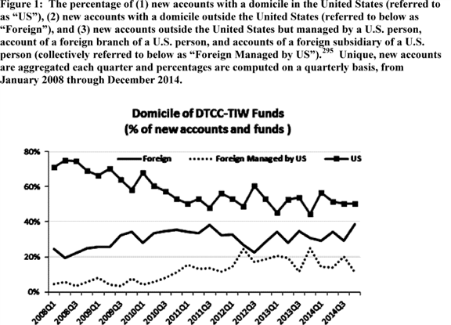

n295 Following publication of the Warehouse Trust Guidance on CDS data access, TIW surveyed market participants, asking for the physical address associated with each of their accounts (*i.e.,* where the account is organized as a legal entity). This is designated the registered office location by TIW. When an account does not report a registered office location, we have assumed that the settlement country reported by the investment adviser or parent entity to the fund or account is the place of domicile. This treatment assumes that the registered office location reflects the place of domicile for the fund or account.

As depicted in Figure 1, the domicile of new accounts participating in the market has shifted over time. A greater share of accounts entering the market either have a foreign domicile, or have a foreign domicile while being managed by a U.S. person. The increase in foreign accounts may reflect an increase in participation by foreign accountholders while the increase in foreign accounts managed by U.S. persons may reflect the flexibility with which market participants can restructure their market participation in response to regulatory intervention, ***competitive*** pressures, and other stimuli. Alternatively, the shifts in new account domicile we observe in Figure 1 may be unrelated to restructuring or increased foreign participation. For example, changes in the domicile of new accounts over time may reflect improvements in reporting by market participants to TIW rather than a change in market participant structure. Additionally, because the data only include accounts that are domiciled in the United States, transact with U.S.-domiciled counterparties, or transact in single-name CDS with U.S. reference entities, changes in the domicile of new accounts may reflect increased transaction activity between U.S. and non-U.S. counterparties or increased transactions in single-name CDS on U.S. reference entities by foreign persons.

ii. Market Centers

Security-based swap participants currently appear to be active in market centers across the globe. Participants in the security-based swap market may bear the financial risk of a security-based swap transaction in a location different from the location where the transaction is arranged, negotiated, or executed or the location where economic decisions are made by managers on behalf of beneficial owners. Similarly, a participant in the security-based swap market may be exposed to counterparty risk from a jurisdiction that is different from the market center or centers in which it participates. Depending on the U.S. person status of the counterparties and the location of the activity, security-based swap transactions that occur across borders or within foreign jurisdictions may trigger U.S. registration requirements and may also be subject to rules in foreign jurisdictions.

The TIW transaction records include, in many cases, information on particular branches involved in transactions, which may provide limited insight as to where security-based swap activity is actually being carried out. n296 These data indicate branch locations in New York, **[*49000]** London, Tokyo, Hong Kong, Chicago, Sydney, Toronto, Frankfurt, Singapore and the Cayman Islands. Because transaction records in the TIW data provided to the Commission do not indicate explicitly the location in which particular transactions were arranged, negotiated or executed, these locations may not represent the full set of locations in which activities relevant for these proposed rules take place. Moreover, because we cannot identify the location of transactions within TIW, we are unable to estimate the general distribution of transaction volume across market centers.

n296 The value of this information is limited in part because some market participants may use business models that do not involve branches to carry out business in jurisdictions other than their home jurisdiction. For example, some market participants may use affiliated or unaffiliated agents to enter into security-based swap transactions in other jurisdictions on their behalf. The available data currently does not allow us to identify with certainty which type of structure is being used in any particular transaction.

iii. Current Estimates of Number of SBS Dealers and Major SBS Participants

In the ***Regulation*** SBSR Adopting Release, we estimated, based on an analysis of TIW data, that out of more than 4,000 entities engaged in single-name CDS activity worldwide in 2013, 170 entities engaged in single-name CDS activity at a sufficiently high level that they would be expected to incur assessment costs to determine whether they meet the "security-based swap dealer" definition. n297 Approximately 45 of these entities are non-U.S. persons and are expected to incur assessment costs as a result of engaging in dealing activity with counterparties that are U.S. persons or engaging in dealing activity that involves recourse to U.S. persons. n298 Analysis of those data further indicated that potentially 50 entities may engage in dealing activity that would exceed the *de minimis* threshold, and thus ultimately have to register as SBS Dealers. The Commission also undertook an analysis of the number of security-based swap market participants likely to register as major security-based swap participants, and estimated a range of between zero and five such participants. n299

n297 *See* ***Regulation*** SBSR Adopting Release, at 14693.

n298 *See* Exchange Act Rule 3a71-3(b).

n299 *See* ***Regulation*** SBSR Adopting Release 14693. Also See Cross-Border Adopting Release, footnotes 150 and 153 at 47296 and 47297 (describing the methodology employed by the Commission to estimate the number of potential SBS Dealers and Major SBS Participants).

As we noted in the Cross-Border Dealing Activity Proposing Release, updated analysis of 2014 data leaves many of these estimates largely unchanged. n300 We estimate that approximately 170 entities engaged in single-name CDS activity at a sufficiently high level that they would be expected to incur assessment costs to determine whether they meet the "security-based swap dealer" definition. Approximately 56 of these entities are non-U.S. persons. Of the approximately 50 entities that we estimate may potentially register as SBS Dealers, we believe it is reasonable to expect 22 to be non-U.S. persons. n301

n300 *See* Cross Border Dealing Activity Proposing Release, at 27452.

n301 These estimates are based on the number of accounts in DTCC-TIW data with total notional volume in excess of de minimis thresholds, increased by a factor of two, to account for any potential growth in the security-based swap market, to account for the fact that we are limited in observing transaction records for activity between non-U.S. persons that reference U.S. underliers, and to account for the fact that we do not observe security-based swap transactions other than in single name CDS. *See* Cross Border Dealing Activity Proposing Release, 80 FR at 27452. *Also see* Intermediary Definitions Adopting Release, foonote 1457 at 30725.

In addition, in the proposed registration requirements for SBS Dealers and Major SBS Participants, we estimated, based on our experience and understanding of the swap and security-based swap markets that of the 55 firms that might register as SBS Dealers or Major SBS Participants, approximately 35 would also register with the CFTC as swap dealers or major swap participants. n302 Available data suggest that these numbers remain largely unchanged. n303 Finally, based on our analysis of TIW data and supervisory filings, we estimate that sixteen market participants expected to register as SBS Entities have already registered with the Commission as broker-dealers. In sum, based on our analysis of TIW data and the current population of registered broker-dealers, swap dealers, and OTC derivative dealers, we anticipate that up to four entities seeking to register with the Commission as SBS Entities will not have already registered as broker-dealers or as swap dealers.

n302 *See* Registration Proposing Release, at 65808.

n303 Based on our analysis of 2014 DTCC-TIW data and the list of swap dealers provisionally-registered with the CFTC, and applying the methodology used in the Intermediary Definitions Adopting Release, we estimate that substantially all registered security-based swap dealers would also register as swap dealers with the CFTC. *See* Cross Border Dealing Activity Proposing Release, at 27458. *See also* CFTC list of provisionally registered swap dealers, available at [*http://www.cftc.gov/LawRegulation/DoddFrankAct/registerswapdealer*](http://www.cftc.gov/LawRegulation/DoddFrankAct/registerswapdealer).

2. Levels of Security-Based Swap Trading Activity

Below we describe the levels of security-based swap trading activity and its concentration among SBS Dealers and Major SBS Participants. Since registration rules may affect resident and nonresident SBS Entities differently, we further discuss domicile issues and participant structures operating across jurisdictions in security-based swap markets as they exist today.

Single-name CDS contracts make up the vast majority of security-based swap products and most are written on corporate issuers, corporate securities, sovereign countries, or sovereign debt (reference entities and securities). Figure 2 below describes the percentage of global, notional transaction volume in North American corporate single-name CDS reported to the TIW between January 2008 and December 2014, separated by whether transactions are between two ISDA-recognized dealers (inter-dealer transactions) or whether a transaction has at least one non-dealer counterparty.

Annual trading activity with respect to North American corporate single-name CDS in terms of notional volume has declined from more than $ 6 trillion in 2008 to less than $ 3 trillion in 2014. n304 While notional volume has declined over the past six years, the portion of the notional volume represented by inter-dealer transactions has remained fairly constant and inter-dealer transactions continue to represent a significant majority of trading activity, whether measured in terms of notional value or number of transactions (*See* Figure 2).

n304 The start of this decline predates the enactment of the Dodd-Frank Act and the proposal of rules thereunder, which is important to note for the purpose of understanding the economic baseline for this rulemaking.

The high level of inter-dealer trading activity reflects the central position of a small number of dealers, each of which intermediates trades between many hundreds of counterparties. While the Commission is unable to quantify the current level of trading costs for single-name CDS, dealers appear to enjoy market power as a result of their small number and the large proportion of order flow they privately observe. This market power in turn appears to be a key determinant of trading costs in this market. **[*49001]**

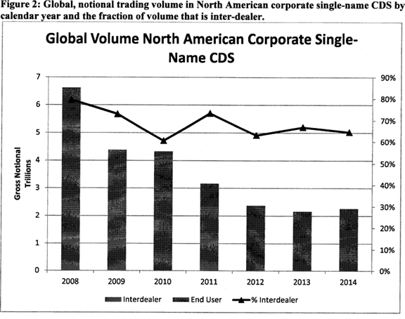

Against this backdrop of declining North American corporate single-name CDS activity, about half of the trading activity in North American corporate single-name CDS reflected in the set of data we analyzed was between counterparties domiciled in the United States and counterparties domiciled abroad. Basing counterparty domicile on the self-reported registered office location of the TIW accounts, the Commission estimates that only 12 percent of the global transaction volume by notional volume between 2008 and 2014 was between two U.S.-domiciled counterparties, compared to 48 percent entered into between one U.S.-domiciled counterparty and a foreign-domiciled counterparty and 40 percent entered into between two foreign-domiciled counterparties (*See* Figure 3). n305

n305 For purposes of this discussion, we have assumed that the registered office location reflects the place of domicile for the fund or account, but we note that this domicile does not necessarily correspond to the location of an entity's sales or trading desk. *See* Cross Border Dealing Activity Proposing Release, footnote 44, at 27451.

When the domicile of TIW accounts is instead defined according to the domicile of an account holder's ultimate parents, headquarters, or home offices (*e.g.,* classifying a foreign bank branch or foreign subsidiary of a U.S. entity as domiciled in the United States), the fraction of transactions entered into between two U.S.-domiciled counterparties increases to 32 percent, and to 51 percent for transactions entered into between a U.S.-domiciled counterparty and a foreign-domiciled counterparty.

Differences in classifications across different definitions of domicile illustrate the effect of participant structures that operate across jurisdictions. Notably, the proportion of activity between two foreign-domiciled counterparties drops from 40 percent to 17 percent when domicile is defined as the ultimate parent's domicile. As noted earlier, foreign subsidiaries of U.S. parent companies and foreign branches of U.S. banks, and U.S. subsidiaries of foreign parent companies and U.S. branches of foreign banks may transact with U.S. and foreign counterparties. However, this change in respective shares based on different classifications suggests that the activity of foreign subsidiaries of U.S. firms and foreign branches of U.S. banks is generally higher than the activity of U.S. subsidiaries of foreign firms and U.S. branches of foreign banks. **[*49002]**

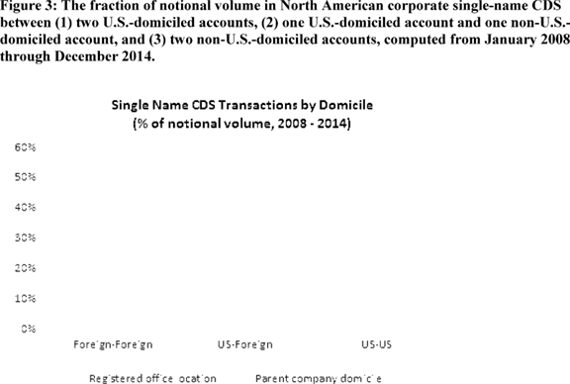

Non-dealer participants remain active in the single name CDS market. Based on our analysis of DTCC-TIW data on single name CDS positions as of the end of 2014, the total notional outstanding of non-dealer accounts was approximately $ 1.3 trillion. There were three market participants with total notional outstanding of over $ 50 billion, 16 market participants with total notional between $ 10 billion and $ 50 billion, 144 market participants with total notional between $ 1 billion and $ 10 billion and 748 participants with total notional outstanding in single name CDS under $ 1 billion.

3. Cross-Market Participation

As noted in the Cross-Border Dealing Activity Proposing Release, persons registered as SBS Dealers or Major SBS Participants are likely also to engage in swap activity, which is subject to ***regulation*** by the CFTC. n306 Indeed, as we discuss above, we estimate that of the 55 firms that might register as SBS Dealers or Major SBS Participants, approximately 35 will also register with the CFTC as swap dealers or major swap participants.

n306 *See* Cross Border Dealing Activity Proposing Release, at 27458.

This overlap reflects the relationship between single-name CDS contracts, which are security-based swaps, and index CDS contracts, which may be swaps or security-based swaps. A single-name CDS contract covers default events for a single reference entity or reference security. Index CDS contracts and related products make payouts that are contingent on the default of index components and allow participants in these instruments to gain exposure to the credit risk of the basket of reference entities that comprise the index, which is a function of the credit risk of the index components. A default event for a reference entity that is an index component will result in payoffs on both single-name CDS written on the reference entity and index CDS written on indices that contain the reference entity. Because of this relationship between the payoffs of single-name CDS and index CDS products, prices of these products depend upon one another, n307 creating hedging opportunities across these markets.

n307 "Correlation" typically refers to linear relationships between variables; "dependence" captures a broader set of relationships that may be more appropriate for certain swaps and security-based swaps. *See, e.g.,* Casella, George and Roger L. Berger, "Statistical Inference" (2002), at 171.

These hedging opportunities mean that participants that are active in one market are likely to be active in the other. Commission staff analysis of approximately 4,500 TIW accounts that participated in the market for single-name CDS in 2014 revealed that approximately 2,500 of those accounts, or 56 percent, also participated in the market for index CDS. Of the accounts that participated in both markets, data regarding transactions in 2014 suggest that, conditional on an account transacting in notional volume of index CDS in the top third of accounts, the probability of the same account landing in the top third of accounts in terms of single-name CDS notional volume is approximately 60 percent; by contrast, the probability of the same account landing in the bottom third of accounts in terms of single-name CDS notional volume is only 11 percent.

Activity in security-based swap markets can impact underlying securities markets. Security-based swaps may be used in order to hedge or speculate on credit risk of reference securities. For instance, prices of both CDS and corporate bonds are sensitive to the credit risk of underlying reference securities and, therefore, trading across markets may sometimes result in a potential positive spillover effect between informational efficiency, pricing and liquidity in security-based swap markets, and market quality in bond markets. At the same time, if some large institutional traders prefer to transact on their credit risk information **[*49003]** in more liquid markets in order to minimize price impact and improve execution quality, price discovery and liquidity in the single name CDS market may draw out these sophisticated investors and lead to a drying up of liquidity in the underlying bond markets. n308

n308 Empirical evidence on the direction and significance of the CDS-bond market spillover is mixed. Massa and Zhang (2012) consider whether the presence of CDS improves pricing and liquidity of investment grade bonds in 2001-2009. They find a positive effect, strongest during the financial crisis period, and document a dampened effect of shocks on bond liquidity and spreads for bonds with CDS contracts. Das *et al.,* (2014) consider the effects of CDS trading on the efficiency, pricing error and liquidity of corporate bond markets. They find that efficiency in corporate bond markets has not improved after the introduction of CDS trading and find no evidence of increases in market quality or bond liquidity. Boehmer, Chava and Tookes (2015) find the emergence of CDS has adversely affected equity market quality. Firms with traded CDS contracts on their debt experience significantly lower liquidity and price efficiency when these firms are closer to default and in times of high market volatility.

*See* Massa & L. Zhang, CDS and the Liquidity Provision in the Bond Market (INSEAD Working Paper No. 2012/114/FIN, 2012), available at [*http://papers.ssrn.com/sol3/papers.cfm?abstract_id=2164675*](http://papers.ssrn.com/sol3/papers.cfm?abstract_id=2164675); M. Oehmke & A. Zawadowski, The Anatomy of the CDS Market (Working Paper, 2014), available at [*http://papers.ssrn.com/sol3/papers.cfm?abstract_id=2023108*](http://papers.ssrn.com/sol3/papers.cfm?abstract_id=2023108); S. Das, M. Kalimipalli & S. Nayak, Did CDS Trading Improve the Market for Corporate Bonds?, 111 J. Fin. Econ. 495 (2014); H. Tookes, E. Boehmer & S. Chava, Related Securities and Equity Market Quality: The Cases of CDS, forthcoming, J. Fin. & Quant. Analysis.

Because of this link between security-based swaps and their underlying reference securities, registration rules are expected to affect not only SBS Entities and their counterparties, but also investors in underlying reference security markets. In the sections that follow we discuss and, wherever possible, quantify the potential costs and benefits of registration for affected parties.

4. Statutory Disqualification

The final registration rules require SBS Entities to certify that no associated person that effects or is involved in effecting security-based swaps on behalf of the SBS Entity is subject to statutory disqualification. The rule implements Exchange Act 15F(b)(6) that makes it unlawful for SBS Entities to permit associated persons subject to statutory disqualification to effect or be involved in effecting security-based swaps on behalf of SBS Entities, except to the extent otherwise specifically provided by rule, ***regulation***, or order of the Commission. The Commission has provided temporary relief from the Exchange Act Section 15F(b)(6) prohibition for persons who were associated with an SBS Entity as of July 16, 2011; this temporary exception expires on the effective date of adopted SBS Entity registration rules. n309

n309 *See* Effective Date Release, at 36301-02.

Thus, there are currently no registered SBS Entities required to comply with either the statutory disqualification certifications in the final registration rules, or the prohibition in Exchange Act Section 15F(b)(6) on associated statutorily disqualified persons effecting or involved in effecting security-based swaps on behalf of SBS Entities. Therefore, the appropriate baseline reflects the state of the world with relief from the general prohibition on disqualified associated persons effecting or being involved in effecting security-based swaps on behalf of SBS Entities.

In evaluating the economic effects of final registration rules, we are mindful of the fact that due to the temporary relief currently in place, entities that are expected to register with the Commission as SBS Entities may not have restructured their business to be in compliance with the statutory prohibition in Exchange Act Section 15F(b)(6) and may currently be associating with disqualified persons for the purposes of effecting security-based swaps. Since the CFTC's approach excepts associated entities from the scope of the disqualification requirement, SBS Entities that have cross-registered as swap entities may be continuing to associate with disqualified persons that are entities, but may have reassigned their current employees, hired new employees or secured natural person waivers from the NFA.

*C. Benefits of Registration*

The economic benefits of entity registration stem from two sources: (1) The direct benefits of registration, such as requirements to provide information regarding disciplinary history and Senior Officer Certifications; and (2) the benefits that flow from having a population of registered participants complying with the Title VII regulatory framework for SBS Entities.

1. Direct Benefits

The certifications and other requirements contained in the final registration rules may enable the Commission to more effectively oversee security-based swap markets. The Senior Officer Certification requirement helps ensure that the CCO considers whether an SBS Entity has developed and implemented written policies and procedures that would be reasonably designed to prevent violations of federal securities laws and rules thereunder. Information about SBS Entities and their control affiliates, including disciplinary history, may facilitate ongoing Commission risk assessments and oversight of SBS markets, as well as help market participants make more informed counterparty choices. Associated person certifications help ensure associated persons subject to a statutory disqualification, who may pose a risk to participants, are precluded from effecting or being involved in effecting security-based swap transactions on behalf of SBS Entities absent a Commission rule, ***regulation*** or order. The books and records certification helps to ensure the Commission will have access to records and data of nonresident SBS Entities to facilitate ongoing risk assessments and market surveillance, and that, like resident SBS Entities, all nonresident SBS Entities are able to be subject to Commission inspections and examinations as part of its regulatory oversight of SBS Entities.

i. Disciplinary History and Other Information

Final registration rules require SBS Entities to submit to the Commission information about their business, including business description, registration status with other regulators and disciplinary histories, including those of control affiliates, with the information subsequently being made public by the Commission. Although much of the information required by registration forms is already publicly available for entities that are registered with the Commission as broker-dealers or with the CFTC as swap dealers, entities that are not cross-registered will make some of this information--for instance, disciplinary history of control affiliates--publicly available for the first time. All new entrants that are not cross-registered would have to provide this information as well, including as it pertains to their control affiliates. Further, SBS Entities seeking to avail themselves of the relief for associated entity disqualifications that precede the compliance date of final registration rules, will have to provide a list of disqualified associated entities which will be made public by the Commission as part of the registration application. The Commission believes these requirements may facilitate ongoing oversight of SBS Entities and may help market participants make more informed counterparty decisions.

Informational asymmetry can negatively affect market participation and decrease the amount of trading--a problem commonly known as adverse **[*49004]** selection. n310 For example, when information about the quality of a counterparty is scarce, market participants may be less willing to enter into transactions and the overall level of trading may fall. To the extent that adverse selection costs are present in security-based swap markets, market participants may become more informed and may increase their activity in security-based swaps, which may improve market quality.

n310 George A. Akerlof, *The Market For "Lemons": Quality Uncertainty and the Market Mechanism,* 84 Q.J. Econ. 488 (1970).

To the extent that SBS market participants consider disciplinary history important in selecting security-based swap market counterparties, this registration requirement may help market participants make more informed counterparty choices. This requirement may also reduce counterparty selection of SBS Entities that have been the subject of disciplinary actions. Moreover, SBS Entities, knowing that disciplinary history must now be disclosed, may have further incentives to avoid engaging in misconduct (or may exit the market). The increased dissemination of information regarding disciplinary history may lead to improved quality-based ***competition*** among SBS Entities to the extent that market participants rely on this information in the selection process. Additionally, disciplinary history information on SBS Entities and their control affiliates may inform ongoing Commission oversight, risk assessments, and examination priorities.

ii. Statutory Disqualification

As discussed in section V.B., SBS Entities may currently be permitting disqualified persons to effect or be involved in effecting security-based swaps. Associated person certifications are designed to help ensure that associated persons subject to a statutory disqualification, who may pose a risk to counterparties and the integrity of security-based swap markets as a whole, are precluded from effecting or being involved in effecting security-based swap transactions on behalf of SBS Entities absent a Commission rule, ***regulation*** or order. The associated person requirement may offer a degree of counterparty protection, which may differ for natural persons and entities, and induce market participants to increase their transaction volume or enter the market for the first time.

The Commission has received comment urging a narrower definition of associated persons to include only natural persons, consistent with the CFTC's approach, arguing that "business disruptions and other ramifications stemming from an entire entity being statutorily disqualified from effecting or being involved in effecting security-based swaps could be considerable." n311 Based on an analysis of DTCC-TIW and Form BD data, approximately three quarters of entities that are likely to trigger registration thresholds based on their dealing activity in single name CDS accounting for approximately 86% of overall U.S. CDS dealing activity in 2014 may be associating with a statutorily disqualified entity. Crucially, however, the general statutory prohibition and the requirements of final registration rules apply not to all associated entities, but only to those entities effecting or involved in effecting security-based swaps on behalf of SBS Entities. In addition, SBS Entities currently intermediating security-based swaps are frequently part of complex organizational structures, which may include hundreds of entities. While we estimate that approximately three quarters of potential registrants may be associating with a statutorily disqualified entity, the Commission lacks data or other information indicating whether associated disqualified entities are effecting or involved in effecting security-based swaps on their behalf. We are, therefore, unable to determine whether and which SBS Entities may be affected by the final registration rule implementing the general statutory prohibition. However, taking into account commenter concerns, final rules allow SBS Entities to permit disqualified associated entity persons associated with them when they file applications to register with the Commission to effect or be involved in effecting security-based swaps on their behalf if the statutory disqualification(s) occurred prior to the compliance date of final registration rules. This aspect of the final rules benefits primarily those SBS Entities that associate with disqualified entities for their security-based swap dealing and would have had to incur costs of discontinuing current associations with disqualified entities and associating with different non-disqualified entities for the purposes of security-based swap transactions. This treatment of associated persons seeks to reduce potential costs for SBS Entities.

n311 *See* SIFMA letter at 8.

The Commission recognizes that this exception may reduce potential counterparty benefits of a general prohibition on disqualified persons effecting or being involved in effecting security-based swaps on behalf of SBS Entities. We note that final rules require SBS Entities to provide a list of associated entities subject to statutory disqualification seeking to avail themselves of this relief, which will facilitate ongoing Commission supervision of SBS Entities, including as it pertains to disqualified entities. We also note that currently inter-dealer transactions account for over 60% of single-name CDS transactions, which reflects the central position of a small number of dealers, each of which may intermediate trades between many hundreds of counterparties. As a practical matter, SBS Entities may be able to easily reassign or disassociate from disqualified natural persons, whereas disassociating from disqualified entity persons may require significant business restructuring by SBS Entities. In light of the above considerations and of the central position of SBS Entities in security-based swap markets, this provision considers counterparty protections of the general prohibition and the risk of market disruptions.

iii. Senior Officer Certification and Nonresident Entity Certification

The Senior Officer Certification and Nonresident Entity Certification requirements facilitate the Commission's ongoing oversight of resident and nonresident SBS Entities. The Senior Officer Certification requires senior officers to certify that SBS Entities have developed and implemented written policies and procedures reasonably designed to prevent violations of federal securities laws and rules thereunder. While the substantive requirement to develop and implement policies and procedures stems from pending business conduct rules, the certification ensures senior officers have reviewed the SBS Entity's policies and procedures, which may facilitate Commission oversight of SBS Entities.

Further, to effectively fulfill its regulatory oversight responsibilities with respect to nonresident SBS Entities registered with it, the Commission must have access to those entities' records and the ability to examine them. The required certification and opinion of counsel regarding the nonresident SBS Entity's ability to provide prompt access to books and records and to be subject to onsite inspection and examination will facilitate ongoing supervision.

iv. Other Direct Benefits

SBS Entity registration will be implemented with fillable forms with a graphical user interface on the EDGAR **[*49005]** Web site. n312 Collecting the data in a structured format will allow the Commission to make the data public in a manner that will enable users of that data to retrieve, search, and analyze the data through automated means. This format may lower costs of analyzing possible counterparty risks arising from prior misconduct and other registration information of a large group of potential counterparties. This may enable counterparties and the marketplace to expend less time and money to independently obtain and compile information on individual SBS Entities. In addition, final registration forms require SBS Entities to list UICs for both SBS Entities and for their control affiliates, if such entities have UICs. The Commission has elsewhere stated that the use of a single identifying code is designed to facilitate the performance of market analysis studies, surveillance activities, and systemic risk monitoring by relevant authorities through the streamlined presentation of security-based swap transaction data. n313 By securing information regarding SBS Entities with the use of UICs and through EDGAR Commission staff should be able to more efficiently retrieve and analyze the data it needs to effectively carry out its mission with respect to SBS Entity activities, including oversight, risk assessment, and examination priorities.

n312 As described in Section II.A.1., we are also developing a batch filing process utilizing the eXtensible Markup Language ("XML") tagged data format that firms could use to upload application information to the EDGAR system should they choose to do so instead of utilizing fillable forms.

n313 *See* ***Regulation*** SBSR Adopting Release, at 14709.

2. Indirect Benefits

The final registration rules create an SBS Entity registration regime, which facilitates the application of substantive requirements of Title VII to registered SBS Dealers and Major SBS Participants. The rules adopted in the Intermediary Definitions Adopting Release identified the dealing volume and other criteria for an SBS Entity determination. The final registration rules and forms rely on the adopted intermediary definitions and facilitate the application of Title VII requirements, such as capital and margin requirements, external business conduct rules, recordkeeping, and reporting requirements, to those entities that meet the dealing and major participant activity thresholds.

Security-based swaps are more opaque and complex products than corporate bonds or equity. While sophisticated security-based swap market participants are likely to have the ability and resources to evaluate these complex products, less sophisticated market participants may be less able to overcome informational asymmetries when transacting with SBS Entities. As discussed above, informational asymmetry can negatively affect market participation and lower the amount of trading. Final registration rules will facilitate application of the Title VII regime with resulting benefits of increasing counterparty protection, transparency and regulatory oversight of SBS Entities.

Since substantive requirements for SBS Entities have not yet been adopted, the Commission cannot currently evaluate the combined economic effects of facilitating the Title VII regime through registration. Importantly, registration requirements may ultimately impact the number of entities acting as dealers and major participants and providing liquidity to the SBS market, which may affect the programmatic benefits and costs of the substantive Title VII requirements. We note that the required certifications in the Registration rulemaking may directly affect which nonresident SBS Entities can register and be subject to the substantive requirements of Title VII (*See* Section V.E. on Efficiency, ***Competition*** and Capital Formation).

*D. Costs of Registration*

1. Direct Compliance Costs

As discussed in section IV above, the Commission estimates that SBS Entities would incur costs of direct compliance associated with: (i) Researching and completing the forms, (ii) reviewing, completing and submitting the required certifications, and documenting the review process, (iii) obtaining or compiling the required questionnaires or employment applications, having the CCO review the questionnaires and certify that no relevant associated person is subject to statutory disqualification, (iv) the requirements that nonresident SBS Entities obtain an agreement for U.S. service of process and an opinion of counsel stating that they can provide the Commission with access to records, and (v) the requirement to retain manually signed signature pages. n314

n314 *See* Registration Proposing Release, 76 FR at 65813 through 65818. All hourly cost figures are based upon data from SIFMA's *Management & Professional Earnings in the Securities Industry 2013* (modified by the SEC staff to account for an 1,800-hour-work-year and multiplied by 5.35 to account for bonuses, firm size, employee benefits, and overhead).

The Commission estimates that filing forms SBSE would incur a cost of approximately $ 47,544, n315 filing forms SBSE-A would incur a cost of approximately $ 336,770, n316 and filing forms SBSE-BD would incur a cost of approximately $ 47,544. n317 The Commission further estimates that the total cost associated with the Senior Officer Certification would be approximately $ 666,875 for all entities. n318 The Commission estimates the combined annual cost to SBS Entities of amending their applications if they find that the information therein has become inaccurate at approximately $ 46,695 annually. n319

n315 This figure is calculated as follows: (Compliance manager (42 hours) at $ 283 per hour) x 4 SBS entities = $ 47,544.

n316 This figure is calculated as follows: (Compliance manager (34 hours) at $ 283 per hour) x 35 SBS entities = $ 336,770.

n317 This figure is calculated as follows: (Compliance manager (101/2 hours) at $ 283 per hour) x 16 SBS entities = $ 47,544.

n318 This figure is calculated as follows: (CCO (5 hours + 20 hours) at $ 485 per hour) x 55 SBS Entities = $ 666,875. We continue to believe the pay for a CCO likely would be similar to the amount paid to other senior officers. For purposes of this estimate we assume that those a senior officer may consult with are paid at approximately the same level. *See* Registration Proposing Release 76 FR at 65816.

n319 This figure is calculated as follows: (Compliance manager (1 hour) at $ 283 per hour) x 3 amendments x 55 SBS Entities = $ 46,695.

Next, we estimate costs from associated person certifications. Section IV.D.3. of this release estimated that the total upfront burden to all SBS Entities to have their CCOs (or designees) review and sign each associated person's employment record and/or conduct whatever review may be necessary to assure that each associated natural person is not subject to statutory disqualification would be approximately 23,157 hours, which we estimate may cost up to $ 11,231,145 for all SBS Entities. n320 The cost of initial certifications for associated entity persons is estimated at $ 1,360,425. n321

n320 This figure is calculated as follows: (CCO at $ 485 per hour) x 23,157 hours = $ 11,231,145. For purposes of this estimate we assume that designees are paid at approximately the same level as the CCO. If CCO designees, such as attorneys, bear the brunt of the burden or are compensated at significantly lower hourly rates in some SBS Entities, this assumption may lead us to overestimate the compliance cost. We recognize that the job title of the designee, extent of delegation and related costs will vary depending on the supervisory structure and complexity of each SBS Entity. We believe it is reasonable to interpret this figure as an upper bound on the potential cost of CCO certification.

n321 This figure is estimated as follows: (CCO at $ 485 per hour) x 2,805 hours = $ 1,360,425. Similar to the initial burden calculated above, we assume that CCO designees are paid at approximately the same level as CCOs. We believe it is reasonable to interpret this figure as an upper bound on the potential cost of CCO certification.

The Commission further estimates that the total initial cost for all **[*49006]** nonresident SBS Entities to complete and file Schedule F would be approximately $ 9,339 n322 in addition to initial outside legal costs of approximately $ 550,000 estimated in Section IV.D.4. The total annual cost for all nonresident SBS Entities to amend and file Schedule F on an ongoing basis would be approximately $ 1,273.50 n323 in addition to outside legal costs of approximately $ 28,938. Lastly, the annual costs of retaining manually signed signature pages for all SBS Entities would be approximately $ 2,547 n324 and the total annual cost of filing the withdrawal form for all SBS Entities would be approximately $ 283. n325

n322 This figure is estimated as follows: (Compliance manager at $ 283 per hour) x 11/2 hours x 22 SBS Entities = $ 9,339.

n323 This figure is estimated as follows: ((Compliance manager at $ 283 per hour) x 11/2 hours x 2 SBS Entities to amend for changes to agent for service of process) + ((Compliance manager at $ 283 per hour) x 11/2 hours x 1 SBS Entities to amend for changes in foreign law) = $ 1,273.50.

n324 This figure is estimated as follows: (Compliance manager at $ 283 per hour) x (10 minutes x 55 SBS Entities)/60 minutes = $ 283 * approximately 9 hours = $ 2,547.

n325 This figure is estimated as follows: (Compliance manager at $ 283 per hour) x 1 hour = $ 283.

Therefore, the Commission estimates that total initial quantifiable cost of registration of $ 14,249,642 n326 and ongoing costs of $ 79,736.50 n327 for all SBS Entities.

n326 This figure is estimated as follows: (Cost of filing forms SBSE, SBSE-A, SBSE-BD ($ 47,544 + $ 336,770 + $ 47,544)) + (Cost of Senior Officer Certification on form SBSE-C ($ 666,875)) + (Cost of associated person certifications on form SBSE-C ($ 11,231,145 + $ 1,360,425)) + (Cost of nonresidents filing Schedule F ($ 9,339)) + Cost of outside counsel ($ 550,000)) = $ 14,249,642.

n327 This figure is estimated as follows: (Amending application forms ($ 46,695)) + (Amending Schedule F (1,273.50)) + (Opinion of counsel and agent for service of process ($ 25,000+$ 3,938)) + (Retaining manually signed pages ($ 2,547)) + (Filing withdrawal form ($ 283)) = $ 79,736.50.

2. Other Direct Costs

The final registration rules would also entail a number of indirect costs for SBS Entities. While these costs are difficult to quantify with any degree of certainty as outlined in section V.A. and are, therefore, discussed qualitatively below, we recognize that they may be as, if not more, significant than the direct costs quantified above.

i. Costs Related to the Disciplinary History Disclosure Requirement

Final registration rules require SBS Entities to disclose disciplinary history, including that of control affiliates, to the Commission. Since SBS Entity disclosures made during the registration process will be publicly available to investors, market participants will be able to easily access and compare such data for all SBS Entities. To the extent that market participants rely on disciplinary history information in counterparty choices and to the extent that market participants cannot easily observe this information for all participants (such as participants not otherwise registered with the Commission as broker-dealers or the CFTC as swap entities and for control affiliates), SBS Entities with prior disciplinary history may suffer a reputational loss and decreased customers and profits.

We have also received comment that entities with extensive control affiliates may face a higher compliance burden. n328 The commenter did not provide specific comments on the burden estimates in the Registration Proposing Release or provide any data regarding control affiliates; no such data is public or otherwise available to the Commission. Tailored registration forms are intended to reduce burdens for cross-registered entities. However, we recognize that some entities may have extensive control affiliate structures and, therefore, face a higher compliance burden. If such control affiliates have adverse disciplinary histories, some SBS Entities may also face greater reputational costs of making affiliate disciplinary history information public.

n328 *See* SIFMA Letter, at 4.

Should certain entities choose to restructure their dealing in order to avoid SBS Entity registration and the requirement to provide disciplinary history information, they would incur costs of forgone profits that stem from having to reduce transaction volume from current levels to levels below the de minimis threshold, and/or costs of moving their security-based swap dealing abroad and outside of the reach of Title VII requirements that include registration. In short, we expect that SBS Entities affected by the disciplinary history requirement will trade off the costs of disclosure with the costs of restructuring, including opportunity costs of lost transaction volume. If certain SBS Entities choose to exit, security-based swap transactions and dealing may become more concentrated. Further, such public disclosure may deter SBS Entities that have significant disciplinary histories from entering the market. However, security-based swap transactions may become concentrated among regulated entities with less severe disciplinary history, which may be less likely to pose risk to counterparties.

ii. Costs Related to Certifications

Final rules include a certification that a senior officer, after due inquiry, has reasonably determined that an SBS Entity has developed and implemented written policies and procedures reasonably designed to prevent violations of federal securities laws and rules thereunder, and that the senior officer has documented the process by which he or she reached such determination. Final rules also include a certification regarding statutorily disqualified associated persons. In addition to the direct burden estimated in Section V.D.1 above, we recognize that the certifications will increase senior officer liability risk and may lead SBS Entities to acquire additional insurance coverage. It is possible, therefore, that the certification requirements may result in liability insurance costs that are above what they would have been in the absence of the rule. The Commission is unable to estimate these costs given that it lacks specific information regarding current insurance costs for SBS Entities, the amount of the demand that there will be for increased coverage, and thereby the potential increases associated with the rule.

In addition to liability insurance costs, certification requirements may affect the structure and levels of senior officer compensation. While the level and structure of a senior officer's pay package generally depends on factors such as the level of risk inherent in the entity's activities, the entity's growth prospects, and the scarcity and specificity of senior officer talent needed by the entity, it may also reflect personal preferences influenced by characteristics of the senior officer, including aversion to risk. In particular, risk aversion may lead senior officers to prefer pay packages with predictable payments, rather incentive-based compensation or pay packages that otherwise reflect underlying uncertainty. n329

n329 Executives typically have personal preferences regarding the form of compensation received. To the extent that executives have different levels of risk aversion, they can arrive at different personal valuations of the same performance-based compensation package. Hence, more risk-averse executives may require additional compensation when paid in the form of less certain performance-based compensation

For senior officers with established compensation packages, heightened liability risk may create an incentive to negotiate changes to the composition of their compensation packages. Because of the increased uncertainty arising from liability risk, risk-averse officers may lower the value that they attach to the **[*49007]** incentive-based component of their pay and may as a result demand an offset to bear the increased uncertainty. The offset could come in the form of a smaller portion of pay being comprised of incentive-based compensation, or through an increase in expected total compensation, which would come at a greater cost to SBS Entities. The extent of any such increase would depend on the structure and conditions of the labor market for senior officers in SBS Entities as well as other economic factors, including the negotiating environment and particular preferences of senior officers, which will likely vary among SBS Entities and are difficult to quantify with any degree of certainty.

iii. Costs Related to the Associated Person Requirements

The associated person certification requires SBS Entities to certify that their associated persons, which include natural persons and legal entities, effecting or involved in effecting security-based swaps on their behalf are not subject to statutory disqualification. As we have noted in sections V.B and V.C.1.ii, Exchange Act Section 15F(b)(6) generally prohibits SBS Entities from permitting statutorily disqualified associated persons to effect or be involved in effecting security-based swaps on their behalf; however, the Commission has granted temporary relief from the prohibition.

All SBS entities will incur direct compliance costs of making the certification required in these final rules in section V.D.1 and V.D.2.ii. SBS Entities that are associating with disqualified persons for the purposes of effecting or being involved in effecting security-based swaps will also incur costs of disassociating with or reassigning such disqualified persons, as well as costs of associating with new persons not subject to disqualification for the purposes of effecting or being involved in effecting security-based swaps.

Importantly, final rules allow SBS Entities, when registering with the Commission, to permit associated disqualified entity persons to effect security based swaps, provided that the disqualification has occurred prior to the compliance date of registration rules. This exception is aimed at mitigating possible business disruptions n330 for SBS Entities which may currently be associating with disqualified entities with potential follow-on effects for security based swap markets as a whole. The Commission recognizes that permitting some associated persons that are entities to effect or be involved in effecting security-based swaps on behalf of SBS Entities may pose risks of repeated misconduct and other violations. As discussed in section II.B.i, the Commission retains full enforcement authority with respect to such associated entity persons, and would be able to take action against entities and individuals based on violative conduct. Lastly, current market conditions reflect the state of the world with temporary blanket relief from the general prohibition on associated disqualified persons effecting or being involved in effecting security-based swaps on behalf of SBS Entities. Relative to that scenario, final registration rules implement the general statutory prohibition while providing limited relief to SBS Entities, when registering with the Commission, if associated entity persons were disqualified prior to the compliance date of the final rules.

n330 *See* SIFMA letter at 8.

In addition to these considerations, we received comment that some SBS Entities may be unable to perform employee background checks necessary to ascertain statutory disqualification status of persons located in some foreign jurisdictions. n331 If some SBS entities associate with persons in jurisdictions with blocking laws, privacy laws, secrecy laws and other legal barriers for the purposes of effecting security-based swaps, they may be unable to obtain requisite employee personally identifiable information in order to perform the statutory disqualification check, make the certification, and register as SBS Entities, or provide information to the SEC. The statutory disqualification requirement may, therefore, impose costs on such entities, requiring them to use other employees to effect their security-based swap transactions, to withdraw associated persons from the reach of jurisdictions with blocking laws, privacy laws, secrecy laws and other legal barriers, or decrease U.S. security-based swap volume below the thresholds. The Commission does not, among other things, have data on the locations of SBS Entity employees effecting security-based swaps in various foreign jurisdictions, their statutory disqualification status, the relative expertise of SBS Entities' employees outside these foreign jurisdictions, or profitability of current dealing activity at volumes in excess of the thresholds. We are, therefore, unable to quantitatively estimate the number of SBS Entities that may be affected or their costs of using other persons, relocating associated persons outside of these foreign jurisdictions or decreasing activity below the thresholds. The commenter did not provide any data to quantify the effects of possible conflicts with blocking laws, privacy laws, secrecy laws and other legal barriers as they pertain to employee questionnaires and a statutory disqualification determination, and such data are not otherwise publicly available. Based on FINRA's experience with low incidence of disqualification review applications by broker dealers seeking to associate with disqualified natural persons, we believe that, as a practical matter, SBS Entities may frequently be able to reassign or disassociate from disqualified employees. The Commission is not adopting an exception for natural persons at this time.

n331 *See* IIB Letter, at 19.

The Commission has received comment that implementing the statutory prohibition on disqualified persons effecting or involved in effecting security-based swaps absent a Commission rule or order may cause business disruptions. n332 The commenter did not provide data on the number of associated persons that may be affected or the extent of potential business disruptions. Based on somewhat analogous data from the NFA and FINRA, the Commission estimates that, on an annual basis, fewer than five SBS Entities would seek relief for natural persons subject to statutory disqualification to effect or be involved in effecting security-based swaps and fewer than two SBS Entities would seek relief for disqualified associated entities. n333 Registration rules also **[*49008]** provide relief to SBS Entities, when registering with the Commission, associating with disqualified entities for the purpose of effecting security-based swaps if disqualification occurred prior to the compliance date of registration rules. We note that, as a practical matter, SBS Entities may be easily able to reassign or disassociate from disqualified natural persons, and SBS Entities currently intermediating large volumes of security-based swaps would be able to take advantage of the exception above. Finally, SBS Entities seeking to associate with disqualified persons may apply to the Commission for relief under Exchange Act Section 15F(b)(6).

n332 *See* SIFMA letter, at 8.

n333 While the incidence of statutory disqualification is difficult to quantify, we draw on data concerning an analogous statutory disqualification review process for broker-dealers. In 2014, FINRA received 24 MC-400 applications for natural persons and 10 MC-400A applications for entities. In total, FINRA has received 177 MC-400 and 63 MC-400A applications during the same five year period (2010-2014). FINRA currently oversees approximately 4,000 currently registered broker-dealers and 272,000 registered representatives. As discussed earlier, the Commission anticipates 55 SBS Entities may register with the Commission with 423 associated persons per entity (23,265 associated persons in total). Therefore, we expect significantly fewer applications in security-based swap markets.

Another somewhat analogous scenario is swap dealer statutory disqualification. According to NFA staff, between October 11, 2012 and July 22, 2015, 11 applications had been made by Swap Entities to the NFA for the NFA to provide notice to the Swap Entity that, had the person applied for registration as an associated person, the NFA would have granted such registration. *See* CFTC staff No-Action Letter No. 12-15, [*http://www.cftc.gov/ucm/groups/public/@lrlettergeneral/documents/letter/12-15.pdf*](http://www.cftc.gov/ucm/groups/public/@lrlettergeneral/documents/letter/12-15.pdf), at 5-8. The Commission has estimated that up to 55 SBS Entities may seek registration, while the CFTC has provisionally registered 112 Swap Entities ([*https://www.nfa.futures.org/NFA-swaps-information/regulatory-info-sd-and-msp/SD-MSP-registry.HTML*](https://www.nfa.futures.org/NFA-swaps-information/regulatory-info-sd-and-msp/SD-MSP-registry.HTML); last accessed July 24, 2015). Using the above data from the NFA concerning 11 applications over approximately 2.78 years, results in an estimate of approximately 2 applications per year (11*55/112)/2.78 [approx.] =1.94).

The Commission, however, recognizes that the number of applications received by the NFA may only present a partial picture of the potential impact of a disqualification because, *inter alia*, (1) the CFTC defines "associated person" of a Swap Entity to be limited solely to natural persons, not entities (*See* [*17 CFR 1.3(aa)(6)*](https://advance.lexis.com/api/document?collection=administrative-codes&id=urn:contentItem:5RS7-P930-008G-Y3YP-00000-00&context=)); (2) in CFTC ***Regulation*** 23.22(b), [*17 CFR 23.22(b)*](https://advance.lexis.com/api/document?collection=administrative-codes&id=urn:contentItem:5RS7-P940-008G-Y402-00000-00&context=), the CFTC provided an exception from the prohibition set forth in CEA Section 4s(b)(6), [*7 U.S.C. 6s(b)(6)*](https://advance.lexis.com/api/document?collection=statutes-legislation&id=urn:contentItem:50P5-8F91-NRF4-4001-00000-00&context=), for any person subject to a statutory disqualification who is already listed as a principal, registered as an associated person of another CFTC registrant, or registered as a floor broker or floor trader.

iv. Costs for Nonresident SBS Entities

Under the final rules, nonresident SBS Entities will have to provide an opinion of counsel that they can, as a matter of law, provide the Commission with prompt access to books and records and submit to onsite inspection, and certify that, as a matter of law, they can and will provide prompt access to books and records for the purposes of facilitating Commission oversight, inspections and examinations. As recognized in the Registration Proposing Release and discussed by commenters, blocking laws, privacy laws, secrecy laws and other legal barriers in some foreign jurisdictions may make such certification and, hence, SBS Entity registration impossible for some nonresident SBS Entities. n334

n334 *See* Registration Proposing Release, at 65800. *Also see, e.g.*, SIFMA Letter, at 9-10, and IIB Letter, at 19.

Nonresident SBS Entities precluded from registration due to blocking laws, privacy laws, secrecy laws and other legal barriers will bear the cost of lowering or restructuring their market activity below the SBS Dealer and Major SBS Participant annual thresholds that trigger registration requirements. Alternatively, nonresident SBS Entities that are unable to make the books and records certification may be able to relocate or otherwise restructure, such that they are no longer subject to foreign blocking laws, privacy laws, secrecy laws and other legal barriers that are not consistent with the required certification, and therefore continue U.S. security-based swap dealing in excess of the thresholds triggering registration requirements. The cost of the books and records certification to nonresident SBS Entities would thus include the costs of such potential relocation or restructuring, which depend on the legal and regulatory frameworks in various foreign jurisdictions and the organizational complexity of entities that may seek SBS Entity registration, including those currently unregistered with the Commission.

Based on internal analysis of TIW data, as well as a review of CFTC staff no action letters, the Commission estimates that nonresident U.S. persons unable to make the books and records certification and register as SBS Entities currently account for approximately 18% of overall security-based swap dealing activity. n335 The anticipated implications of this registration requirement for efficiency, ***competition*** and capital formation are discussed in Section V.E.

n335 More specifically, since we expect a large number of U.S. SBS Entities will have cross-registered as Swap Entities, we considered foreign jurisdictions where CFTC staff provided no-action relief for trade repository reporting requirements as they apply to swap dealers (available at [*http://www.cftc.gov/ucm/groups/public/@lrlettergeneral/documents/letter/15-01.pdf*](http://www.cftc.gov/ucm/groups/public/@lrlettergeneral/documents/letter/15-01.pdf)) *to inform our analysis.* These no-action letters identify a set of "Enumerated Jurisdictions" where blocking laws, privacy laws, secrecy laws and other legal barriers may inhibit compliance with regulatory requirements. We then matched the "Enumerated Jurisdictions" to the domicile classifications in the set of the 55 entities we anticipate will register as SBS Entities to identify the subset of affected entities. We estimate that this subset currently accounts for approximately 18% of overall dealing activity. This estimate is based on current market activity and could differ if affected nonresident SBS Entities seeking registration with the Commission are able to change their residency before the compliance date of final registration rules.

3. Indirect Costs

As discussed in Sections V.A. and V.C.2. above, final registration rules create a population of SBS Entity registrants with activity and position volumes determined in the adopted intermediary definitions, which will be subject to ongoing Commission oversight and pending substantive Title VII requirements, including capital and margin, external business conduct, recordkeeping and reporting requirements. Entities choosing to register with the Commission as SBS Entities will incur the costs of compliance with substantive rules, as well as costs relating to Commission inspections and examinations. While the costs of pending Title VII rules will be evaluated in each substantive rulemaking, the Commission recognizes that registration facilitates the application of the substantive rules to SBS Entities and therefore SBS Entities registering with the Commission will incur additional costs related to other Title VII rules.

*E. Effects on Efficiency,* ***Competition*** *and Capital Formation*

Final registration rules may impose a burden on ***competition*** for smaller SBS Entities to the extent that they impose relatively fixed costs, which could represent a higher percentage of net income for smaller SBS Entities. However, registration costs may impact SBS Entities already registered as broker dealers with the Commission or swap entities with the CFTC to a lesser degree because we have accommodated cross-registered entities by providing separate and tailored forms that minimize duplicate disclosures. Indeed, based on an analysis of TIW data and the current population of registered broker dealers, swap dealers, and OTC derivative dealers, of the fifty SBS Dealers and up to five Major SBS Participants that may seek to register with the Commission as SBS Entities, we anticipate that up to four will not have already registered as broker dealers or as swap dealers. n336 Our assessment is that all other registrants will be able to take advantage of the streamlined registration forms SBSE-A and SBSE-BD.

n336 *See also* Registration Proposing Release, at 65808.

Beyond the cost of completing and submitting registration forms, some SBS Entities may be unable or unwilling to make the senior officer, associated person, books and records certifications and disciplinary history disclosures, and those SBS Entities could consider exiting the U.S. SBS market. We do not believe that the direct registration costs quantified in section V.D.1 would be high enough to materially affect the application for registration or prompt large scale exit by SBS Entities. However, reputational costs and direct burdens of disciplinary history disclosures, including those affecting control affiliates, books and records requirements and certifications for nonresident SBS Entities, and statutory disqualification requirements may impose significant and, possibly, **[*49009]** prohibitive costs on some SBS Entities. Such costs could lead to fewer intermediaries ***competing*** for security-based swap business in the U.S. market. At the same time, mitigating this potential impact, these requirements may offer a degree of counterparty protection and enable market participants to make more informed counterparty choices, potentially leading to increases in market participation and liquidity in security-based swaps.

While programmatic costs and benefits of the substantive Title VII requirements will be assessed in each of the substantive rulemakings, we recognize that some SBS Entities may determine the registration requirements, substantive requirements and transparency of the Title VII regime are not cost-effective for them, and may withdraw from U.S. security-based swap markets or lower their dealing activity below the minimum thresholds which trigger registration.

Some SBS entities outside of foreign jurisdictions with blocking laws, privacy laws, secrecy laws and other legal barriers may associate with persons in jurisdictions with blocking laws, privacy laws, secrecy laws and other legal barriers for the purposes of effecting security-based swaps. Affected SBS Entities may be unable to perform background checks necessary to ascertain statutory disqualification status of associated persons located in these foreign jurisdictions. Should affected SBS Entities choose not to use other employees or entities to effect their security-based swap transactions or to withdraw associated persons from certain foreign jurisdictions, they may decrease U.S. security-based swap volume below the thresholds. This requirement may, therefore, preclude some SBS Entities from registering and place affected SBS Entities at a ***competitive*** disadvantage. Furthermore, depending on the specificity and scarcity of skills necessary to profitably effect security-based swaps, entities affected by foreign jurisdictions with blocking laws, privacy laws, secrecy laws and other legal barriers may choose to associate with different personnel for the purposes of effecting security-based swaps.

As indicated by commenters, n337 some nonresident SBS Entities meeting registration thresholds may be unable to satisfy the access to records requirement due to blocking laws, privacy laws, secrecy laws and other legal barriers. The unavailability of substituted compliance with respect to registration of SBS Entities, the requirement to provide an opinion of counsel indicating that the entity can, as a matter of law, provide the Commission with prompt access to its books and records, and the requirement to certify that the entity can and will provide the Commission with prompt access to its books and records may have ***competitive*** effects. In particular, foreign SBS Entities from certain jurisdictions may be forced to withdraw from U.S. security-based swap markets or decrease their security-based swap market participation below the threshold levels if laws or other barriers in their local jurisdictions preclude them from complying with Title VII registration requirements, which may lead to differential market access and create ***competitive*** disadvantages for some non-resident SBS Entities.

n337 *See* letters from SIFMA, Futures Industry Association, and The Financial Services Roundtable Letter; Institute of International Bankers Letter; European Commission Letter.

As discussed above, the Commission estimates that SBS Entities with up to 18% market share may be affected by the books and records requirement in foreign jurisdictions with blocking laws, privacy laws, secrecy laws and other legal barriers. The feasibility and costs of potential organizational restructuring--relocating, spinning off or in other ways severing an affiliation with a subsidiary, such that they are no longer subject to these foreign laws and other barriers and can make the books and records certification--are unclear. Due to the high concentration of dealing activity in security-based swap markets among large entities, the potential decrease in volume by affected SBS Entities may be significant. Potential withdrawal of affected SBS Entities from U.S. security-based swap markets may increase the market share and pricing power of remaining SBS Entities, which may result in higher costs of risk mitigation through security-based swaps for firms and market participants. If SBS Entities meeting registration thresholds are precluded from registration due to conflicts with foreign blocking laws, privacy laws, secrecy laws and other legal barriers, the total volume of trading and liquidity in security-based swap markets may decrease, which may be accompanied by lower price discovery and informational efficiency in security-based swap markets, as well as higher transaction costs for customers of dealers. However, SBS Entities currently participating in U.S. security-based swap market with lower transaction volumes may be able to capture the newly opened market share. Further, the newly available market share may encourage new entry. Thus, the overall effects of the books and records and associated person certification requirements on U.S. security-based swap market ***competition*** are unclear, and depend on whether affected volume is captured by existing dealers with large market share, existing dealers with small market share, or new entrants.

As discussed above, in adopting these final rules, we are required to consider, in addition to ***competition***, the impact of these rules on efficiency and capital formation. In many respects, the effect of these rules on efficiency and capital formation are expected to flow from their effects on ***competition***. For example, markets that are ***competitive***, with equal access by financial intermediaries to swaps, security-based swaps, and underlying reference securities, promote informational efficiencies, increased hedging opportunities, and therefore the efficient allocation of capital. In evaluating the economic effects of our rules, we have been mindful of the close relationship between single-name and index CDS contracts, as well as the linkages between security-based swaps and their underlying reference securities. Rules that facilitate access to CFTC-regulated and SEC-regulated swap and security-based swap markets should increase hedging opportunities for financial market intermediaries; such hedging opportunities reduce risks and allow intermediaries to facilitate a greater volume of financing activities, including issuance of equity and debt securities, and therefore contribute to capital formation.

This may be particularly true in underlying securities markets, where potential pricing and liquidity effects in security-based swap markets may feed back and impact the market for reference entity securities. Security-based swap markets may enable better risk mitigation by investors in underlying reference securities, such as CDS hedging of credit risk of corporate bond investments. The possible contraction in security-based swap market participation by affected SBS Entities in or associating with persons in jurisdictions with blocking laws, privacy laws, secrecy laws and other legal barriers may adversely impact underlying reference security markets, including pricing and liquidity in corporate bond markets. This may have a negative effect on the ability of firms to raise debt capital in order to finance real investment. However, the spillover from deterioration in security-based swap markets into underlying reference security markets may also be positive. **[*49010]** Sophisticated institutional investors transact across CDS and bond markets to trade on information pertaining to the credit risk of underlying reference debt. A potential negative shock to security-based swap market liquidity and dealing by nonresident SBS Entities may, in fact, drive sophisticated institutions to search for liquidity pools and lower price impact of informed trades to reference security markets. n338 If institutions begin to trade more actively in underlying reference security markets, such as corporate bond markets as a result, there may be positive effects on liquidity and informational efficiency of corporate bond markets. This may enable firms to raise more debt at potentially lower costs to finance real investment. n339 However, to the extent that potential exit of SBS Entities due to foreign blocking laws, privacy laws, secrecy laws and other legal barriers and registration requirements creates opportunities for SBS Entities with smaller market share to capture more volume or opens up the opportunity for new entry, effects on security-based swap and reference security markets may differ from the scenario above.

n338 Some SBS Entities may also move their security-based swap transactions to foreign SBS markets with potential implications for foreign reference security markets. Also see Section V.B.3 on cross-market participation.

n339 *See* Section V.B.3 above.

Finally, as noted above, we estimate that entities in foreign jurisdictions with blocking laws, privacy laws, secrecy laws and other legal barriers currently account for 18% of security-based swap transaction activity, and the inability of these entities to make the required books and records certifications can potentially impose significant burdens on either the security-based swap market or certain participants. In crafting our final rules, we have attempted to minimize business disruptions and ***competitive*** burdens where possible. As we have discussed above, the Commission's inspection and examination authority is vital to proper oversight of SBS Dealers and Major SBS Participants, and any limitation on oversight of non-U.S. registered SBS entities would raise significant challenges to the Commission's effective ***regulation*** of these firms. Given our Exchange Act mandate to ensure the maintenance of fair, orderly, and efficient markets, and given our belief that examination authority and access to books and records is essential to enabling effective market oversight, the Commission believes that any burden on ***competition*** that results from the provisions in this rule is necessary and appropriate in furtherance of the purposes of the Exchange Act and thus consistent with Exchange Act Section 23(a)(2).

*F. Registration Rule Alternatives*

1. Associated Person Certification Requirement

The Commission has evaluated alternatives to the associated person certification requirement, including narrowing the definition of associated persons to natural persons similar to the CFTC's approach. This alternative involves interpreting the prohibition under Exchange Act Section 15F(b)(6) to apply only to natural persons and providing blanket relief allowing SBS Entities to associate with disqualified persons that are not natural persons regardless of the nature or timing of disqualification, or any other factors. Under this alternative, treatment of associated entities would be identical for SBS Entities dually-registered with the CFTC, creating potential economies of scope for dual registrants in associating with persons that are entities. Further, this approach could eliminate associated person certification costs and barriers to entry for SBS Entities associating with disqualified entities. However, the Commission would not be able to prohibit those disqualified entities that pose a risk to counterparties and integrity of security-based swap markets from effecting or being involved in effecting security-based swaps on behalf of SBS Entities. Further, statutory disqualification and an inability to continue associating with SBS Entities creates a disincentive against underlying misconduct for associated persons, and a blanket exception for disqualified associated persons that are entities may reduce the disincentive against misconduct. These effects could reduce the counterparty protection benefits of the associated person certification and may pose a risk to market participants.

The Commission is adopting an approach which permits SBS Entities, when registering with the Commission, to associate with disqualified entity persons if the conduct that gave rise to disqualification occurred prior to the compliance date of registration. Similar to the approach discussed above, this aspect of the final rules mitigates the risk of potential market disruptions from SBS Entities being unable to register due to associations with disqualified entities around the compliance date of final registration rules. The Commission also retains flexibility to grant relief for SBS Entities associating with disqualified entities under Exchange Act Section 15F(b)(6).

The Commission also considered applying the statutory disqualification prohibition on a transaction level and limiting its application to associated persons conducting activity with U.S. person counterparties on behalf of U.S. SBS Entities. This alternative would effectively remove the associated person prohibition for foreign associated persons that engage in activity outside of the U.S. It would lower direct costs of the associated person certification, particularly for those SBS Entities which extensively associate with foreign associated persons. Further, it could lower potential barriers to registration of SBS Entities associating with persons in foreign jurisdictions with blocking laws, privacy laws, secrecy laws and other legal barriers, which may preclude background checks for foreign persons. n340 Like other relief or exceptions from the prohibition this approach would lead to a greater number of disqualified persons being permitted to effect or be involved in effecting security-based swaps on behalf of U.S. SBS Entities outside of the U.S., diluting the positive signal of registration as a U.S. SBS Entity and related counterparty protections. SBS Entities engage in extensive cross-border activity and any counterparty risks to foreign counterparties of U.S. SBS Entities from foreign disqualified associated persons may spill over into trading and pricing with U.S. market participants. The Commission lacks data to support or quantify the effects of possible conflicts with foreign blocking laws, privacy laws, secrecy laws and other legal barriers as they pertain to employee questionnaires and a statutory disqualification determination. We do not have data about the location and statutory disqualification status of SBS Entity associated persons, as well as transaction level detail on the nature of their activities, in order to evaluate the possible costs and benefits of this alternative relative to the baseline as well as relative to the requirements in the final rules. Such data is also not available to the public. In light of the above considerations and the Commission's risk interest from foreign disqualified associated persons transacting on behalf of US SBS Entities, it is unclear that the overall economic effects of this alternative are more positive than those of the final rules being adopted. Final rules implement a general statutory prohibition on disqualification, while providing relief for certain SBS Entities associating with **[*49011]** disqualified entities. We further note that should some SBS Entities become precluded from registration or incur high costs as a result, for instance, of foreign person associations, affected SBS Entities could request relief from the Commission under Exchange Act Section 15F(b)(6).

n340 *See* IIB letter, at 20.

Another commenter proposed limiting "the scope of who is considered to be an associated person effecting or involved in effecting security-based swaps." n341 The commenter proposed that the Commission more narrowly define the relevant terms, for instance to align with the CFTC's proposed definition that limits the term to persons involved in the solicitation or acceptance of security-based swaps, or the supervision of any person or persons so engaged, or that the Commission exercise its statutory authority to grant exceptions from the statutory prohibition in Exchange Act Section 15F(b)(6). This alternative would decrease the scope of disqualified persons, resulting in lower costs for and offering greater flexibility to potential SBS Entity registrants, reducing barriers to entry and potentially increasing ***competition*** among SBS Entities. However, since a greater number of disqualified persons would be permitted to associate with SBS Entities in security-based swap markets, these alternatives may increase risks of fraud and other misconduct. If, for instance, persons involved in structuring security-based swaps, facilitating execution or handling customer funds and securities are excepted from the requirement, counterparty protection benefits of the statutory disqualification provision may be reduced. The Commission is providing relief for SBS Entities, when registering with the Commission, associated with disqualified entity persons if the statutory disqualification occurred prior to the compliance date of final registration rules. SBS Entities also may request relief from the Commission under Exchange Act 15F(b)(6).

n341 *See* SIFMA Letter, at 8.

2. Licensing, Control Affiliates and CCO Certification Regarding Associated Persons

The Commission also considered alternatives to the CCO Certification Requirement. One alternative is to establish a licensing and examination regime to investigate associated persons before permitting them to effect or be involved in effecting security-based swaps on behalf of an SBS Entity. n342 Such a regime may increase the level of screening of persons effecting security-based swaps at SBS Entities, potentially reducing risks to market participants and counterparties and establishing a minimum level of ***competence*** for associated persons. However, SBS Entities may be able to independently evaluate whether associated persons have necessary knowledge, skill and qualifications to price, arrange and execute security-based swap transactions. Given the extent of market integration, and since we expect a majority of SBS Entities will have already registered with the CFTC as swap entities, consistency in the regulatory treatment of swap and security-based swap entities is another important consideration. Specifically, the NFA waives examination requirements for associated persons whose activities are limited to swaps. n343 Further, as discussed above, SBS Entities are not required to be members of SROs, which administer similar exams for brokers, futures professionals etc. In light of the above considerations, Commission objectives in registering and overseeing SBS Entities delineated in Section II, and constraints on SRO oversight of SBS Entities, at present time the Commission does not believe that cost and benefit considerations of this alternative are superior to the approach being adopted.

n342 *See* Better Markets Letter, at 7.

n343 *See* NFA Registration Proficiency Requirements: [*https://www.nfa.futures.org/nfa-registration/proficiency-requirements.html*](https://www.nfa.futures.org/nfa-registration/proficiency-requirements.html), accessed 05/12/2015.

The requirement to provide information on the disciplinary matters affecting control affiliates may impose significant burdens on registrants. n344 The Commission has examined the alternative of narrowing the requirement to exclude control affiliates, which would decrease the overall compliance burdens on applicants, potentially increasing incentives to register and marginally lowering a barrier to entry by SBS Entities with a large number of control affiliates. We note that the tailored registration forms we are adopting are designed to reduce burdens for those entities that have already registered with the CFTC as swap entities or with the Commission as broker dealers. Further, if applicants have control affiliates with a history of misconduct that they are not required to disclose to the Commission, the Commission's ability to perform risk assessment and market oversight duties may be affected, particularly in light of the high complexity of SBS Entity dealing structures. The Commission believes that disciplinary information about control affiliates is essential to ongoing supervision of SBS Entities. Further, making such disclosures public may enhance the ability of market participants to assess potential counterparty risks, particularly when dealing with SBS Entities with highly complex organizational forms, and make more informed counterparty choices.

n344 *See* SIFMA Letter, at 4.

We have also considered the costs and benefits of alternatives of a pre-registration review performed by the Commission or an independent external audit of each SBS Entity as part of the registration process. n345 A pre-registration review by the Commission or a third party independent audit could result in greater scrutiny of SBS Entities before they are permitted to transact in security-based swap markets in excess of the thresholds triggering registration requirements, potentially increasing counterparty protections and positive signaling benefits of registration as an SBS Entity. It would also be consistent with the CFTC's approach to registration of swap dealers and major swap participants. However, the CFTC was able to leverage its existing registration processes and forms, including a pre-registration review by NFA, by requiring swap entities to become members of the NFA, n346 whereas the Exchange Act Sections 15A(a) and 3(a)(3)(B) generally limit the membership of national securities associations to brokers and dealers. Final registration rules create a registration process through which the Commission will review applicant documents and information provided in the forms and may request follow-up information from applicants based on initial assessment of applications. At this time it is unclear that, in the context of a highly concentrated market in US security-based swaps with a central role of a small number of SBS Entities, the overall economic effects of requiring extensive pre-registration reviews are more beneficial than the registration process being adopted by the Commission.

n345 *See* 2011 Better Markets Letter, at 3.

n346 *See supra*, foonote 46. S *ee also supra*, footnote 7.

The Commission proposed requiring registering entities to certify that they have operational, financial and compliance capabilities to act as SBS Entities. The Commission has considered commenter n347 concerns that the language of the proposed certification is unduly burdensome and insufficiently explicit. The commenters claimed that the requirement was burdensome due to a lack of clarity **[*49012]** regarding substantive Title VII rules and their impact on the certification, and that there was not an explicit list of factors to be taken into account to determine each capability. The Commission has been persuaded that the "policies and procedures" certification we are adopting is reasonably designed to provide assurances that each SBS Entity has put in place a framework to enable it to operate in compliance with the applicable laws, rules and ***regulations***. Further, we believe it is more concrete and understandable than the certification that was proposed, n348 and avoids uncertainty about potential definitions of capabilities and how they may be impacted by pending substantive Title VII rules. The Commission is adopting a requirement for a senior officer to certify that, after due inquiry, he or she has reasonably determined that the applicant has established, and maintains and reviews, policies and procedures reasonably designed to prevent violation of federal securities laws and rules thereunder, and that he or she has documented the process by which he or she reached such determination. The Commission expects this certification will be easier to implement and mitigates commenter concerns about undue burdens on registrants, while providing sufficient assurance that SBS Entities will be able to comply with securities laws and rules thereunder.

n347 *See, e.g.*, SIFMA Letter, at 5-7; 2011 Better Markets Letter, at 5-6.

n348 *See supra*, footnote 33.

3. Requirements on Nonresidents

The Commission has considered registration costs imposed on nonresident entities, particularly as they pertain to the books and records certification and the opinion of counsel, n349 the alternative of substituted compliance with respect to registration requirements, and possible removal of the books and records certification requirement for nonresident SBS Entities. These alternatives would eliminate nonresident SBS Entity cost of obtaining an opinion of counsel as well as potential costs of restructuring security-based swap dealing such that these entities are no longer exceeding registration dealing thresholds. As a result, SBS Entities from jurisdictions with blocking laws, privacy laws, secrecy laws and other legal barriers, which we estimate may currently execute approximately 18% of SBS Dealing, would enjoy equal market access. However, these alternatives may preclude the Commission from accessing books and records of some registered entities, and impede the ability of the Commission to inspect and examine SBS Entities that it is overseeing and to conduct ongoing market surveillance and risk assessments. Further, these alternatives would introduce a disparity between nonresident SBS Entities in some foreign jurisdictions and all other SBS Entities with respect to their ability to submit to Commission inspections and examinations. Commission staff regularly access books and records in the Commission's oversight of registered entities for purposes of improving compliance, preserving market integrity, fraud prevention and ongoing risk assessments. The Commission's ability to examine entities subject to its oversight facilitates identification of compliance deficiencies and potential enforcement actions for securities law violations, as well as counterparty protection. Thus we are not adopting this alternative.

n349 *See* letters from *:* SIFMA, the Futures Industry Association, and the Financial Services Roundtable; the Institute of International Bankers; the European Commission, all dated August 21, 2013.

In formulating these final registration rules, we are sensitive to global regulatory efforts in OTC derivative markets. Due to the extensive cross-border activity by U.S. SBS Entities and nonresident SBS Dealers across jurisdictions, global ***regulation*** of swaps markets and, particularly, substantive requirements for swap market participants, are likely to have an effect on incentives to register with the Commission as SBS Entities. Jurisdictions with major OTC derivatives markets have taken steps toward substantive ***regulation*** of these markets, though the pace of ***regulation*** varies. Accordingly, many foreign participants likely will face substantive ***regulation*** of their security-based swap activities that may address concerns similar to those addressed by the Title VII regulatory framework. While the costs, benefits and economic effects of substantive rulemakings under Title VII will be evaluated in a global regulatory landscape in pending rules, we recognize that regulatory harmonization across countries, whenever feasible, may enhance ***competition***, facilitate price discovery and trading across these markets, as well as prevent market frictions and persistent mispricing across countries. Absent a substituted compliance regime for registration, n350 the books and records requirement for nonresident SBS Entities may preclude some foreign SBS Entities from registering with the Commission as discussed in Section V.E above. This may lead to market fragmentation with potential adverse effects on ***competition***, price, informational efficiency and liquidity. However, the Commission continues to believe that its ability to inspect books and records and examine SBS Entities is integral to ongoing oversight of security-based swap markets.

n350 *See* IIF Letter, at 3-4.

4. Other Considerations

Finally, the Commission received comment concerning potential adverse effects of the electronic method of filing through EDGAR. n351 This commenter suggested that the Commission should provide at least six months between the adoption of final rules and the effective date of the registration requirement to allow for resolution of these types of issues. Electronic filing of data in a structured format facilitates Commission supervision and public dissemination of disclosures to market participants, improving transparency in security-based swap markets. The commenter indicated that the rule may impose a barrier to registration by entities if their computer systems cannot access the EDGAR system because of incompatible security protocols or technology. The commenter did not provide any cost estimates and the Commission has no information about potential deficiencies in SBS Entity technological and IT capabilities that would preclude registration. In an opaque and rapidly evolving market, electronic filing of disclosures as structured data has the benefit of streamlining analysis and aggregation across time, participants, instrument types and other important dimensions. We seek to minimize initial and ongoing compliance costs through the implementation of final registration rules, which will include an interactive form structured by the Commission, which will be submitted directly to EDGAR. Further, given the extended compliance date for these rules, we believe firms will have sufficient time to work out any technological issues associated with filing registration forms through the Commission's EDGAR system.

n351 *See* SIFMA Letter, at 3.

**VI. Regulatory Flexibility Act Certification**

The Regulatory Flexibility Act ("RFA") n352 requires Federal agencies, in promulgating rules, to consider the impact of those rules on small entities. The Commission certified in the Registration Proposing Release, pursuant to Section 605(b) of the **[*49013]** RFA, n353 that proposed Rules 15Fb1-1 through 15Fb6-2 and Forms SBSE, SBSE-A, SBSE-C, SBSE-BD, and SBSE-W would not, if adopted, have a significant economic impact on a substantial number of "small entities." n354 The Commission received no comments on this certification.

n352 *5 U.S.C. 601* *et seq.*

n353 *5 U.S.C. 605(b)*.

n354 Although Section 601(b) of the RFA defines the term "small entity," the statute permits agencies to formulate their own definitions. The Commission has adopted definitions for the term small entity for the purposes of Commission rulemaking in accordance with the RFA. Those definitions, as relevant to this proposed rulemaking, are set forth in Rule 0-10, [*17 CFR 240.0-10*](https://advance.lexis.com/api/document?collection=administrative-codes&id=urn:contentItem:5NBM-FKC0-008G-Y0T4-00000-00&context=). *See Statement of Management on Internal Control,* Exchange Act Release No. 18451 (January 28, 1982), *47 FR 5215* (Feb. 4, 1982).

For purposes of Commission rulemaking in connection with the RFA, a small entity includes: (i) When used with reference to an "issuer" or a "person," other than an investment company, an "issuer" or "person" that, on the last day of its most recent fiscal year, had total assets of $ 5 million or less; n355 or (ii) a broker-dealer with total capital (net worth plus subordinated liabilities) of less than $ 500,000 on the date in the prior fiscal year as of which its audited financial statements were prepared pursuant to Rule 17a-5(d) under the Exchange Act, n356 or, if not required to file such statements, a broker-dealer with total capital (net worth plus subordinated liabilities) of less than $ 500,000 on the last day of the preceding fiscal year (or in the time that it has been in business, if shorter); and is not affiliated with any person (other than a natural person) that is not a small business or small organization. n357 Under the standards adopted by the Small Business Administration, small entities in the finance and insurance industry include the following: (i) For entities in credit intermediation and related activities, n358 entities with $ 550 million or less in assets or, (ii) for non-depository credit intermediation and certain other activities, n359 $ 38.5 million or less in annual receipts; (iii) for entities in financial investments and related activities, n360 entities with $ 38.5 million or less in annual receipts; (iv) for insurance carriers and entities in related activities, n361 entities with $ 38.5 million or less in annual receipts, or 1,500 employees for direct property and casualty insurance carriers; and (v) for funds, trusts, and other financial vehicles, n362 entities with $ 32.5 million or less in annual receipts. n363

n355 *See* [*17 CFR 240.0-10(a)*](https://advance.lexis.com/api/document?collection=administrative-codes&id=urn:contentItem:5NBM-FKC0-008G-Y0T4-00000-00&context=).

n356 *See* [*17 CFR 240.17a-5(d)*](https://advance.lexis.com/api/document?collection=administrative-codes&id=urn:contentItem:5NBM-FP00-008G-Y19J-00000-00&context=).

n357 *See* [*17 CFR 240.0-10(c)*](https://advance.lexis.com/api/document?collection=administrative-codes&id=urn:contentItem:5NBM-FKC0-008G-Y0T4-00000-00&context=).

n358 Including commercial banks, savings institutions, credit unions, firms involved in other depository credit intermediation, credit card issuing, sales financing, consumer lending, real estate credit, and international trade financing. [*13 CFR 121.201*](https://advance.lexis.com/api/document?collection=administrative-codes&id=urn:contentItem:5SH4-RJN0-008G-Y195-00000-00&context=) at Subsector 522.

n359 Including firms involved in secondary market financing, all other non-depository credit intermediation, mortgage and nonmortgage loan brokers, financial transactions processing, reserve, and clearing house activities, and other activities related to credit intermediation. [*13 CFR 121.201*](https://advance.lexis.com/api/document?collection=administrative-codes&id=urn:contentItem:5SH4-RJN0-008G-Y195-00000-00&context=) at Subsector 522.

n360 Including firms involved in investment banking and securities dealing, securities brokerage, commodity contracts dealing, commodity contracts brokerage, securities and commodity exchanges, miscellaneous intermediation, portfolio management, providing investment advice, trust, fiduciary and custody activities, and miscellaneous financial investment activities. [*13 CFR 121.201*](https://advance.lexis.com/api/document?collection=administrative-codes&id=urn:contentItem:5SH4-RJN0-008G-Y195-00000-00&context=) at Subsector 523.

n361 Including direct life insurance carriers, direct health and medical insurance carriers, direct property and casualty insurance carriers, direct title insurance carriers, other direct insurance (except life, health and medical) carriers, reinsurance carriers, insurance agencies and brokerages, claims adjusting, third party administration of insurance and pension funds, and all other insurance related activities. [*13 CFR 121.201*](https://advance.lexis.com/api/document?collection=administrative-codes&id=urn:contentItem:5SH4-RJN0-008G-Y195-00000-00&context=) at Subsector 524.

n362 Including pension funds, health and welfare funds, other insurance funds, open-end investment funds, trusts, estates, and agency accounts, real estate investment trusts and other financial vehicles. [*13 CFR 121.201*](https://advance.lexis.com/api/document?collection=administrative-codes&id=urn:contentItem:5SH4-RJN0-008G-Y195-00000-00&context=) at Subsector 525.

n363 *See* [*13 CFR 121.201*](https://advance.lexis.com/api/document?collection=administrative-codes&id=urn:contentItem:5SH4-RJN0-008G-Y195-00000-00&context=).

With respect to SBS Entities, based on feedback from market participants and our information about the security-based swap markets, the Commission continues to believe that (1) the types of entities that would engage in more than a *de minimis* amount of dealing activity involving security-based swaps--which generally would be large financial institutions--would not be "small entities" for purposes of the RFA; and (2) the types of entities that may have security-based swap positions above the level required to be "major security-based swap participants" would not be "small entities" for purposes of the RFA. n364

n364 *See* Recordkeeping and Reporting Requirements for Security-Based Swap Dealers, Major Security-Based Swap Participants, and Broker-Dealers; Capital Rule for Certain Security-Based Swap Dealers, Exchange Act Release No. 71958 (Apr. 17, 2014), [*79 FR 25194, 25296-97 & n.1441*](https://advance.lexis.com/api/document?collection=administrative-codes&id=urn:contentItem:5C3W-TWG0-006W-84H4-00000-00&context=) (May 2, 2014); Further Definition of "Swap Dealer," "Security-Based Swap Dealer," "Major Swap Participant," "Major Security-Based Swap Participant" and "Eligible Contract Participant," Exchange Act Release No. 66868 (Apr. 27, 2012), [*77 FR 30596, 30743*](https://advance.lexis.com/api/document?collection=administrative-codes&id=urn:contentItem:55PP-R380-006W-8100-00000-00&context=) (May 23, 2012) (joint Commission/CFTC final rules).

For the foregoing reasons, the Commission certifies that the SBS Entity registration rules and forms, as adopted would not have a significant economic impact on a substantial number of small entities for purposes of the RFA.

**VII. Statutory Basis**

The Commission is adopting Rule 15Fb1-1 through 15Fb6-2 and Forms SBSE, SBSE-A, SBSE-BD, SBSE-C, and SBSE-W pursuant to Sections 15F(a) through (d), 17(a), 23(a) and 30 of the Securities Exchange Act of 1934, as amended.

***Regulations***

**List of Subjects**

*17 CFR Part 240*

Registration, Reporting and recordkeeping requirements, Securities, Security-based swaps, Security-based swap dealers, Major security-based swap participants,

*17 CFR Part 249*

Brokers, Reporting and recordkeeping requirements, Securities, Forms.

**Text of Final Rules**

In accordance with the foregoing, the Securities and Exchange Commission is amending Title 17, Chapter II of the Code of Federal ***Regulations*** as follows:

1. ***EGULATIONS, SECURITIES EXCHANGE ACT OF 1934***
2. The general authority citation for part 240 is revised to read as follows:

**Authority:** [*15 U.S.C. 77c*](https://advance.lexis.com/api/document?collection=statutes-legislation&id=urn:contentItem:4YF7-GWF1-NRF4-40ND-00000-00&context=), [*77d*](https://advance.lexis.com/api/document?collection=statutes-legislation&id=urn:contentItem:4YF7-GN31-NRF4-40BF-00000-00&context=), [*77g*](https://advance.lexis.com/api/document?collection=statutes-legislation&id=urn:contentItem:4YF7-GN91-NRF4-42NP-00000-00&context=), [*77j*](https://advance.lexis.com/api/document?collection=statutes-legislation&id=urn:contentItem:4YF7-GR81-NRF4-411F-00000-00&context=), [*77s*](https://advance.lexis.com/api/document?collection=statutes-legislation&id=urn:contentItem:4YF7-GN41-NRF4-40NY-00000-00&context=), [*77z-2*](https://advance.lexis.com/api/document?collection=statutes-legislation&id=urn:contentItem:4YF7-GT21-NRF4-438V-00000-00&context=), [*77z-3*](https://advance.lexis.com/api/document?collection=statutes-legislation&id=urn:contentItem:4YF7-GTF1-NRF4-41YH-00000-00&context=), [*77eee*](https://advance.lexis.com/api/document?collection=statutes-legislation&id=urn:contentItem:4YF7-GNY1-NRF4-4414-00000-00&context=), [*77ggg*](https://advance.lexis.com/api/document?collection=statutes-legislation&id=urn:contentItem:4YF7-GPK1-NRF4-44YY-00000-00&context=), [*77nnn*](https://advance.lexis.com/api/document?collection=statutes-legislation&id=urn:contentItem:4YF7-GNP1-NRF4-417B-00000-00&context=), [*77sss*](https://advance.lexis.com/api/document?collection=statutes-legislation&id=urn:contentItem:4YF7-GM91-NRF4-42T7-00000-00&context=), [*77ttt*](https://advance.lexis.com/api/document?collection=statutes-legislation&id=urn:contentItem:4YF7-GSX1-NRF4-41YG-00000-00&context=), [*78c*](https://advance.lexis.com/api/document?collection=statutes-legislation&id=urn:contentItem:4YF7-GHC1-NRF4-407J-00000-00&context=), [*78c-3*](https://advance.lexis.com/api/document?collection=statutes-legislation&id=urn:contentItem:50S9-3N11-NRF4-4001-00000-00&context=), [*78c-5*](https://advance.lexis.com/api/document?collection=statutes-legislation&id=urn:contentItem:50S9-3P01-NRF4-4001-00000-00&context=), [*78d*](https://advance.lexis.com/api/document?collection=statutes-legislation&id=urn:contentItem:4YF7-GW11-NRF4-41R0-00000-00&context=), [*78e*](https://advance.lexis.com/api/document?collection=statutes-legislation&id=urn:contentItem:4YF7-GTP1-NRF4-44GW-00000-00&context=), [*78f*](https://advance.lexis.com/api/document?collection=statutes-legislation&id=urn:contentItem:4YF7-GPC1-NRF4-4309-00000-00&context=), [*78g*](https://advance.lexis.com/api/document?collection=statutes-legislation&id=urn:contentItem:4YF7-GTJ1-NRF4-4357-00000-00&context=), [*78i*](https://advance.lexis.com/api/document?collection=statutes-legislation&id=urn:contentItem:4YF7-GP91-NRF4-42BX-00000-00&context=), *78j*, [*78j-1*](https://advance.lexis.com/api/document?collection=statutes-legislation&id=urn:contentItem:4YF7-GTM1-NRF4-43MS-00000-00&context=), [*78k*](https://advance.lexis.com/api/document?collection=statutes-legislation&id=urn:contentItem:4YF7-GMJ1-NRF4-401D-00000-00&context=), [*78k-1*](https://advance.lexis.com/api/document?collection=statutes-legislation&id=urn:contentItem:4YF7-GK71-NRF4-4360-00000-00&context=), 78 *l,* 78m, 78n, 78n-1, 78 *o,* 78 *o* -4, 78 *o* -10, 78p, 78q, 78q-1, 78s, 78u-5, 78w, 78x, 78dd, 78 *ll,* 78mm, 80a-20, 80a-23, 80a-29, 80a-37, 80b-3, 80b-4, 80b-11, 7201 *et seq.,* and 8302; [*7 U.S.C. 2(c)(2)(E)*](https://advance.lexis.com/api/document?collection=statutes-legislation&id=urn:contentItem:4YF7-GJ91-NRF4-44CM-00000-00&context=); [*12 U.S.C. 5221(e)(3)*](https://advance.lexis.com/api/document?collection=statutes-legislation&id=urn:contentItem:4YF7-GVK1-NRF4-438D-00000-00&context=); [*18 U.S.C. 1350*](https://advance.lexis.com/api/document?collection=statutes-legislation&id=urn:contentItem:4YF7-GWF1-NRF4-40P8-00000-00&context=); and *Pub. L. 111-203*, 939A, *124 Stat. 1376* (2010), unless otherwise noted.    *    *    *    *    *

1. Add an undesignated center heading and §§ 240.15Fb1-1 through 240.15Fb6-2 to read as follows:

**Registration of Security-Based Swap Dealers and Major Security-Based Swap Participants**

Sec.

1. Signatures.
2. Registration of security-based swap dealers and major security-based swap participants.
3. Amendments to Form SBSE, Form SBSE-A, and Form SBSE-BD.
4. Nonresident security-based swap dealers and major security-based swap participants.
5. Registration of successor to registered security-based swap dealer or major security-based swap participant.
6. Registration of fiduciaries.
7. Duration of registration.
8. Withdrawal from registration.
9. Cancellation or revocation from registration.
10. Associated persons.
11. Associated person certification.

   *    *    *    *    * **[*49014]**

1. Required signatures to, or within, any electronic submission (including, without limitation, signatories within the forms and certifications required by §§ 240.15Fb2-1, 240.15Fb2-4, and 240.15Fb6-2) must be in typed form rather than manual format. Signatures in an HTML, XML or XBRL document that are not required may, but are not required to, be presented in a graphic or image file within the electronic filing. When used in connection with an electronic filing, the term "signature" means an electronic entry in the form of a magnetic impulse or other form of computer data compilation of any letters or series of letters or characters comprising a name, executed, adopted or authorized as a signature.
2. Each signatory to an electronic filing (including, without limitation, each signatory to the forms and certifications required by §§ 240.15Fb2-1, 240.15Fb2-4, and 240.15Fb6-2) shall manually sign a signature page or other document authenticating, acknowledging or otherwise adopting his or her signature that appears in typed form within the electronic filing. Such document shall be executed before or at the time the electronic filing is made. Upon request, the security-based swap dealer or major security-based swap participant shall furnish to the Commission or its staff a copy of any or all documents retained pursuant to this paragraph (b).
3. A person required to provide a signature on an electronic submission (including, without limitation, each signatory to the forms and certifications required by §§ 240.15Fb2-1, 240.15Fb2-4, and 240.15Fb6-2) may not have the form or certification signed on his or her behalf pursuant to a power of attorney or other form of confirming authority.
4. Each manually signed signature page or other document authenticating, acknowledging or otherwise adopting his or her signature that appears in typed form within the electronic filing--
5. On Schedule F to Form SBSE (§ 249.1600 of this chapter), SBSE-A (§ 249.1600a of this chapter), or SBSE-BD (§ 249.1600b of this chapter), as appropriate, shall be retained by the filer until at least three years after the form or certification has been replaced or is no longer effective;
6. On Form SBSE-C (§ 249.1600c of this chapter) shall be retained by the filer until at least three years after the Form was filed with the Commission.
7. **security-based swap dealers and major security-based swap participants.**
8. An application for registration of a security-based swap dealer or a major security-based swap participant that is filed pursuant to Section 15F(b) of the Securities Exchange Act of 1934 ([*15 U.S.C. 78o-10(b)*](https://advance.lexis.com/api/document?collection=statutes-legislation&id=urn:contentItem:50S9-6TX1-NRF4-4001-00000-00&context=)) shall be filed on Form SBSE (§ 249.1600 of this chapter) or Form SBSE-A (§ 249.1600a of this chapter) or Form SBSE-BD (§ 249.1600b of this chapter), as appropriate, in accordance with paragraph (c) and the instructions to the forms. Applicants shall also file as part of their application the required certifications on Form SBSE-C (§ 249.1600c of this chapter).
9. ***on.***A senior officer shall certify on Form SBSE-C (§ 249.1600c of this chapter) that;
10. After due inquiry, he or she has reasonably determined that the security-based swap dealer or major security-based swap participant has developed and implemented written policies and procedures reasonably designed to prevent violation of federal securities laws and the rules thereunder, and
11. He or she has documented the process by which he or she reached such determination.
12. Every application for registration of a security-based swap dealer or major security-based swap participant and any additional registration documents shall be filed electronically with the Commission through the Commission's EDGAR system.
13. An application of a security-based swap dealer or a major security-based swap participant submitted pursuant to paragraph (a) of this section shall be considered filed when an applicant has submitted a complete Form SBSE-C (§ 249.1600c of this chapter) and a complete Form SBSE (§ 249.1600 of this chapter), Form SBSE-A (§ 249.1600a of this chapter), or Form SBSE-BD (§ 249.1600b of this chapter), as appropriate, and all required additional documents electronically with the Commission.
14. An applicant that has submitted a complete Form SBSE-C (§ 249.1600c of this chapter) and a complete Form SBSE (§ 249.1600 of this chapter) or Form SBSE-A (§ 249.1600a of this chapter) or Form SBSE-BD (§ 249.1600b of this chapter), as applicable, in accordance with paragraph (b) within the time periods set forth in § 240.3a67-8 (if the person is a major security-based swap participant) or § 240.3a71-2(b) (if the person is a security-based swap dealer), and has not withdrawn its registration shall be conditionally registered.
15. The Commission may deny or grant ongoing registration to a security-based swap dealer or major security-based swap participant based on a security-based swap dealer's or major security-based swap participant's application, filed pursuant to paragraph (a) of this section. The Commission will grant ongoing registration if it finds that the requirements of Section 15F(b) of the Securities Exchange Act of 1934 ([*15 U.S.C. 78o-10(b)*](https://advance.lexis.com/api/document?collection=statutes-legislation&id=urn:contentItem:50S9-6TX1-NRF4-4001-00000-00&context=)) are satisfied. The Commission may institute proceedings to determine whether ongoing registration should be denied if it does not or cannot make such finding or if the applicant is subject to a statutory disqualification (as described in Sections 3(a)(39)(A) through (F) of the Securities Exchange Act of 1934 ([*15 U.S.C. 78c(a)(39)(A)*](https://advance.lexis.com/api/document?collection=statutes-legislation&id=urn:contentItem:4YF7-GHC1-NRF4-407J-00000-00&context=)-(F)), or the Commission is aware of inaccurate statements in the application. Such proceedings shall include notice of the grounds for denial under consideration and opportunity for hearing. At the conclusion of such proceedings, the Commission shall grant or deny such registration.
16. **rm SBSE, Form SBSE-A, and Form SBSE-BD.**

If a security-based swap dealer or a major security-based swap participant finds that the information contained in its Form SBSE (§ 249.1600 of this chapter), Form SBSE-A (§ 249.1600a of this chapter), or Form SBSE-BD (§ 249.1600b of this chapter), as appropriate, or in any amendment thereto, is or has become inaccurate for any reason, the security-based swap dealer or a major security-based swap participant shall promptly file an amendment electronically with the Commission through the Commission's EDGAR system on the appropriate Form to correct such information.

1. **rity-based swap dealers and major security-based swap participants.**
2. For purposes of this section, the terms *nonresident security-based swap dealer* and *nonresident major security-based swap participant* shall mean:
3. In the case of an individual, one who resides, or has his or her principal place of business, in any place not in the United States;
4. In the case of a corporation, one incorporated in or having its principal place of business in any place not in the United States; or
5. In the case of a partnership or other unincorporated organization or **[*49015]** association, one having its principal place of business in any place not in the United States.
6. Each nonresident security-based swap dealer and nonresident major security-based swap participant registered or applying for registration pursuant to Section 15F(b) of the Securities Exchange Act of 1934 ([*15 U.S.C. 78o-10(b)*](https://advance.lexis.com/api/document?collection=statutes-legislation&id=urn:contentItem:50S9-6TX1-NRF4-4001-00000-00&context=)) shall obtain a written irrevocable consent and power of attorney appointing an agent in the United States, other than the Commission or a Commission member, official or employee, upon whom may be served any process, pleadings, or other papers in any action brought against the nonresident security-based swap dealer or nonresident major security-based swap participant to enforce the Securities Exchange Act of 1934 ([*15 U.S.C. 78a*](https://advance.lexis.com/api/document?collection=statutes-legislation&id=urn:contentItem:4YF7-GHK1-NRF4-42KX-00000-00&context=) *et seq.*). This consent and power of attorney must be signed by the nonresident security-based swap dealer or nonresident major security-based swap participant and the named agent(s) for service of process.
7. Each nonresident security-based swap dealer and nonresident major security-based swap participant registered or applying for registration pursuant to section 15F(b) of the Securities Exchange Act of 1934 ([*15 U.S.C. 78o-10(b)*](https://advance.lexis.com/api/document?collection=statutes-legislation&id=urn:contentItem:50S9-6TX1-NRF4-4001-00000-00&context=)) shall, at the time of filing its application on Form SBSE (§ 249.1600 of this chapter), Form SBSE-A (§ 249.1600a of this chapter), or Form SBSE-BD (§ 249.1600b of this chapter), as appropriate, furnish to the Commission the name and address of its United States agent for service of process on Schedule F to the appropriate form.
8. Any change of a nonresident security-based swap dealer's and nonresident major security-based swap participant's agent for service of process and any change of name or address of a nonresident security-based swap dealer's and nonresident major security-based swap participant's existing agent for service of process shall be communicated promptly to the Commission through amendment of the Schedule F of Form SBSE (§ 249.1600 of this chapter), Form SBSE-A (§ 249.1600a of this chapter), or Form SBSE-BD (§ 249.1600b of this chapter), as appropriate.
9. Each nonresident security-based swap dealer and nonresident major security-based swap participant must promptly appoint a successor agent for service of process, consistent with the process described in paragraph (b)(1), if the nonresident security-based swap dealer and nonresident major security-based swap participant discharges its identified agent for service of process or if its agent for service of process is unwilling or unable to accept service on behalf of the nonresident security-based swap dealer or nonresident major security-based swap participant.
10. Each nonresident security-based swap dealer and nonresident major security-based swap participant must maintain, as part of its books and records, the agreement identified in paragraphs (b)(1) and (b)(4) of this section for at least three years after the agreement is terminated.
11. ***s --***
12. ***of counsel.***Each nonresident security-based swap dealer and nonresident major security-based swap participant applying for registration pursuant to Section 15F(b) of the Securities Exchange Act of 1934 ([*15 U.S.C. 78o-10(b)*](https://advance.lexis.com/api/document?collection=statutes-legislation&id=urn:contentItem:50S9-6TX1-NRF4-4001-00000-00&context=) shall:
13. Certify on Schedule F of Form SBSE (§ 249.1600 of this chapter), Form SBSE-A (§ 249.1600a of this chapter), or Form SBSE-BD (§ 249.1600b of this chapter), as appropriate, that the nonresident security-based swap dealer and nonresident major security-based swap participant can, as a matter of law, and will provide the Commission with prompt access to the books and records of such nonresident security-based swap dealer and nonresident major security-based swap participant, and can, as a matter of law, and will submit to onsite inspection and examination by the Commission; and
14. Provide an opinion of counsel that the nonresident security-based swap dealer and nonresident major security-based swap participant can, as a matter of law, provide the Commission with prompt access to the books and records of such nonresident security-based swap dealer and nonresident major security-based swap participant, and can, as a matter of law, submit to onsite inspection and examination by the Commission.
15. Each nonresident security-based swap dealer and nonresident major security-based swap participant shall re-certify, on Schedule F to Form SBSE (§ 249.1600 of this chapter), Form SBSE-A (§ 249.1600a of this chapter), or Form SBSE-BD (§ 249.1600b of this chapter), as applicable, within 90 days after any changes in the legal or regulatory framework that would impact the nonresident security-based swap dealer's or nonresident major security-based swap participant's ability to provide, or the manner in which it provides the Commission with prompt access to its books and records, or would impact the Commission's ability to inspect and examine the nonresident security-based swap dealer or nonresident major security-based swap participant. The re-certification shall be accompanied by a revised opinion of counsel describing how, as a matter of law, the nonresident security-based swap dealer or nonresident major security-based swap participant will continue to meet its obligations to provide the Commission with prompt access to its books and records and to be subject to Commission inspection and examination under the new regulatory regime.
16. **successor to registered security-based swap dealer or a major security-based swap participant.**
17. In the event that a security-based swap dealer or major security-based swap participant succeeds to and continues the business of a security-based swap dealer or major security-based swap participant registered pursuant to Section 15F(b) of the Securities Exchange Act of 1934 ([*15 U.S.C. 78o-10(b)*](https://advance.lexis.com/api/document?collection=statutes-legislation&id=urn:contentItem:50S9-6TX1-NRF4-4001-00000-00&context=)), the registration of the predecessor shall be deemed to remain effective as the registration of the successor if the successor, within 30 days after such succession, files an application for registration in accordance with § 240.15Fb2-1, and the predecessor files a notice of withdrawal from registration on Form SBSE-W (§ 249.1601 of this chapter).
18. Notwithstanding paragraph (a) of this section, if a security-based swap dealer or major security-based swap participant succeeds to and continues the business of a registered predecessor security-based swap dealer or major security-based swap participant, and the succession is based solely on a change in the predecessor's date or state of incorporation, form of organization, or composition of a partnership, the successor may, within 30 days after the succession, amend the registration of the predecessor security-based swap dealer or major security-based swap participant on Form SBSE (§ 249.1600 of this chapter), Form SBSE-A (§ 249.1600a of this chapter), or Form SBSE-BD (§ 249.1600b of this chapter), as appropriate, to reflect these changes. This amendment shall be deemed an application for registration filed by the predecessor and adopted by the successor.
19. **fiduciaries.**

The registration of a security-based swap dealer or a major security-based swap participant shall be deemed to be the registration of any executor, administrator, guardian, conservator, assignee for the benefit of creditors, receiver, trustee in insolvency or bankruptcy, or other fiduciary, **[*49016]** appointed or qualified by order, judgment, or decree of a court of ***competent*** jurisdiction to continue the business of such registered security-based swap dealer or a major security-based swap participant; Provided, that such fiduciary files with the Commission, within 30 days after entering upon the performance of his or her duties, an amended Form SBSE (§ 249.1600 of this chapter), Form SBSE-A (§ 249.1600a of this chapter), or Form SBSE-BD (§ 249.1600b of this chapter), as appropriate, indicating the fiduciary's position with respect to management of the firm and, as an additional document, a copy of the order, judgment, decree, or other document appointing the fiduciary.

1. **stration.**
2. A person registered as a security-based swap dealer or major security-based swap participant in accordance with § 240.15Fb2-1 will continue to be so registered until the effective date of any cancellation, revocation or withdrawal of such registration.
3. Notwithstanding paragraph (a) of this section, conditional registration shall expire on the date the registrant withdraws from registration or the Commission grants or denies the person's ongoing registration in accordance with § 240.15Fb2-1(e).
4. **registration.**
5. Notice of withdrawal from registration as a security-based swap dealer or major security-based swap participant pursuant to Section 15F(b) of the Securities Exchange Act of 1934 ([*15 U.S.C. 78o-10(b)*](https://advance.lexis.com/api/document?collection=statutes-legislation&id=urn:contentItem:50S9-6TX1-NRF4-4001-00000-00&context=)) shall be filed on Form SBSE-W (§ 249.1601 of this chapter) in accordance with the instructions contained therein. Every notice of withdrawal from registration as a security-based swap dealer or major security-based swap participant shall be filed electronically with the Commission through the Commission's EDGAR system. Prior to filing a notice of withdrawal from registration on Form SBSE-W, a security-based swap dealer or major security-based swap participant shall amend its Form SBSE (§ 249.1600 of this chapter), Form SBSE-A (§ 249.1600a of this chapter) or Form SBSE-BD (§ 249.1600b of this chapter), as appropriate, in accordance with § 240.15Fb2-3(a) to update any inaccurate information.
6. A notice of withdrawal from registration filed by a security-based swap dealer or major security-based swap participant pursuant to Section 15F(b) of the Securities Exchange Act of 1934 ([*15 U.S.C. 78o-10(b)*](https://advance.lexis.com/api/document?collection=statutes-legislation&id=urn:contentItem:50S9-6TX1-NRF4-4001-00000-00&context=)) shall become effective for all matters (except as provided in this paragraph (b)) on the 60th day after the filing thereof with the Commission or its designee, within such longer period of time as to which such security-based swap dealer or major security-based swap participant consents or which the Commission by order may determine as necessary or appropriate in the public interest or for the protection of investors, or within such shorter period of time as the Commission may determine. If a notice of withdrawal from registration is filed with the Commission at any time subsequent to the date of the issuance of a Commission order instituting proceedings to censure, place limitations on the activities, functions or operations of, or suspend or revoke the registration of, such security-based swap dealer or major security-based swap participant, or if prior to the effective date of the notice of withdrawal pursuant to this paragraph (b), the Commission institutes such a proceeding or a proceeding to impose terms or conditions upon such withdrawal, the notice of withdrawal shall not become effective pursuant to this paragraph (b) except at such time and upon such terms and conditions as the Commission deems necessary or appropriate in the public interest or for the protection of investors.
7. **revocation of registration.**
8. If the Commission finds that any person registered pursuant to § 240.15Fb2-1 is no longer in existence or has ceased to do business as a security-based swap dealer or major security-based swap participant, the Commission shall by order cancel the registration of such person.
9. The Commission, by order, shall censure, place limitations on the activities, functions, or operations of, or revoke the registration of any security-based swap dealer or major security-based swap participant that has registered with the Commission if it makes a finding as specified in Section 15F(l)(2) of the Securities Exchange Act of 1934 ([*15 U.S.C. 78o-10(l)(2)*](https://advance.lexis.com/api/document?collection=statutes-legislation&id=urn:contentItem:50S9-6TX1-NRF4-4001-00000-00&context=)).
10. **ns.**

Unless otherwise ordered by the Commission, when it files an application to register with the Commission as a security-based swap dealer or major security-based swap participant, a security-based swap dealer or a major security-based swap participant may permit a person that is associated with such security-based swap dealer or major security-based swap participant that is not a natural person and that is subject to statutory disqualification to effect or be involved in effecting security-based swaps on its behalf, provided that the statutory disqualification(s), described in Sections 3(a)(39)(A) through (F) of the Securities Exchange Act of 1934 ([*15 U.S.C. 78c(a)(39)(A)*](https://advance.lexis.com/api/document?collection=statutes-legislation&id=urn:contentItem:4YF7-GHC1-NRF4-407J-00000-00&context=)-(F)), occurred prior to the compliance date of this rule, and provided that it identifies each such associated person on Schedule C of Form SBSE (§ 249.1600 of this chapter), Form SBSE-A (§ 249.1600a of this chapter), or Form SBSE-BD (§ 249.1600b of this chapter), as appropriate.

1. **n certification.**
2. No registered security-based swap dealer or major security-based swap participant shall act as a security-based swap dealer or major security-based swap participant unless it has certified electronically on Form SBSE-C (Section 249.1600c of this chapter) that it neither knows, nor in the exercise of reasonable care should have known, that any person associated with such security-based swap dealer or major security-based swap participant who effects or is involved in effecting security-based swaps on behalf of the security-based swap dealer or major security-based swap participant is subject to a statutory disqualification, as described in Sections 3(a)(39)(A) through (F) of the Securities Exchange Act of 1934 ([*15 U.S.C. 78c(a)(39)(A)*](https://advance.lexis.com/api/document?collection=statutes-legislation&id=urn:contentItem:4YF7-GHC1-NRF4-407J-00000-00&context=)-(F)), unless otherwise specifically provided by rule, ***regulation*** or order of the Commission.
3. To support the certification required by paragraph (a) of this section, the security-based swap dealer's or major security-based swap participant's Chief Compliance Officer, or his or her designee, shall review and sign the questionnaire or application for employment, which the security-based swap dealer or major security-based swap participant is required to obtain pursuant to the relevant recordkeeping rule applicable to such security-based swap dealer or major security-based swap participant, executed by each associated person who is a natural person and who effects or is involved in effecting security based swaps on the security-based swap dealer's or major security-based swap participant's behalf. The questionnaire or application shall serve as a basis for a background check of the associated person to verify **[*49017]** that the person is not subject to statutory disqualification.
4. **XCHANGE ACT OF 1934**
5. The authority citation for part 249 continues to read, in part, as follows:

**Authority:** [*15 U.S.C. 78a*](https://advance.lexis.com/api/document?collection=statutes-legislation&id=urn:contentItem:4YF7-GHK1-NRF4-42KX-00000-00&context=) *et seq.* and [*7201*](https://advance.lexis.com/api/document?collection=statutes-legislation&id=urn:contentItem:4YF7-GHB1-NRF4-401B-00000-00&context=) *et seq.;* [*12 U.S.C. 5461*](https://advance.lexis.com/api/document?collection=statutes-legislation&id=urn:contentItem:50S9-6TD1-NRF4-4001-00000-00&context=) *et seq.;* and [*18 U.S.C. 1350*](https://advance.lexis.com/api/document?collection=statutes-legislation&id=urn:contentItem:4YF7-GWF1-NRF4-40P8-00000-00&context=), unless otherwise noted.    *    *    *    *    *

1. Add subpart Q to read as follows:
2. **curity-Based Swap Dealers and Major Security-Based Swap Participants**

Sec.

1. **ation for registration as a security-based swap dealer or major security-based swap participant or to amend such an application for registration.**
2. **lication for registration as a security-based swap dealer or major security-based swap participant or to amend such an application for registration by firms registered or registering with the Commodity Futures Trading Commission as a swap dealer or major swap participant that are not also registered or registering with the Commission as a broker or dealer.**
3. **plication for registration as a security-based swap dealer or major security-based swap participant or to amend such an application for registration by firms registered or registering with the Commission as a broker or dealer.**
4. **tification by security-based swap dealers and major security-based swap participants.**
5. **drawal from registration as a security-based swap dealer or major security-based swap participant or to amend such an application for registration.**
6. **ication for registration as a security-based swap dealer or major security-based swap participant or to amend such an application for registration.**

This form shall be used for application for registration as a security-based swap dealer or major security-based swap participant by firms that are not registered with the Commission as a broker or dealer and that are not registered or registering with the Commodity Futures Trading Commission as a swap dealer or major swap participant, pursuant to Section 15F(b) of the Securities Exchange Act of 1934 ([*15 U.S.C. 78o-10(b)*](https://advance.lexis.com/api/document?collection=statutes-legislation&id=urn:contentItem:50S9-6TX1-NRF4-4001-00000-00&context=)) and to amend such an application for registration.

1. **pplication for registration as a security-based swap dealer or major security-based swap participant or to amend such an application for registration by firms registered or registering with the Commodity Futures Trading Commission as a swap dealer or major swap participant that are not also registered or registering with the Commission as a broker or dealer.**

This form shall be used instead of Form SBSE (§ 249.1600) to apply for registration as a security-based swap dealer or major security-based swap participant by firms that are not registered or registering with the Commission as a broker or dealer but that are registered or registering with the Commodity Futures Trading Commission as a swap dealer or major swap participant, pursuant to Section 15F(b) of the Securities Exchange Act of 1934 ([*15 U.S.C. 78o-10(b)*](https://advance.lexis.com/api/document?collection=statutes-legislation&id=urn:contentItem:50S9-6TX1-NRF4-4001-00000-00&context=)) and to amend such an application for registration. An entity that is registered or registering with the Commission as a broker or dealer and is also registered or registering with the Commodity Futures Trading Commission as a swap dealer or major swap participant shall apply for registration as a security-based swap dealer or major security-based swap participant on Form SBSE-BD (§ 249.1600b) and not on this Form SBSE-A.

1. **application for registration as a security-based swap dealer or major security-based swap participant or to amend such an application for registration by firms registered or registering with the Commission as a broker or dealer.**

This form shall be used instead of either Form SBSE (§ 249.1600) or SBSE-A (§ 249.1600a) to apply for registration as a security-based swap dealer or major security-based swap participant solely by firms registered or registering with the Commission as a broker or dealer, pursuant to Section 15F(b) of the Securities Exchange Act of 1934 ([*15 U.S.C. 78o-10(b)*](https://advance.lexis.com/api/document?collection=statutes-legislation&id=urn:contentItem:50S9-6TX1-NRF4-4001-00000-00&context=)) and to amend such an application for registration. An entity that is registered or registering with the Commission as a broker or dealer and is also registered or registering with the Commodity Futures Trading Commission as a swap dealer or major swap participant, shall apply for registration as a security-based swap dealer or major security-based swap participant on this Form SBSE-BD and not on Form SBSE-A.

1. **ertification by security-based swap dealers and major security-based swap participants.**

This form shall be used to file required certifications on Form SBSE-C pursuant to § 240.15Fb2-1(a) of this chapter.

1. **thdrawal from registration as a security-based swap dealer or major security-based swap participant or to amend such an application for registration.**

This form shall be used to withdraw from registration as a security-based swap dealer or major security-based swap participant, pursuant to Section 15F(b) of the Securities Exchange Act of 1934 ([*15 U.S.C. 78o-10(b)*](https://advance.lexis.com/api/document?collection=statutes-legislation&id=urn:contentItem:50S9-6TX1-NRF4-4001-00000-00&context=)).

By the Commission.

Dated: August 5, 2015.

**Brent J. Fields,**

*Secretary.*

**Note:** The following Forms will not appear in the Code of Federal ***Regulations***.

BILLING CODE 8011-01-P **[*49018]**

**[*49019]**

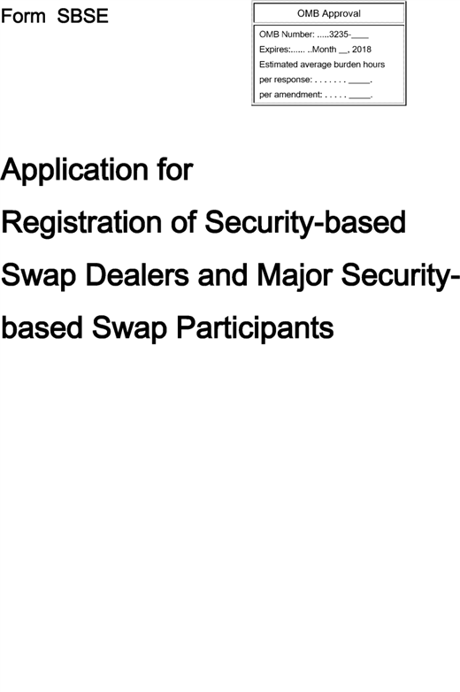

**[*49019]**



**[*49020]**

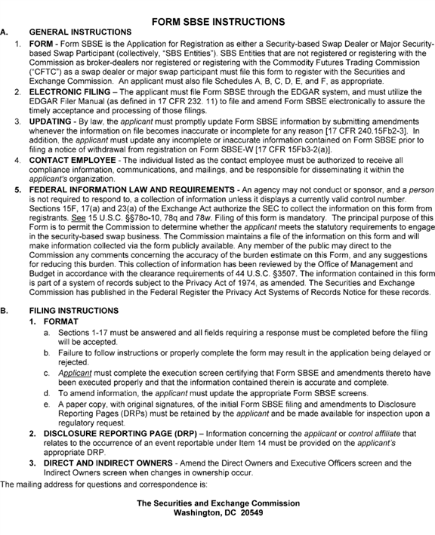

**[*49020]**



**[*49021]**

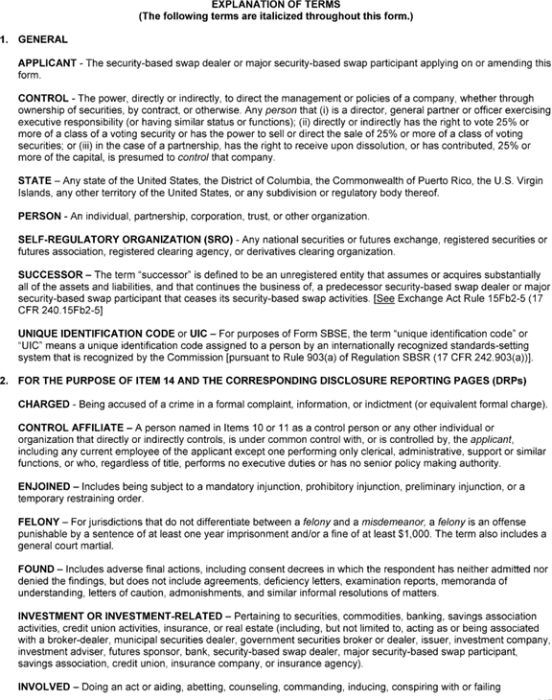

**[*49021]**



**[*49022]**

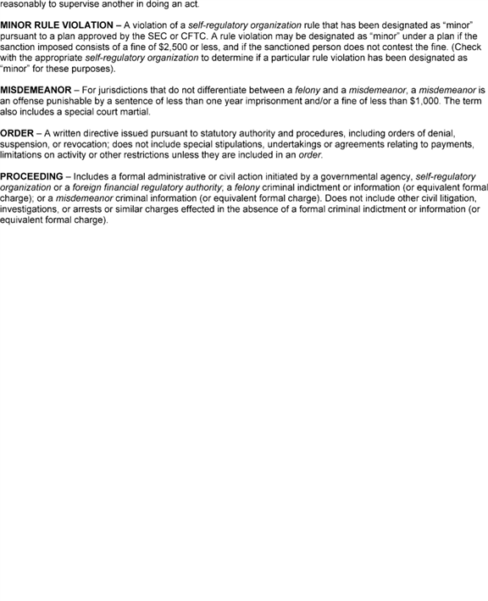

**[*49022]**



**[*49023]**

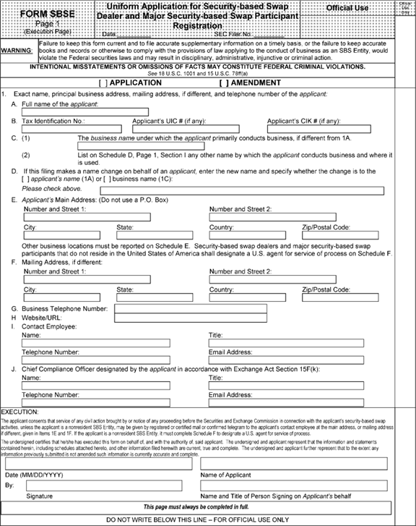

**[*49023]**



**[*49024]**

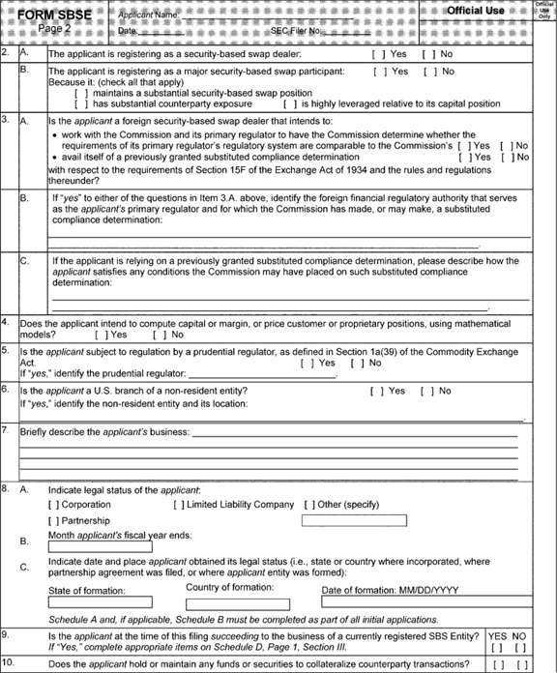

**[*49024]**



**[*49025]**

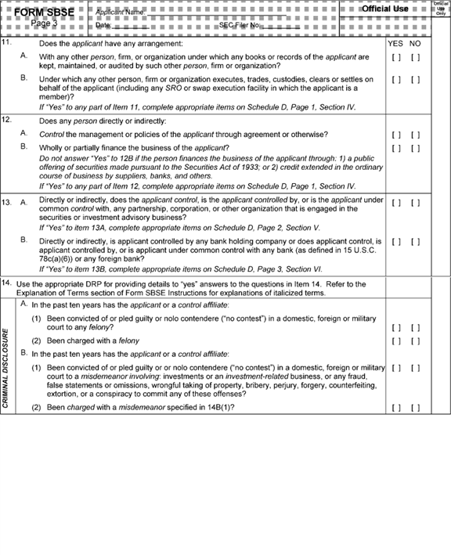

**[*49025]**



**[*49026]**

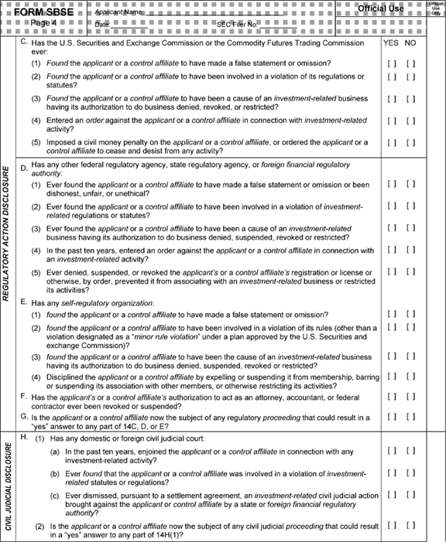

**[*49026]**



**[*49027]**

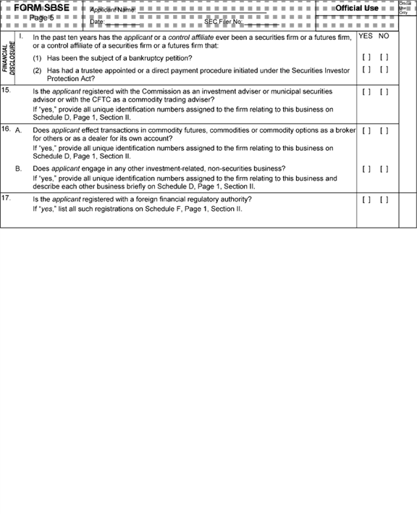

**[*49027]**



**[*49028]**

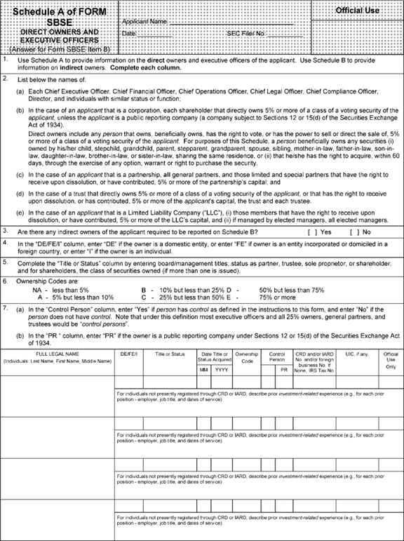

**[*49028]**



**[*49029]**

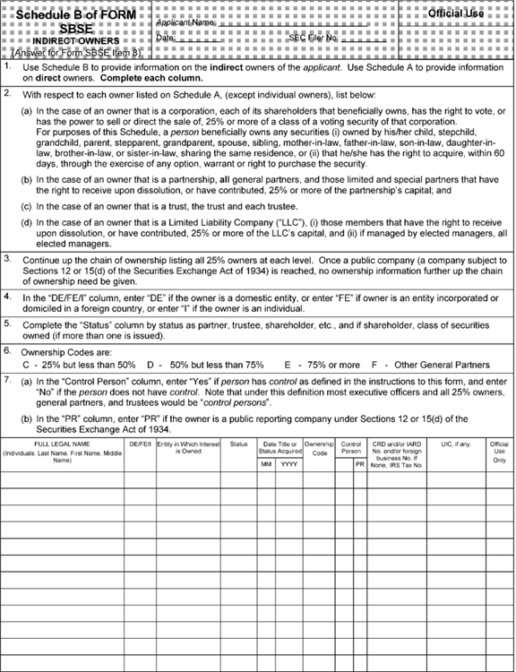

**[*49029]**



**[*49030]**

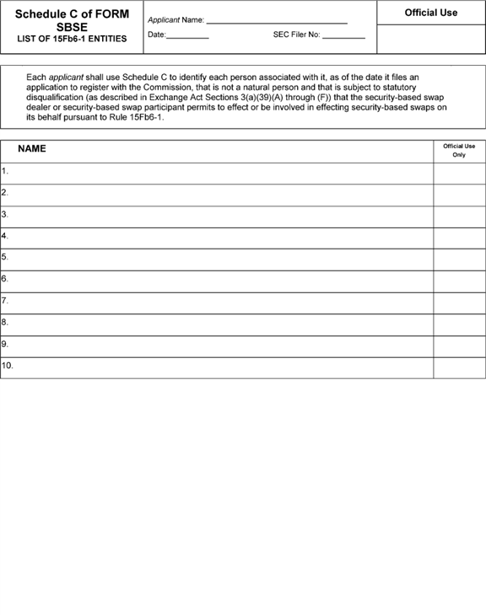

**[*49030]**



**[*49031]**

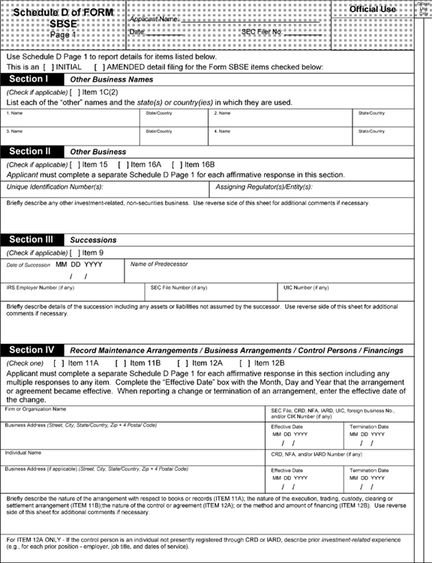

**[*49031]**



**[*49032]**

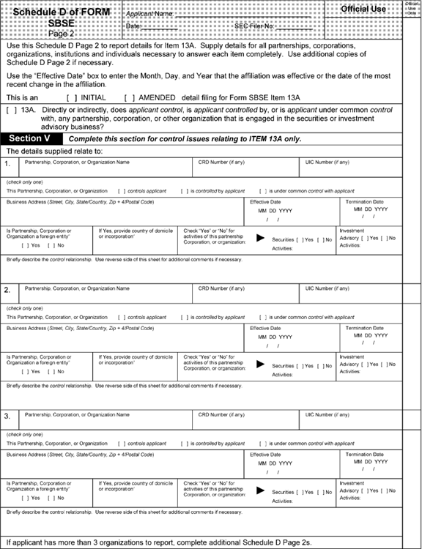

**[*49032]**



**[*49033]**

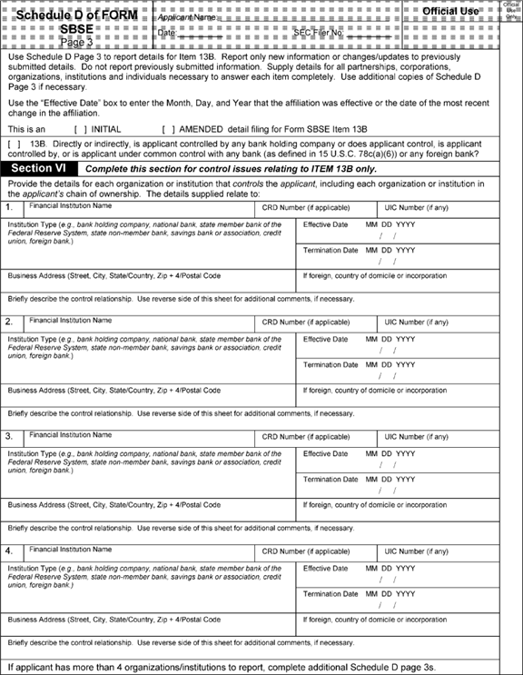

**[*49033]**



**[*49034]**

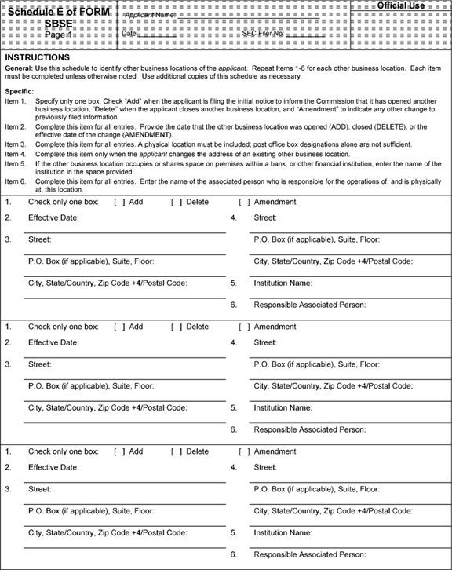

**[*49034]**



**[*49035]**

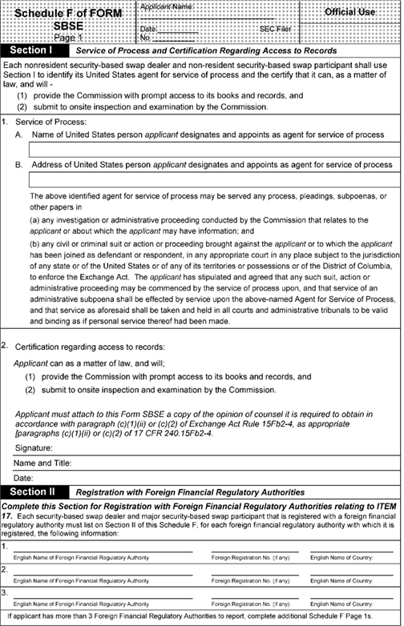

**[*49035]**



**[*49036]**

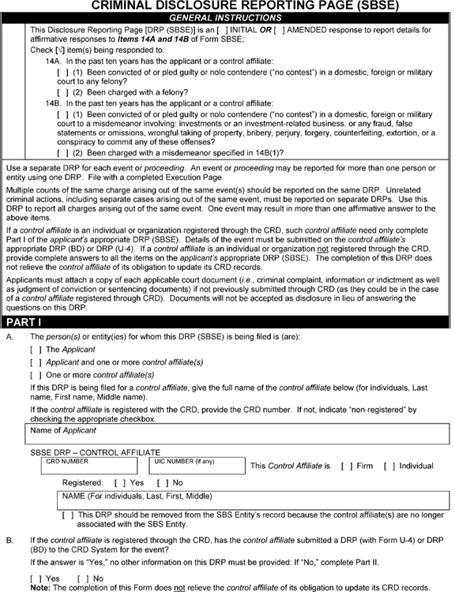

**[*49036]**



**[*49037]**

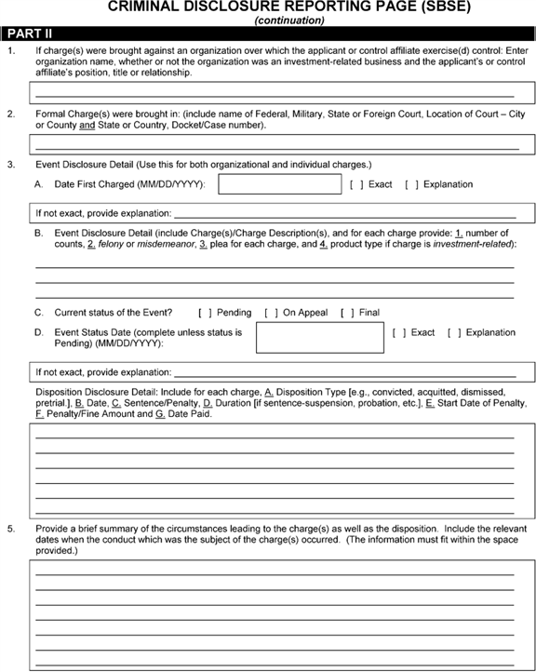

**[*49037]**



**[*49038]**

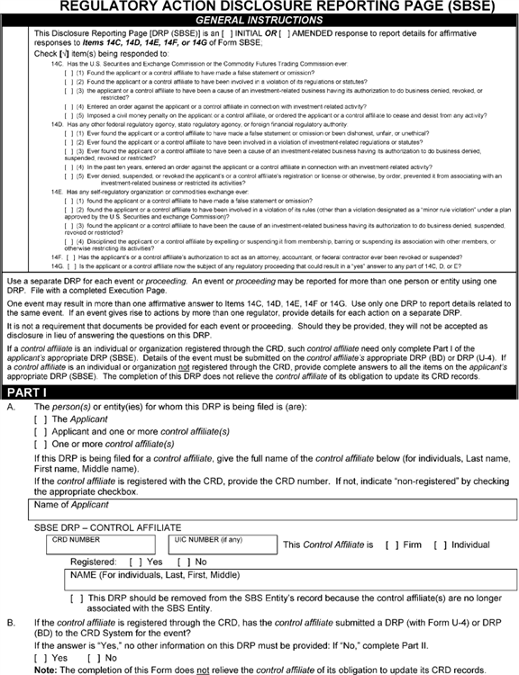

**[*49038]**



**[*49039]**

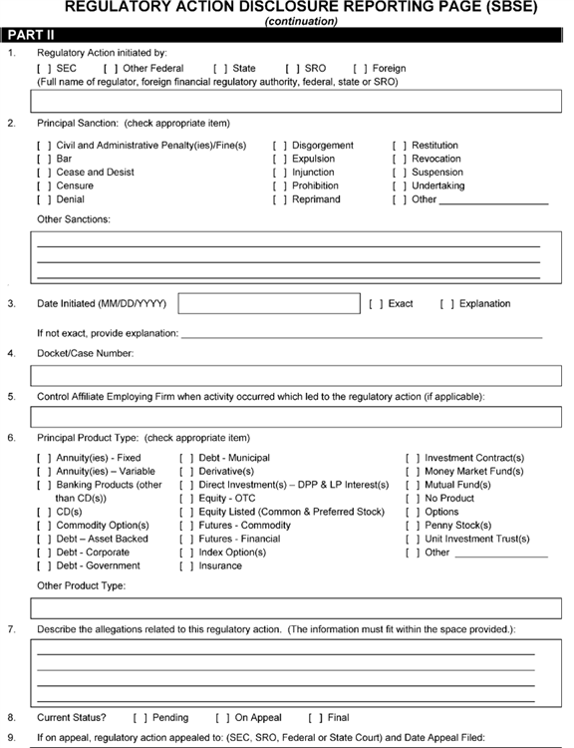

**[*49039]**



**[*49040]**

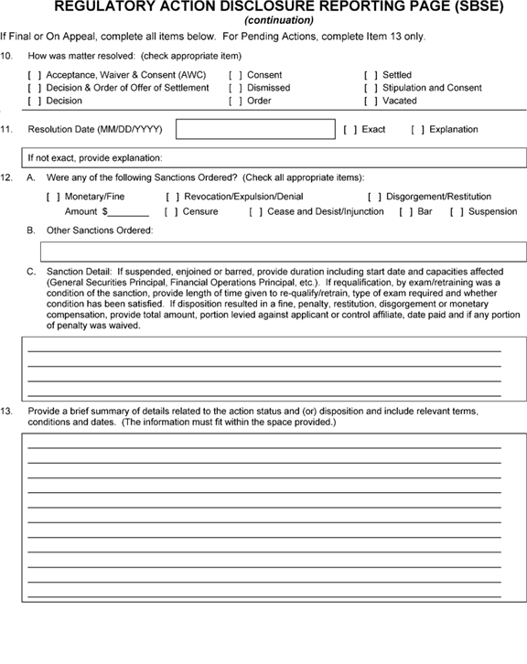

**[*49040]**



**[*49041]**

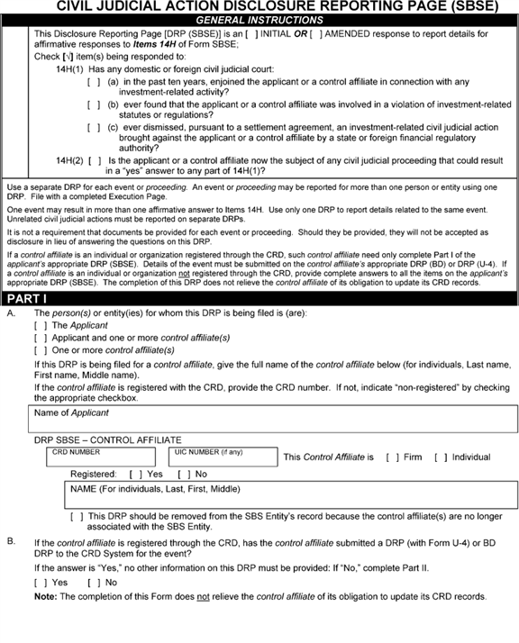

**[*49041]**



**[*49042]**

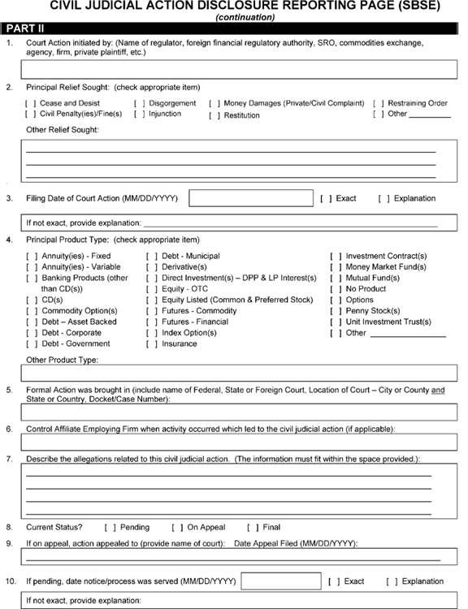

**[*49042]**



**[*49043]**

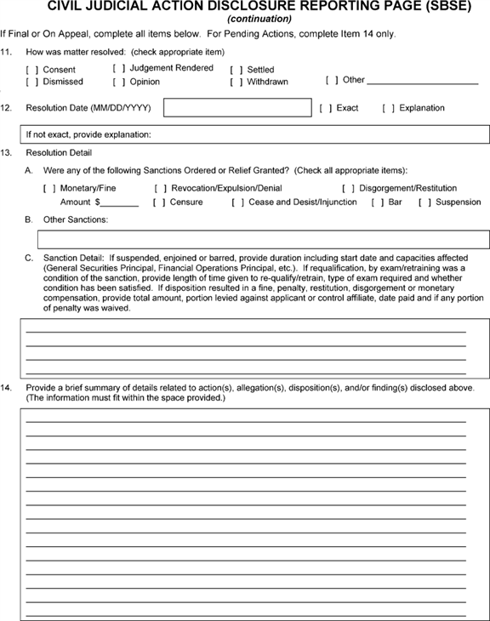

**[*49043]**



**[*49044]**

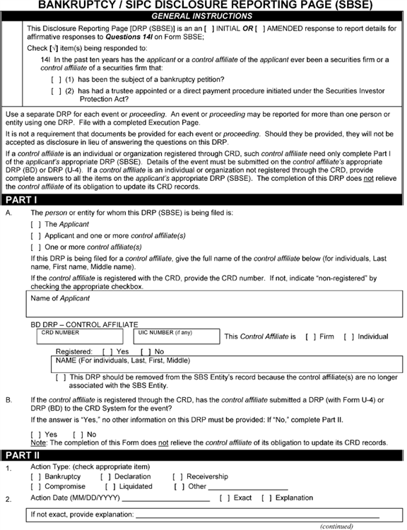

**[*49044]**



**[*49045]**

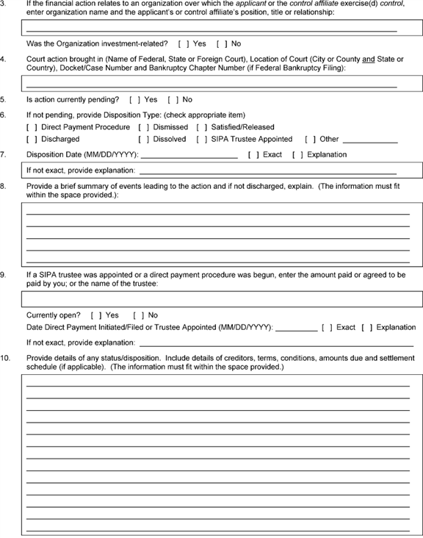

**[*49045]**



**[*49046]**

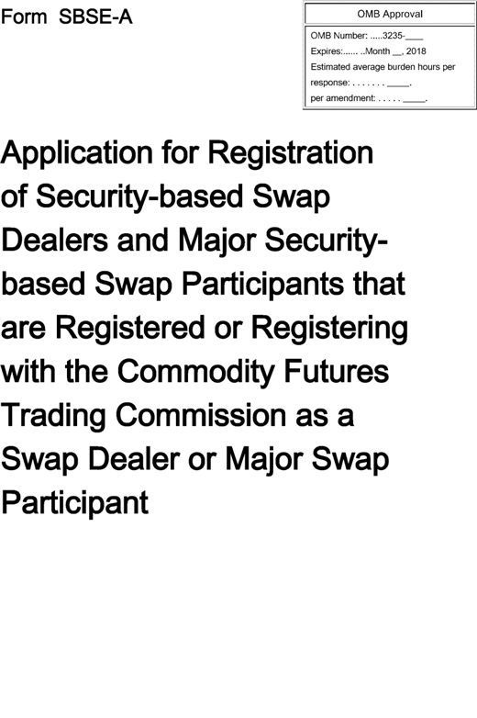

**[*49046]**



**[*49047]**

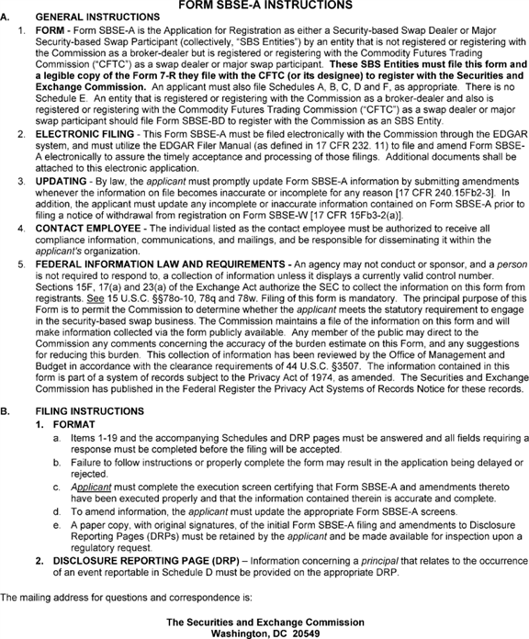

**[*49047]**



**[*49048]**

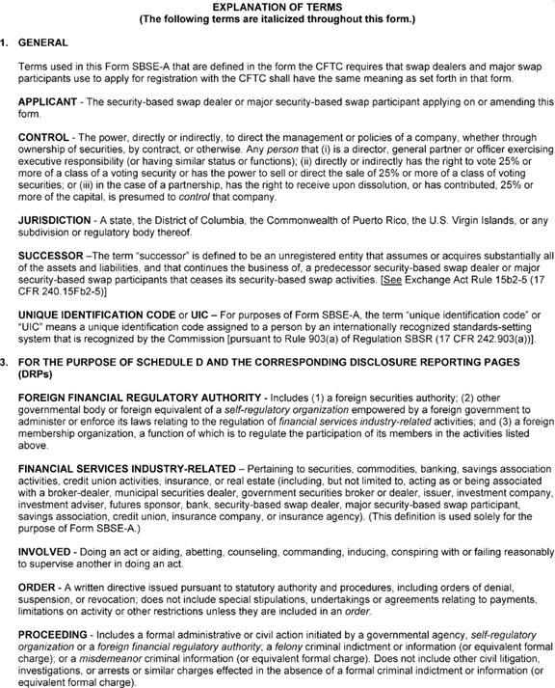

**[*49048]**



**[*49049]**

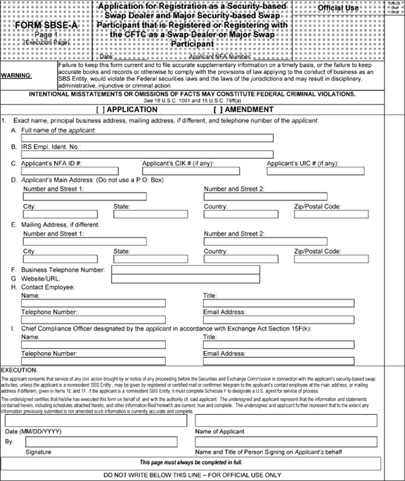

**[*49049]**



**[*49050]**

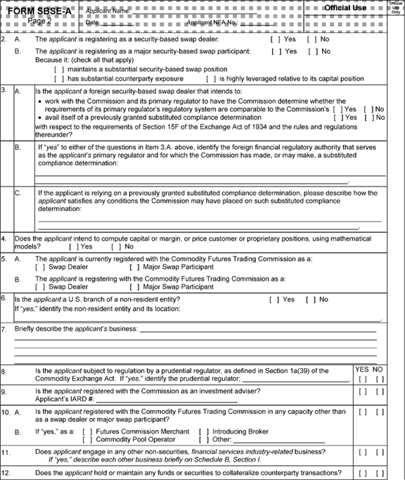

**[*49050]**



**[*49051]**

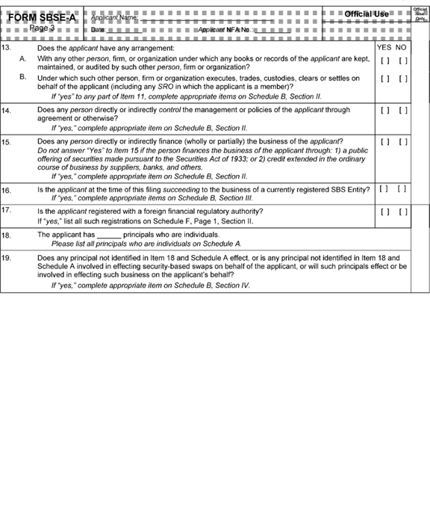

**[*49051]**



**[*49052]**

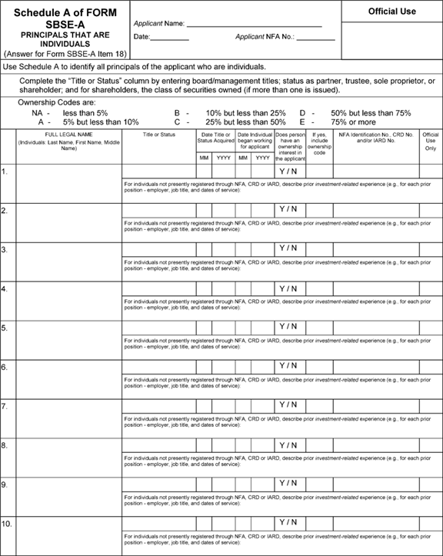

**[*49052]**



**[*49053]**

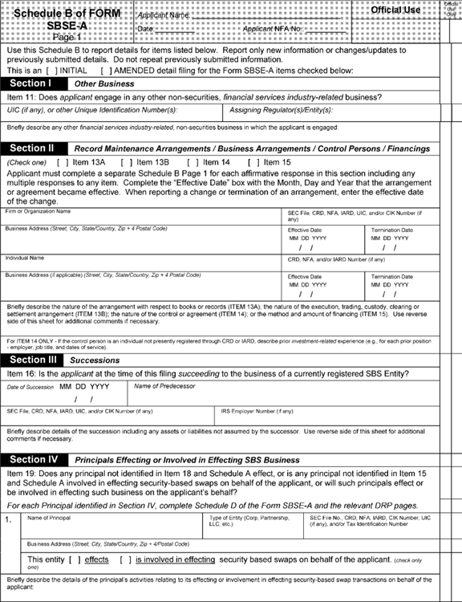

**[*49053]**



**[*49054]**

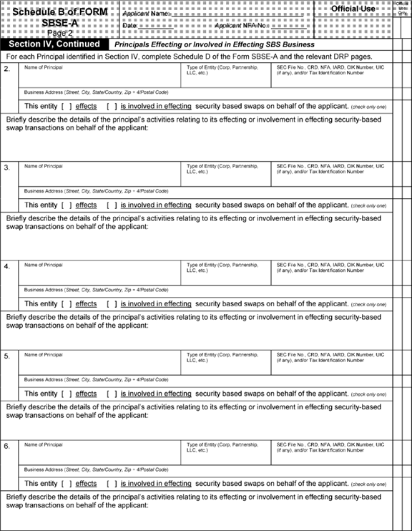

**[*49054]**



**[*49055]**

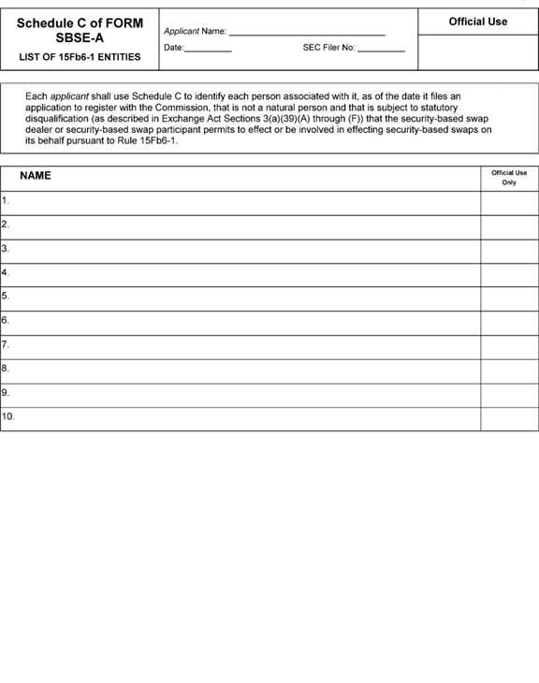

**[*49055]**



**[*49056]**

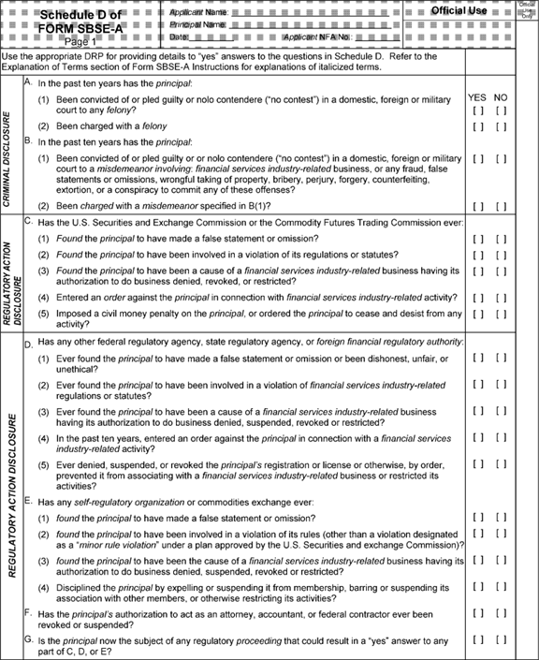

**[*49056]**



**[*49057]**

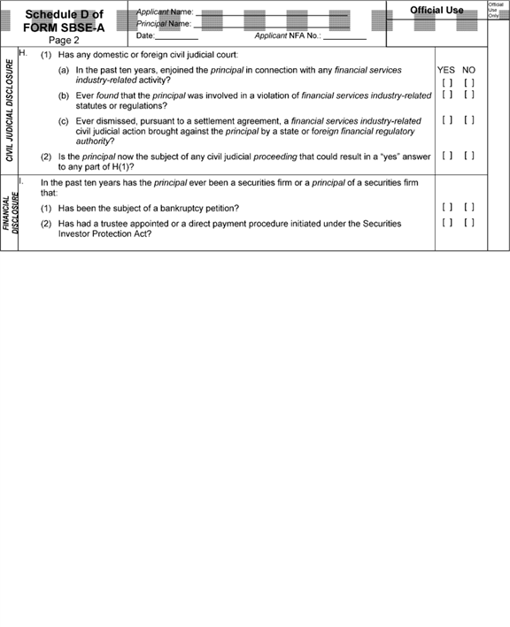

**[*49057]**



**[*49058]**

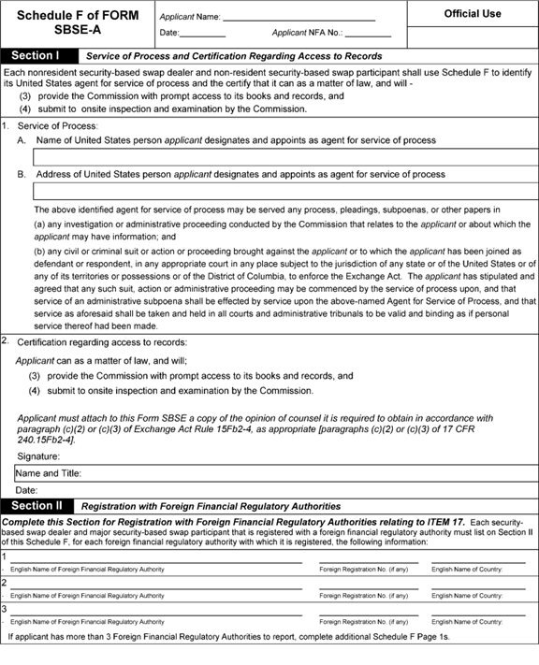

**[*49058]**



**[*49059]**

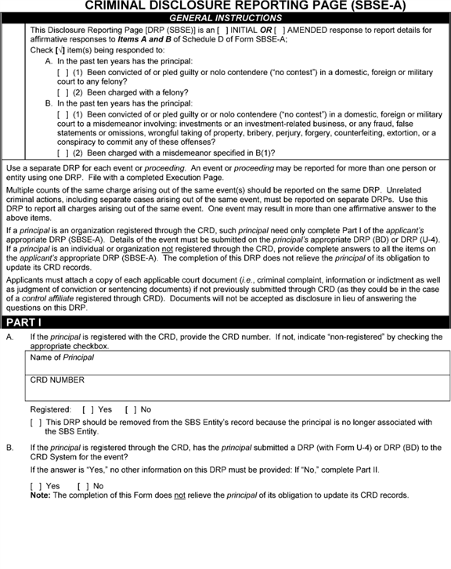

**[*49059]**



**[*49060]**

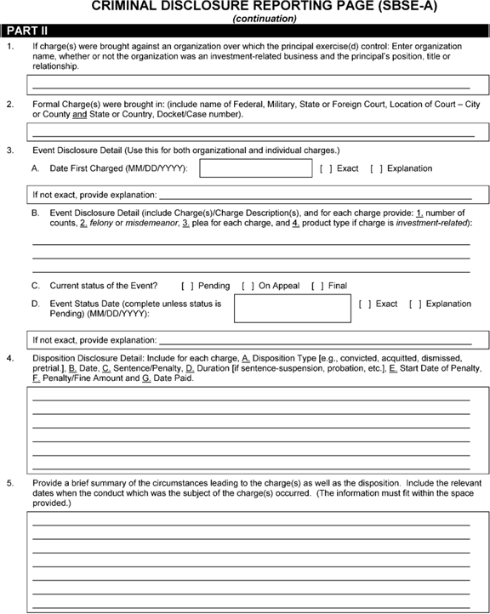

**[*49060]**



**[*49061]**

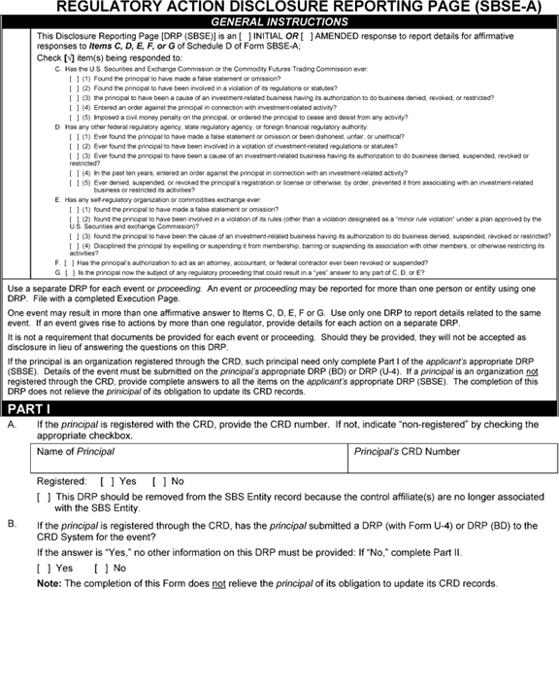

**[*49061]**



**[*49062]**

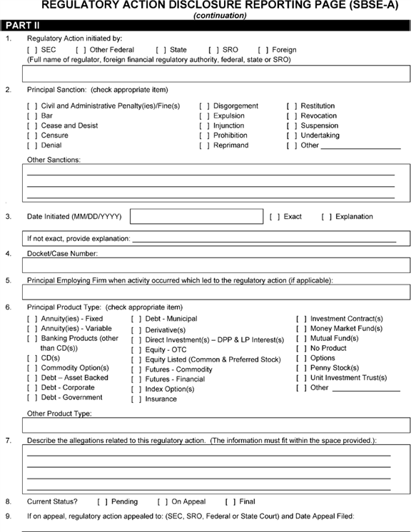

**[*49062]**



**[*49063]**

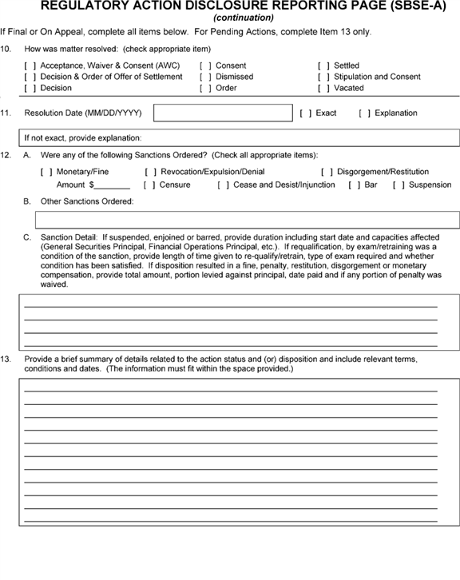

**[*49063]**



**[*49064]**

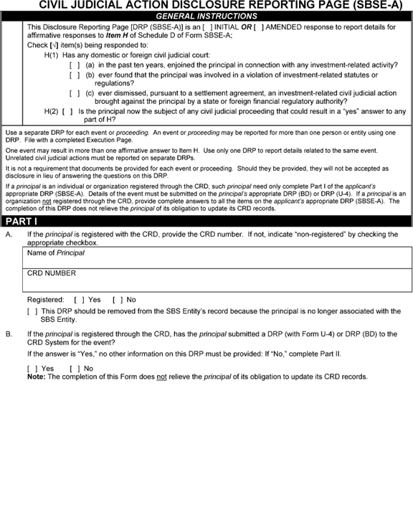

**[*49064]**



**[*49065]**

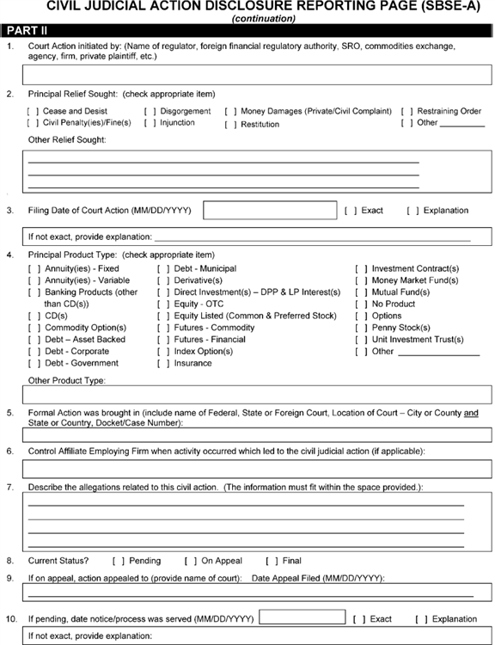

**[*49065]**



**[*49066]**

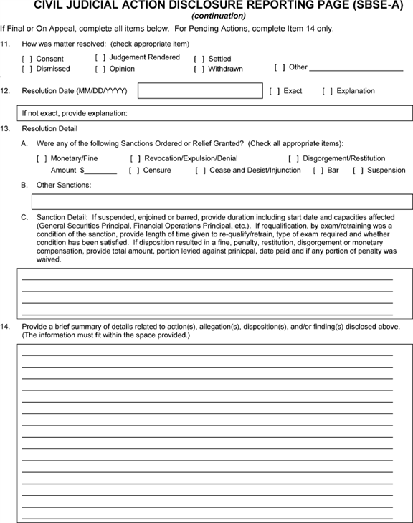

**[*49066]**



**[*49067]**

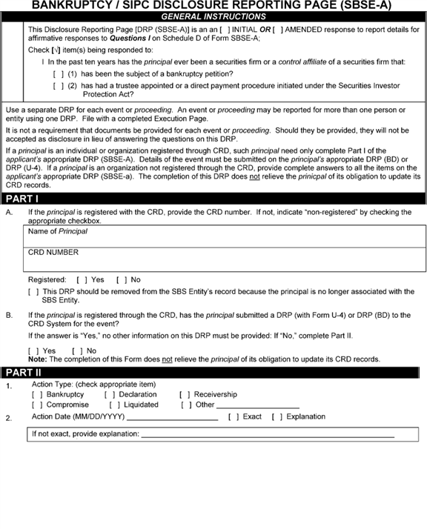

**[*49067]**



**[*49068]**

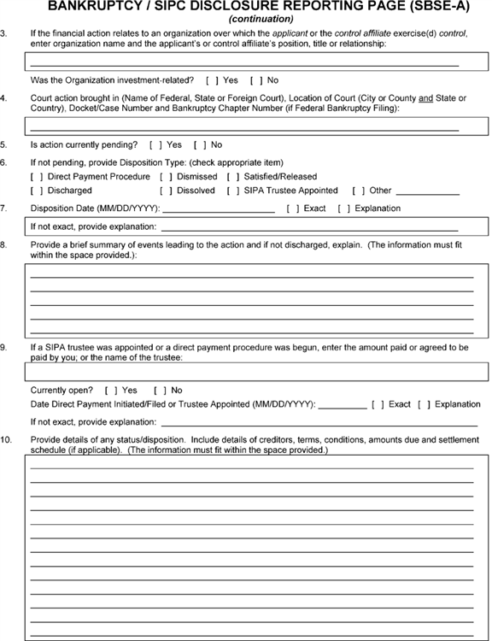

**[*49068]**



**[*49069]**

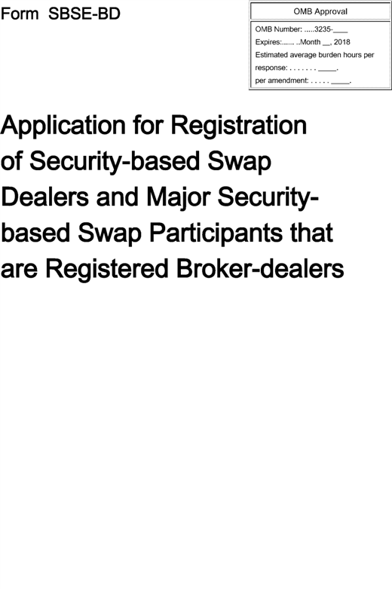

**[*49069]**



**[*49070]**

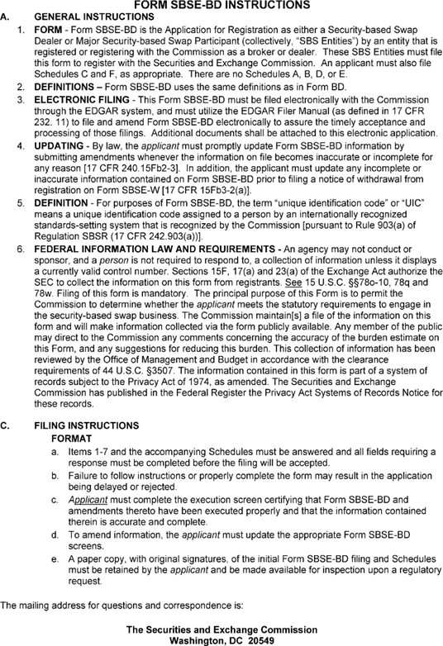

**[*49070]**



**[*49071]**

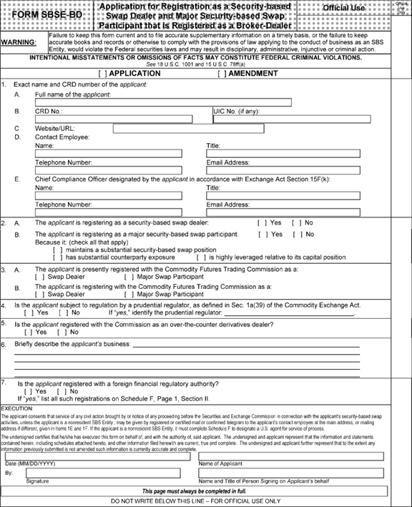

**[*49071]**



**[*49072]**

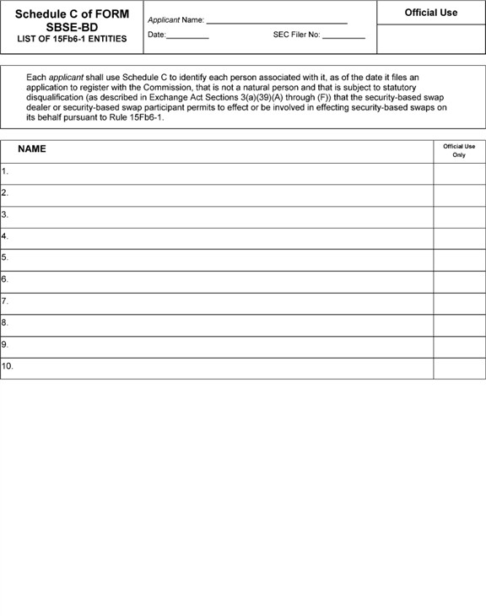

**[*49072]**



**[*49073]**

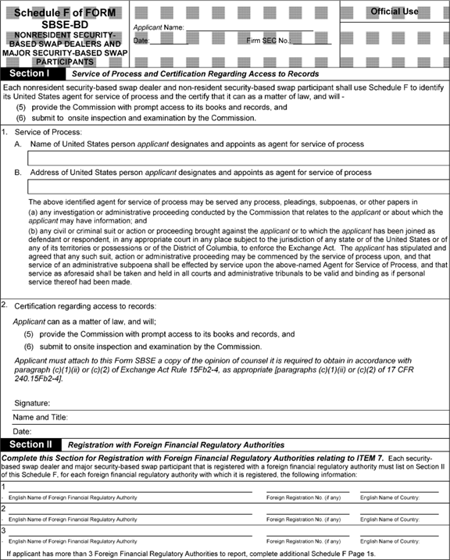

**[*49073]**



**[*49074]**

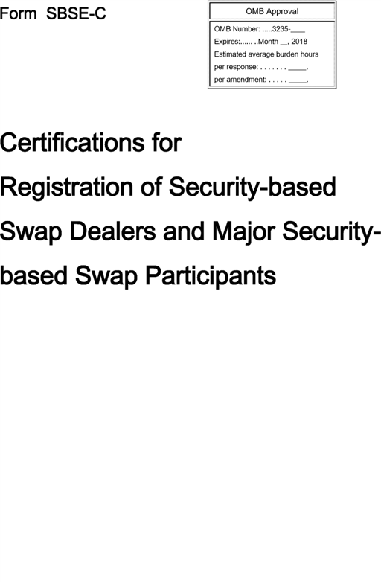

**[*49074]**



**[*49075]**

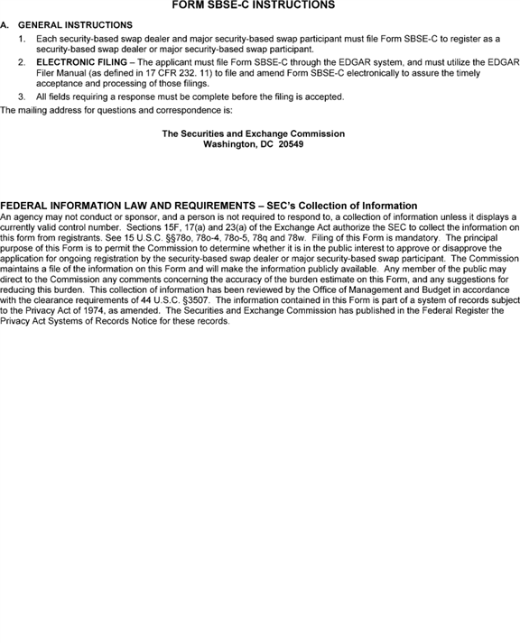

**[*49075]**



**[*49076]**

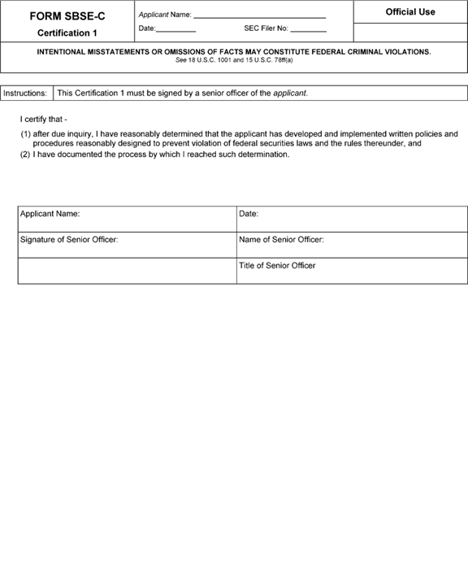

**[*49076]**



**[*49077]**

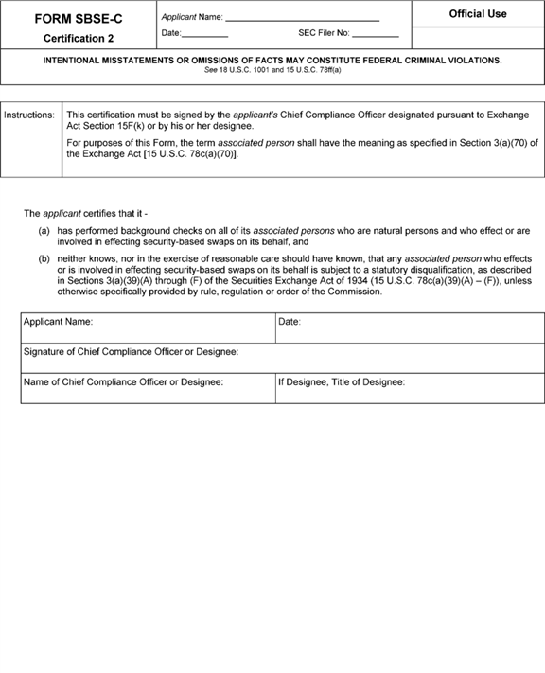

**[*49077]**



**[*49078]**

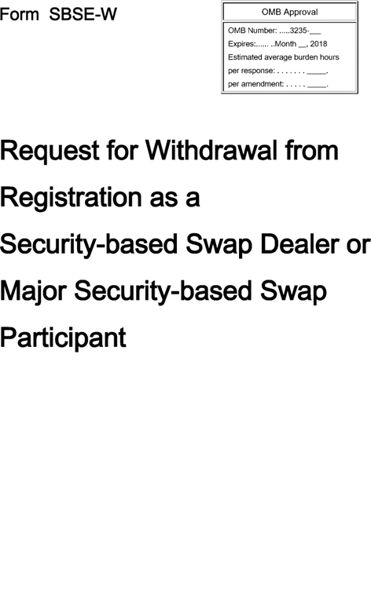

**[*49078]**



**[*49079]**

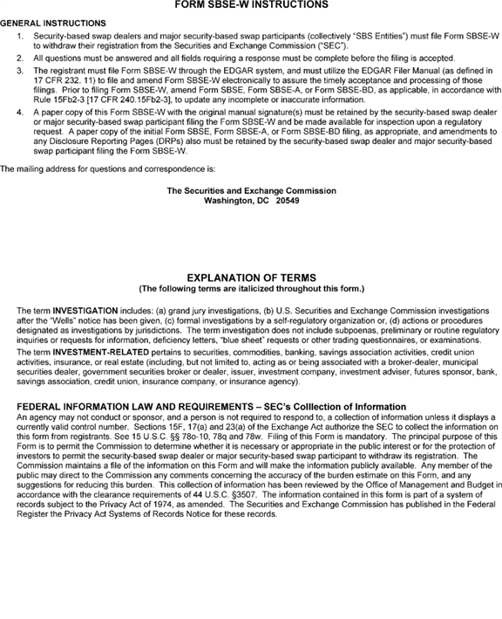

**[*49079]**

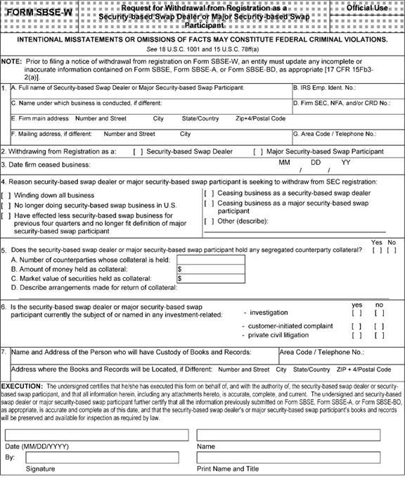

[FR Doc. 2015-19661 Filed 8-13-15; 8:45 am]

BILLING CODE 8011-01-C

**Dates**

**EFFECTIVE DATE:** *Effective Date:* October 13, 2015.

*Compliance Date:* The later of: Six months after the date of publication in the **Federal Register** of a final rule release adopting rules establishing capital, margin and segregation requirements for SBS Entities; the compliance date of final rules establishing recordkeeping and reporting requirements for SBS Entities; the compliance date of final rules establishing business conduct requirements under Exchange Act Sections 15F(h) and 15F(k); or the compliance date for final rules establishing a process for a registered SBS Entity to make an application to the Commission to allow an associated person who is subject to a statutory disqualification to effect or be involved in effecting security-based swaps on the SBS Entity's behalf.

*Counting Date:* For purposes of complying with the registration and other requirements, persons are not required to begin calculating whether their activities meet or exceed the thresholds established in Exchange Act Rules 3a71-2, 3a67-3, and 3a67-5 until two months prior to the Compliance Date of these rules.

**Contacts**

**FOR FURTHER INFORMATION CONTACT:** Paula Jenson, Deputy Chief Counsel; Joseph Furey, Assistant Chief Counsel; Bonnie Gauch, Senior Special Counsel; Joanne Rutkowski, Senior Special Counsel; or Jonathan Shapiro, Special Counsel; (202) 551-5550; Division of Trading and Markets, Securities and Exchange Commission, 100 F Street NE., Washington, DC 20549-7010.

FEDERAL REGISTER

**End of Document**